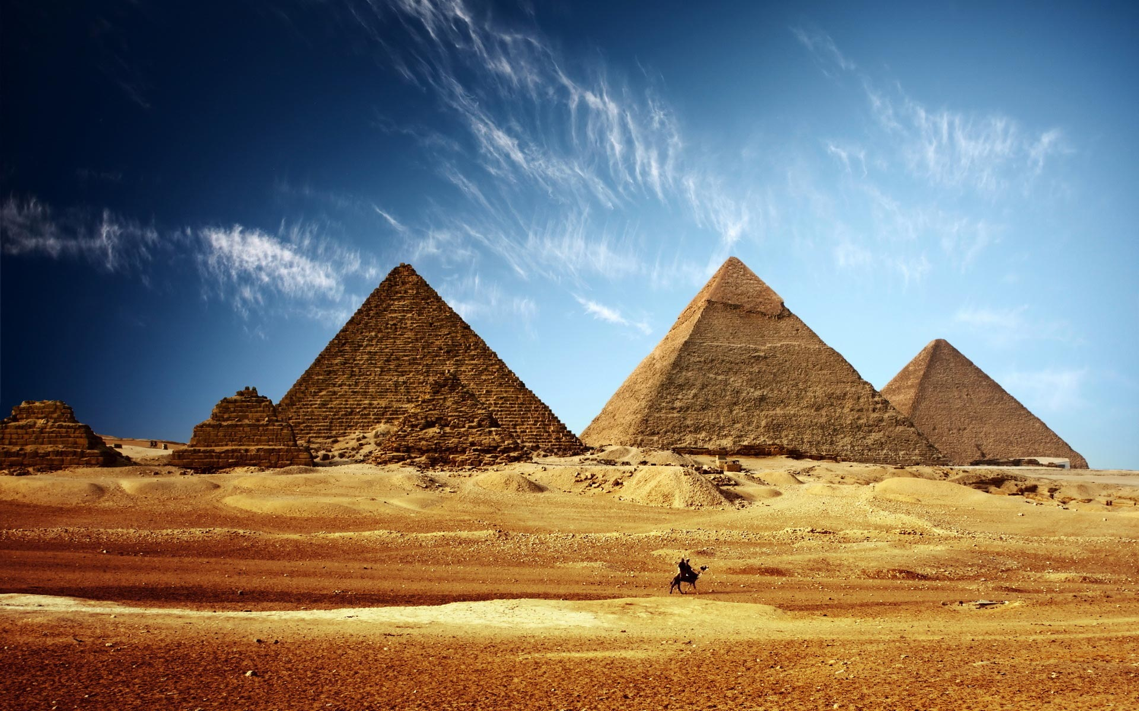
Homework
- Create top trump cards using Ancient Egyptian Gods and Goddesses.
- Write instructions for mummification.
- Design a death mask for Tutankhamun.
.

RE
- Authority
Looking at the Torah ‘s authority and relating it to their own lives
Egyptians – Summer
Hook
Mayflower Theatre Trip
Science
How plants make their food
- Plants make food in their leaves provide and absorb light and carbon dioxide
- Roots provide support and moisture

English
- Fiction text with historical settings.
- Non fiction – Fact file based on person of significance from Egyptian times.
- Myths – reviewing and using this as stimulus to create own.
Art/DT
- Architecture – Pyramids
- Making Jewellery
History/Geography
- Who were the Egyptians?
- How did the Egyptians live?
- Famous Egyptians and Gods
- What impact did they have on civilisation?
PE
- Athletics
- Real PE – Co-ordination and agility

Maths
- Place value
- Addition and subtraction
- Multiplication and division
- Fractions
- Geometry

OutcomeHooke Court – Live as an Egyptian for a night

