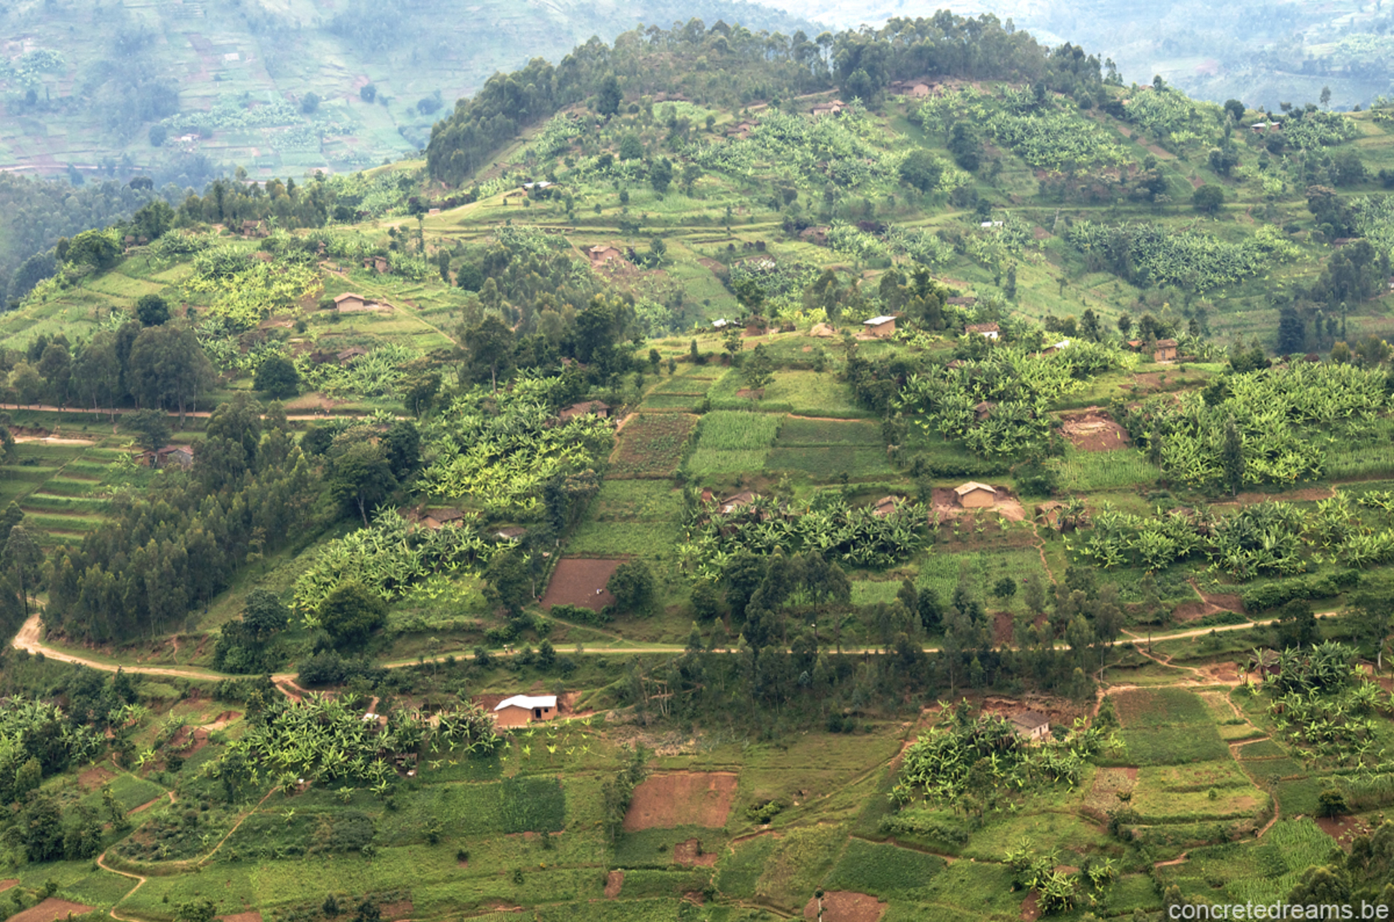
Homework
Summer 1:
- Create a poster about our local area. Why should people visit? What can people expect if they were to visit?
Or
- Draw/create a place in our local area. Label key features and identify whether they are man-made or natural.
Summer 2:
- Research one of the continents we have been learning about. Create an information leaflet.
Or
- Compare Rwanda and the UK –record any differences or similarities that you have learnt about.

Maths
- Place value
- Addition and subtraction
- Multiplication and division
- Fractions
- Geometry
- Measure

Geometry
English
- To write a range of narratives.
- Explore different text types including fiction, non-fiction and poetry.
History/Geography
- Understand geographical similarities and differences.
- Identify key human features.
RE
- Dharma
- Hindu Temples.

Core PE
- Gymnastics
Outcome
Create our own African inspired art.

Hook
Exploration of artefacts and photos. Where are they? What is it like there?
Rwanda
Summer 1 and 2

Art/DT
- To use the work of others to inspire clay sculpture work.
- Understand the basic principles of a healthy diet and where food comes from.
PE
- Cricket
- Athletics
- Physical and health and fitness.
Science
Plants:
- Flowering plants make seeds to reproduce and make more plants.
- Some plants die after producing seeds and others live for many generations.

