English homework
Year 6 - Autumn term 1

All writing tasks MUST be the same at home as in school.

Topic task 1
This week you need to write a couple of paragraphs about a Coastal area that you have visited.
This is a chance for your to show your teacher how good you writing is.

Gold
-use connectives ‘consequently,’ ‘nevertheless’ and ‘furthermore in some sentences
-use at least 3 complex sentences – where the subordinate is at the beginning, middle AND end of sentence (underline them).
-Accurate spelling and punctuation.
-Use a semi colon
Silver
-Use punctuation for parenthesis (comma, dash, bracket)
-use a range of sentence openers (fronted adverbials, -ly, connectives, subordinating conjunctions) Bronze
-use 4 adjectives
Use 2 adverbs
-use ‘because’ and ‘so’ in sentences

Punctuation work
Choose a task and rewrite the sentences/paragraphs, correcting the punctuation.

Bronze These sentences are missing a full stop and capital letter. Rewrite them so they have the correct punctuation
- jess and jake went for a walk it began to rain so they ran home
- at new chapter primary school we always try our best
- it was a cold day outside john put his coat on
- my friend is flying to spain next summer im going to my nans
- the butterfly danced upon the leaf but it soon clouded over the heavens began to pour

In these sentences you will need to put a ? or ! at the end
- Where are you going
- How exciting
- How rude
- How was school today

Silver – Task 1: Write these sentences out using commas where appropriate.

  - Jake bought an orange apple two bananas some sugar and a pineapple.
  - Mary looked in the cupboard: she found some bread some butter a bone and a can of dog food.
  - Jane had forgotten the washing powder the peanuts and the yoghurts..
  - Susan tidied up the garden. She put the rake the spade and the hose in the shed. Next she put the wheelbarrow the bike and the chair in the garage.
5.Joe loved to go to the park with his friends Tanya Jason Fiona and Colin.

Task 2: For the following sentence re-write them using appropriate punctuation
- Jess and jake went for a long romantic walk it began to rain so they ran home
- Despite being at school at new chapter primary school we are hard working
- Quivering because of the cold john put his coat on wrapped his scarf tightly around his neck and left the house
- my friend eventhough shes scared of flying is traveling to spain next summer im going to my nans
- without a care in the world the butterfly danced upon the leaf but it soon clouded over the heavens began to pour

Gold
In this story, there is missing punctuation and the full stops have been put in the wrong places. Read the story carefully and try to work out where the full stops should go.
Rewrite using the correct punctuation in your homework book.

Marks backpack was slung over his shoulder as he and his sister ran to the bus stop they were taking a new bus route along the cliffs the beach in the distance, Mark could see the sea sparkling it was as though it was smiling at them he paid for the tickets and sat down on the drivers lap. there was a newspaper with a bold headline, reading Burglar Caught at the back of the bus. A commotion started up, with two teenage boys arguing over the hills. The bus travelled until it pulled up at Marks stop- the beach below the deep water in the sea. Fish swam in the crystal water turning down a side alley. Mark reached an ice cream parlour and took out his wallet from behind him. He could he his sister giggling with delight.

Reading comprehension

Gold = Complete A, B and C below AND ‘Life’s not fair’ (on next page).
Silver = Complete ‘Life’s not fair’ on the lined paper
Bronze = Complete A, B and C below

A)The captain announced over the intercom that all passengers needed to fasten their seatbelts and prepare for landing.
Q1: What type of transport were the passengers on?

B) Fog can be very difficult to see through. Fog is made up of millions of tiny droplets of water that absorb sound, and make vision quite difficult. If heavy fog occurs on a busy freeway, drivers have to slow down. Driving a car quickly through dense fog will soon lead to accidents.
Q 1: Would it be easy to hear clearly in a dense fog?

Q 2: Why would driving a car quickly through thick fog be dangerous?

C) The captain ordered me to the top of the mast. The main sail needed to be secured. The wind howled and its sharp fingers scratched at my shirt, making it ripple fiercely. The waves pounded against the ship’s wooden beams. Each wave thrust the ship to the side and the main mast shivered, nearly tossing me down into the violent swell of the ocean. I hung onto the mast for dear life, determined to do my job.
Q1: What was the weather like? How do you know that?

Q2: Is the character frightened? How do you know that?

Lined paper to answer the ‘Life’s not fair’ questions:

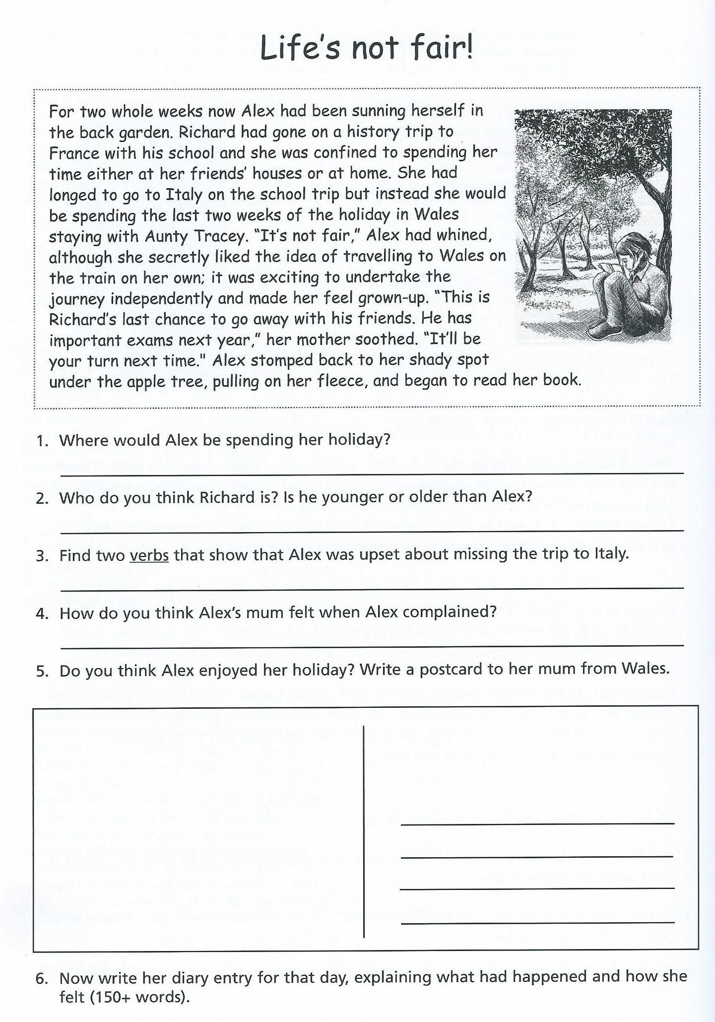

Grammar work
Complete all the tasks

1. Write a sentence explaining what each these are:
a) Verb
________________________________________________________________ b) preposition
________________________________________________________________

c) adjective
________________________________________________________________

2. Underline the following in the sentences below:
Red for verbs Blue for adjectives Green for nouns

- The man wore a tatty and worn hat on his head.
- It was under the table that I found the fluffy rabbit.
- Before I could run, the shiny red sports car stopped in front of me.

THEN Circle the objects of the sentences above.

3. underline the main clause in each sentence
- Despite hating chocolate, she still ate it.
- At the bottom of the garden, behind the overgrown shed, stood the metal gate. 3. Sarah, even though she came last, was overjoyed

4.Write a sentence saying what these words mean.
a) Plural
________________________________________________________________ b) singular
________________________________________________________________

5. Write the plurals of these words
a) Scarf = b) goose = c)tooth = d)class =

e) Ox = f) servant g)church h)person =
6.Write the following contracted words in their expanded forms:
- Won’t
- We’re
- Can’t
- We’ll

Reading comprehension
Gold = Read both texts and answer all the questions
Silver = Read ‘Insects, colour and camouflage’ and answer the questions below:
Bronze = Read ‘A thoroughly modern Grandmama’ and answer the questions below:

A thoroughly modern Grandmama:
- What does the poet say most Grandmamas like to do?
- What does this Grandmama like to do?
- How do we know she doesn’t have grey hair?
- What kind of clothes did she like to where?
- How does this poem rhyme?
- Does this compare to your grandmamma? Why?

Insects, colour and camouflage:
- What colours tell birds that an insect would taste horrible if they ate it?
- Explain how some butterflies can scare birds away:
- Why is it difficult to see grasshoppers when they are among the leaves and twigs?
- What do the eggs of an insect look like?
- What word in the ‘flash colours’ section means bewildered?
- Explain what camouflage means:

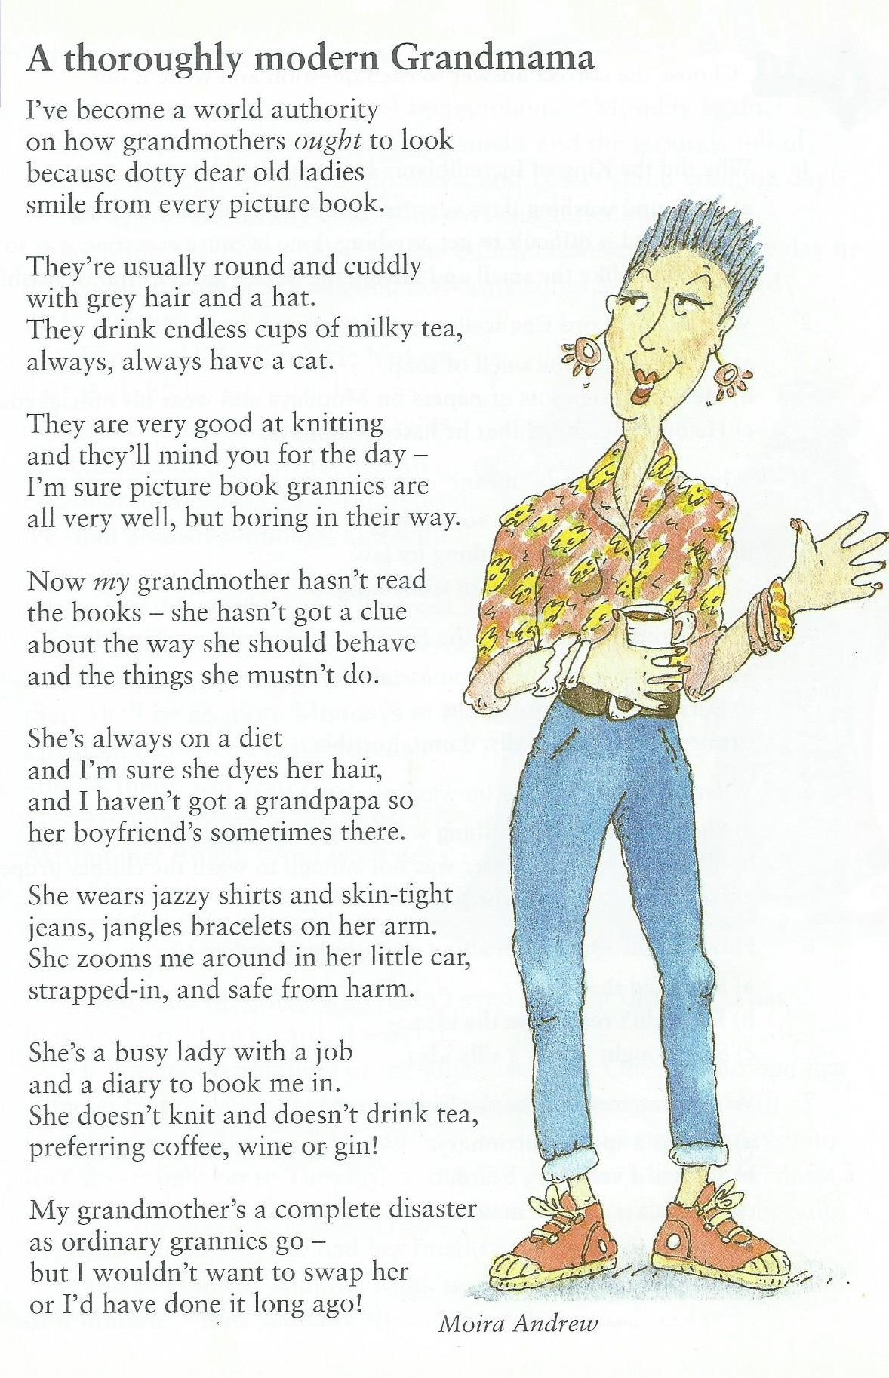
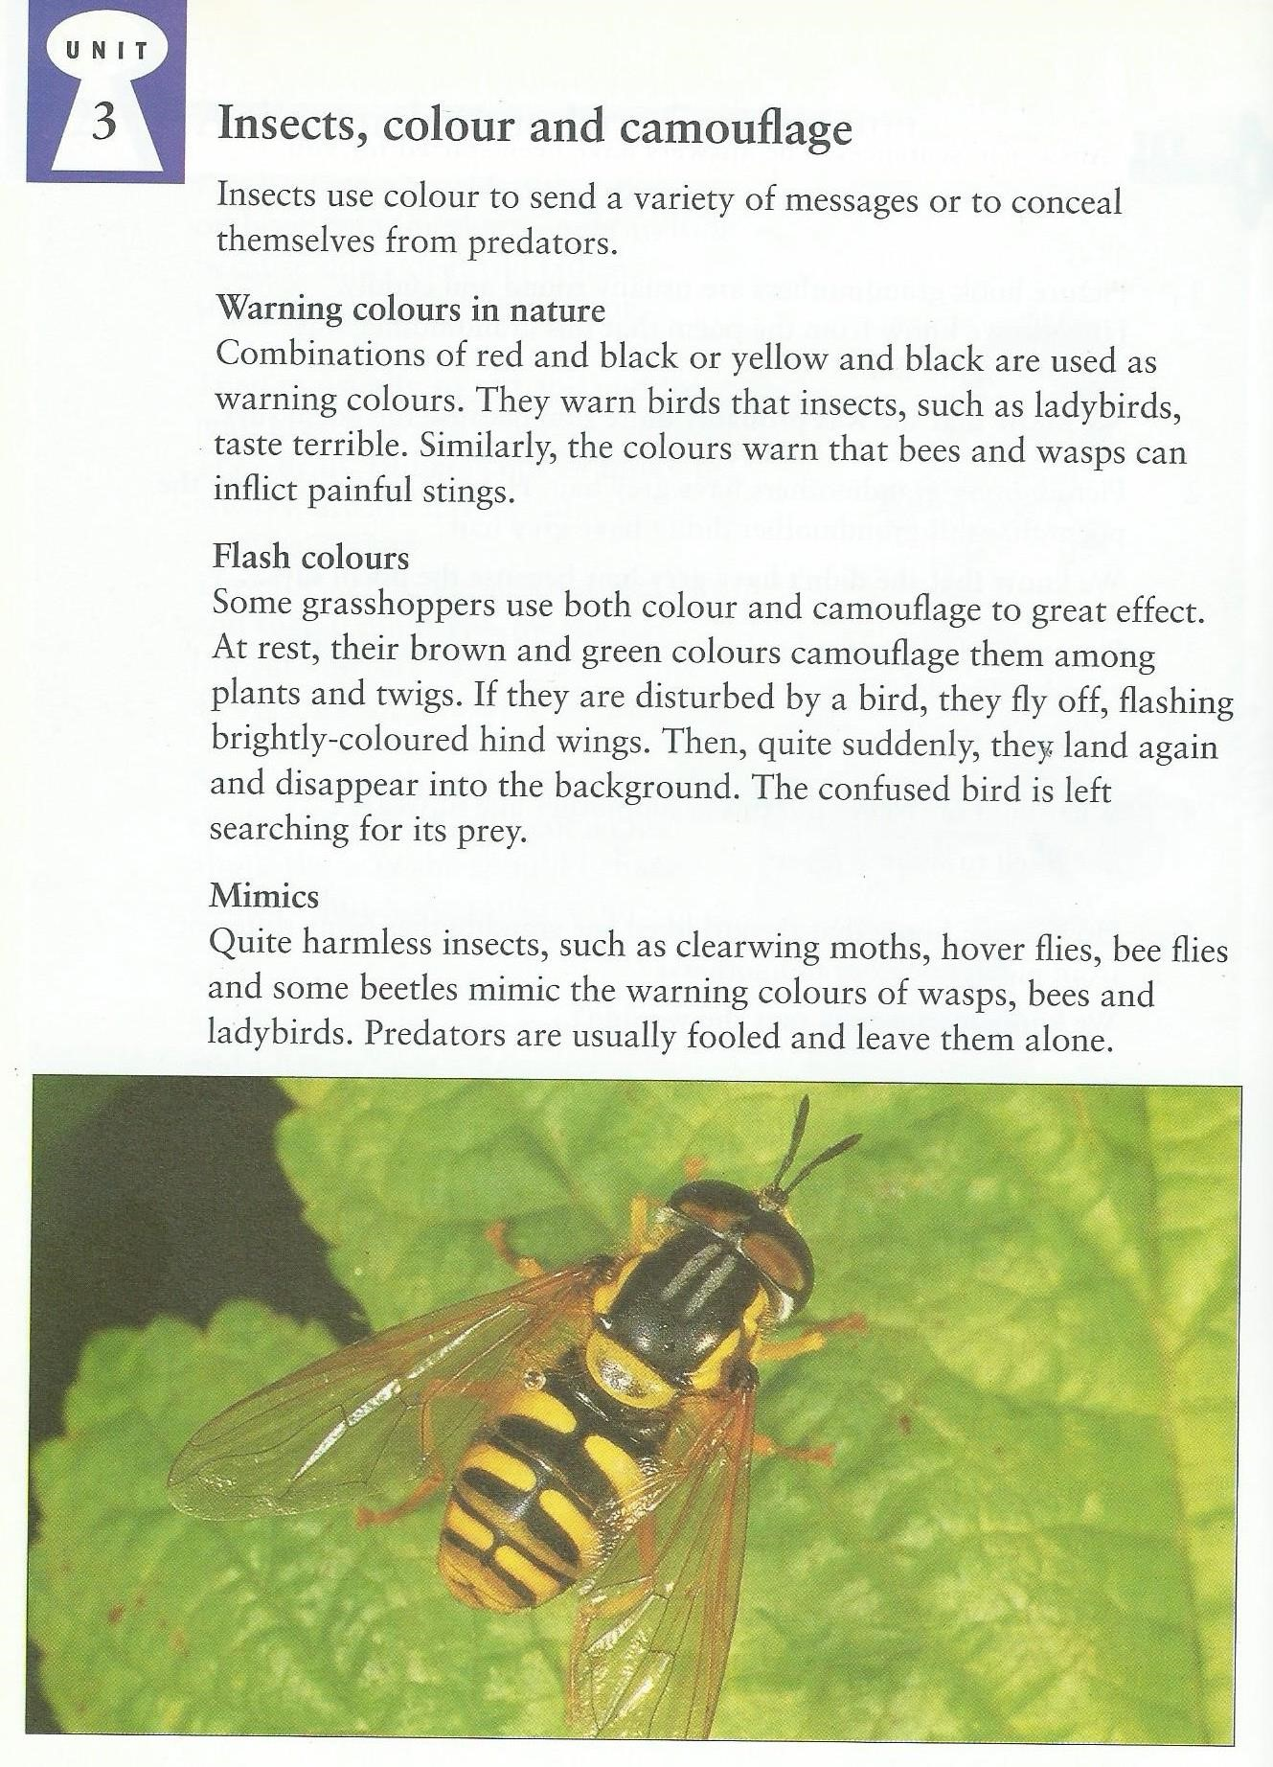

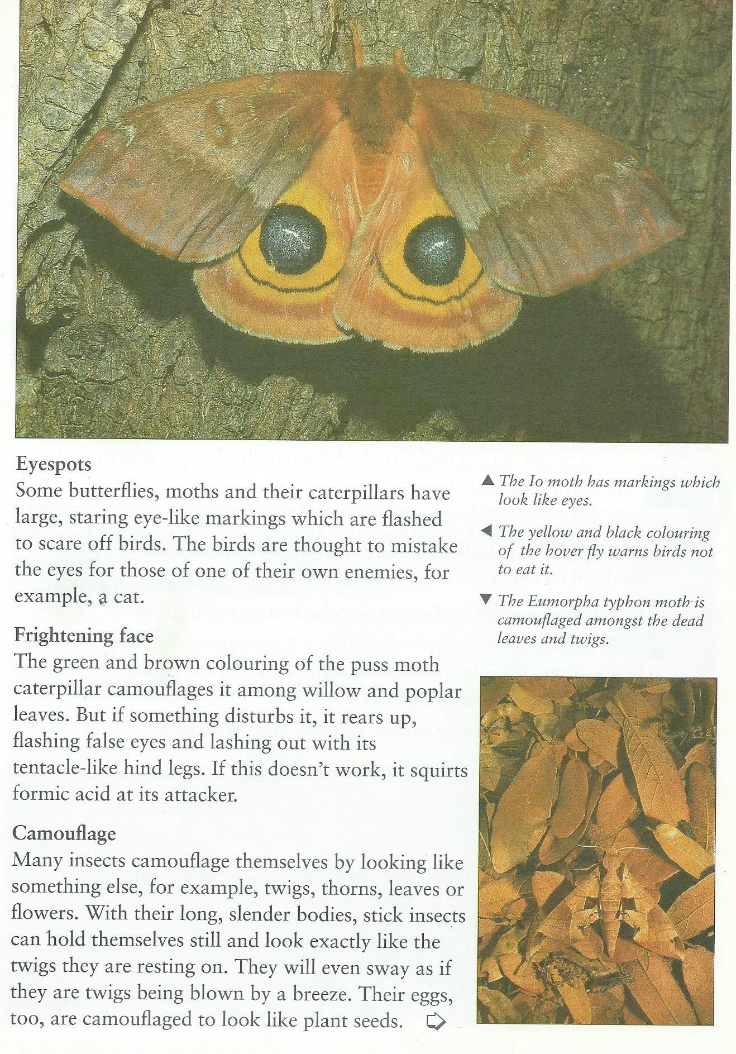

Tigers | Nonfiction Reading

Who would win in a fight, a lion or a tiger? Well, if size has anything to do with the matter, the tiger would win. That’s because tigers are the largest of all cat species. They grow up to eleven feet long and weigh as much as 670 lbs. This makes tigers the third largest land carnivore. The only larger land carnivores are polar bears and brown bears. Tigers are not only large, they are also fast. They can sprint as fast as 40 miles per hour for short distances and leap as far as 30 feet horizontally. This makes for an extremely dangerous pounce. You might not think that such large, fast, and ferocious creatures need help to survive, but they do.
The tiger is an endangered species.

Despite all of the tiger’s strengths, the future of the species is uncertain. Tigers face a very high risk of extinction. It is estimated that at the start of the 20th century, there were over 100,000 tigers living in the wild. By the turn of the century, the number of tigers outside of captivity dwindled to just over 3,000. Interestingly, the most serious threats that tigers face come from a much smaller species, one with an average weight of around 140 lbs. That species is Homo sapiens, better known as humans. Humans threaten tigers in primarily two ways: hunting and destroying habitat.

Tigers are hunted for many reasons. People have long valued the famous striped skins. Though trading tiger skins is now illegal in most parts of the world, tiger pelts are worth around $10,000 on the black-market. Though the fur would be incentive enough for most poachers, other parts of the tiger can also fetch a pretty penny. Some people in China and other Asian cultures believe that various tiger parts have healing properties. Traditional Chinese medicine calls for the use of tiger bones, amongst other parts, in some prescriptions.

Tigers have also been hunted as game. In other words people hunted tigers solely for the thrill and achievement of killing them. Such killings took place in large scale during the 19th and early 20th centuries, when a single maharaja or English hunter might claim to kill over a hundred tigers in their hunting career. Though this practice is much less popular today than it was in the past, it has not ceased entirely.

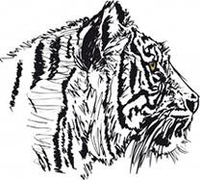

Humans have done considerable damage to the world’s tiger population through hunting, but perhaps more damage has been caused through the destruction of habitat. Tigers once ranged widely across Asia, all the way from Turkey to the eastern coast of Russia. But over the past 100 years, tigers have lost 93% of their historic range. Instead of spanning all the way across Asia, the tiger population is now isolated in small pockets in south and southeastern Asia. This is because humans have drastically changed the environments. Humans have built towns and cities. Road and transit systems were created to connect these towns and cities. To feed the people living in these areas, forests and fields have been cleared to create farmland. Large tracts of land have been strip-mined to yield metals and other materials used in manufacturing. All of these activities have consumed habitats that at one time supported tigers.

A major obstacle to preserving tigers is the enormous amount of territory that each tiger requires. Each wild tiger demands between 200 and 300 square miles.
Tigers are also both territorial and solitary animals. This means that they are protective of the areas that they claim and they generally do not share with other tigers. Because tigers need so much territory, it is difficult for conservationists to acquire land enough to support a large population of tigers. Even when such these considerable spaces are allocated, it is even more difficult to patrol such large areas to prevent poaching. There is no easy way to preserve the wild tiger

Though tiger population faces many threats and obstacles to recovery, there have been some successes in conservation and preservation efforts. For example, Save China’s Tigers, an organization working to restore population without making large sacrifices. This organization brought these tigers to South Africa and helped them learn the necessary skills for a predator to survive in the wild. Current evidence indicates that the project was been successful. While

the wild tiger population, successfully rewilded a small this is just a small step, it shows that restoring the number of South China tigers. These tigers were born world’s tiger population is possible. into concrete cages from parents who were also captive and unable to sustain in the wild.

Directions: Read each question carefully and choose the best answer. Refer to the text if necessary. Write your answer on the provided space.
1. Which of the following is not a reason in the article explaining why tigers are hunted? a. Because tiger skins are worth a lot of money  - Because tiger parts are used as medicines in some cultures  - Because some tigers attack local villages  - Because tigers are hunted for enjoyment by some people  2. Which animal does not grow larger than the tiger?  a. Brown bear b. Lion  c. Polar bear d. All of these animals grow larger than a tiger  3. Which number is closest to the estimation of the wild Tiger population in 2003?  a. 3,000 b. 100,000  c. 140 d. 30,000  4. Which of the following best describes the author’s main purpose in writing this article?  - To provide readers with interesting information about the lifestyles of tigers  - To persuade readers to help the world’s tiger population and to offer ways to help  - To entertain readers with stories about how tigers hunt and are hunted  - To explain to readers why the world’s tiger population is endangered  5. Information in the third paragraph is mainly organized using which text structure?  a. Cause and effect b. Compare and contrast  c. Chronological order d. Spatial order  6. Which best explains why tigers have lost so much of their habitat according to the text? a. Because humans are afraid of tigers  - Because tiger skins are extremely valuable  - Because humans have changed the land  - Because tigers need so much space to survive  7. Based on information in the text, which best explains why tigers are poached?  - Poachers hunt tigers to protect their families from dangerous animals.  - Poachers hunt tigers for medicine to cure sick family members.  - Poachers hunt tigers because they enjoy killing dangerous animals.  - Poachers hunt tigers to earn large amounts money.  8. Which best explains why it is so difficult to preserve the wild tiger population?  - Tigers do not get along with most other animals.  - Tigers must make their homes close to rivers and the world’s rivers are evaporating. c. Tigers require a lot of space.  d. Tigers hunt in large packs and there are too few tigers left to make these packs.  9. Which of the following is an opinion? | __________  __________  __________  __________  __________  __________  __________  __________  __________
- Tigers can grow up to eleven feet long.  - Saving the wild tiger population is important.  - South China tigers were brought to live in South Africa.  - Humans have endangered the world’s wild tiger population.  10. Based on context, which best defines the term “rewilded” as used in the last paragraph? a. To preserve animals by keeping them in zoos  - To teach animals to coexist with humans  - To teach humans to coexist with animals  - To bring animals born in zoos back to nature  11. What does this idiom mean: “other parts of the tiger can also fetch a pretty penny”? a. The fur is the only valuable part of the tiger.  - Other parts of the tiger are worth a lot of money.  - The tiger is a very beautiful animal.  - Tigers can be trained to do tricks like in the circus.  12. Which of the following could be best supported by information from the text?  - Efforts to save tigers have had some success, but there are many obstacles to recovery.  - Efforts to save tigers have failed in the past, but there is reason to continue trying.  - Efforts to save tigers have been so successful that they saved tigers from endangerment. d. Efforts to save tigers have failed completely. |  | __________  __________  __________

Effective Story Endings

The ending to a piece of fiction is really important. It can make or break your story! Don’t spoil a good story by having a rubbish ending. When planning your story you should make sure the ending is effective and matches earlier events in the plot.
Here is a plan for a story with three possible endings:
OPENING
Three hikers decide to go on a hike through the Amazon Rainforest
BUILD UP
They begin their hike into the Amazon but don’t tell anyone they are going as it is dangerous to go to the Amazon on their own.
DILEMMA
They want to climb to the canopy layer to get a good view of where they are. One falls but is saved from plummeting to his death by a large branch – he has broken his leg
EVENTS
The three hikers spend an uncomfortable Night in the Amazon. The rain begins to fall and the injured man becomes ill.
RESOLUTION / ENDINGS
Happy Ending  An Amazonian tribe finds them and gets them to safety. | Cliff Hanger  Two of the hikers go back to get help, leaving the injured man behind.  Will they return? | Tragic  A Brazilian Wandering Spider approaches the injured man – it bites him and injects its fatal venom before the other two have a chance to get it off the injured man.

Your Task!
You are going to write THE ENDING of this story. You can either choose the ending you like best or create your own.
Think of some good vocabulary and phrases you would like to use in your writing.

Trapped! Half term

Write a short story with the title Trapped.
You will need to decide:
- Where the story is set and what your main character is like
- Whats the weather like- set the scene
- how and why the character/s become trapped
- how they react to the situation and what they do
- If and how they get out
Make sure you use the success criteria below- remember you must have achieve bronze in order to achieve silver or gold. Tick off what you think you have included.

Gold = o A range of punctuation o A variety of sentence structures o Semi colon
- Passive voice (object…by… subject)
- Descriptive phrases to interest the reader (personification) o A range of sentence types (Alan peat as well)
- Your word makes sense throughout
- There are no spelling mistakes

Silver = o Include an opening, build up, problem, solution and ending o Include descriptive detail o Include a mix of dialogue and description o Use 2 x 4A sentences
- Adverbial phrases (how, where, whe) o Dashes to show parenthesis o Commas to show parenthesis o Your work mostly makes sense
- There are a few spelling mistakes

Bronze = o Write the beginning, middle and end of the story o Include adjectives
- Use paragraphs to organise ideas o Co-ordinating conjunction (FANBOYS) o Subordinating conjunctions (because, although, if) o Capital letter for names of places and people o Capital letters at the beginning of sentences

