Starter questions
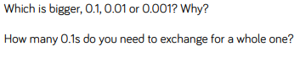
Fluency
A.
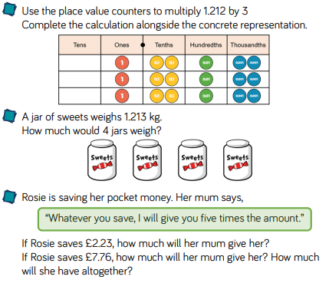
B. 1. 4.34 x 5
2. 8.67 x 7
3. 34.32 x 9
4. 8 x 723.9

C. Reasoning and problem solving


