MATHS

Check out Mathletics

There is a problem solving activity to be completed today. There are different ones for different groups.

If you finish early, TT Rock Stars, try to complete a range of tasks on TT.

Missing Numbers

Top tips - use the inverse
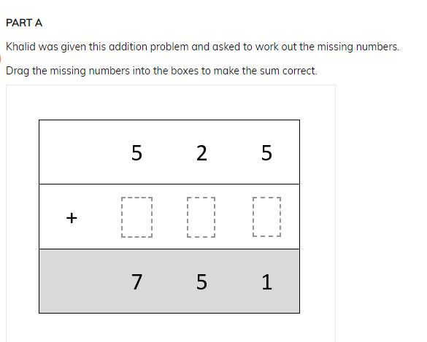

Dog Bone Problem

Firstly highlight the key words and numbers. Even, 24 bones etc.

There is more than one way of solving this problem.


