2 Choices - This work can be completed in your books or you can create a google doc and send to me via - share (top right corner), then enter my email address sam.wilcox@brockenhurstpri.co.uk

Option 1: Plant a seed and make observations as it grows.

My top tips when planting seeds.
Create your pot!
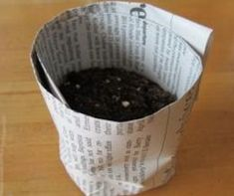
(Read your seed packet for proper instructions)
Fill your pot with compost until it is a fingernail away from the top. Water the compost. Using something flat, press the compost flat. Add your seeds, spacing them out. Add a little more compost to cover the seeds, but run your hands together as you add it. Press the compost down again. Store in a place that gets a bit of sunshine and a bit of shade. Water again in about ten days time or if it is dry.

Fill in the sheets below as you go.

WK1 | WK2 | WK3 | WK4 | WK5 | WK6 | WK7
CM | CM | CM | CM | CM | CM | CM

Option 2: Design a picture instructions labelling the different things that a seed needs to grow.

https://www.gardenersworld.com/how-to/grow-plants/how-to-sow-seeds-indoors-video/

