6 x 3 x 5 is larger because the first calculation starts with a 6 which is larger than the first number in the second calculation.
Challenge 2
Reasoning and Problem Solving
Ella the Egyptian has been looking at this calculation.
6 x 3 x 5 > 3 x 5 x 6

Do you agree with Ella?
Explain why/ why not.



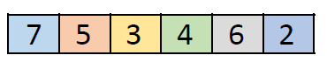
Challenge 3
Reasoning and Problem Solving
Make the target number 30 by using three of the digits below.

_____ x _____ x _____ = 30

Extra Challenge
Reasoning and Problem Solving
Make the target number 84 by using three of the digits below.

_____ x _____ x _____ = 84

