Subject | Timings | Activity
PE | 30 mins | Joe Wicks Daily
Reading and writing | 1 hour | To write a diary from the girls point of view.  Writing features to include:  First person - I, me, we, myself  Describe the thoughts and feelings of the girl  Talk about what happened in the day  Read through the book/slides (some of the slides are really hard to read). You can use the video of the author reading the book, but do not go past 2:47. https://vimeo.com/73026206  Why do you think the old lady smiled when she released the bag?  Why does the girl feel rich beyond her wildest dreams, even though she hasn't gained any money?  When you promise, what does it mean to you?  I want you to imagine that the girl has woken up and written in her diary about the events the day before. I want you to spend 5 minutes stealing key words and 20 minutes writing.  Your structure should be;  What the girl got up to in the morning (stealing wallets and purses from people at the bus stop)  Seeing the old lady and thinking - easy prey  The old lady making me promise  Seeing the seeds and starting to imagine what might happen  Extension - what does she plan to do next?
Spellings | 15 mins | Fresh spellings  Rule: When adding the suffix ‘ly’ to root words that end in ‘le’ then the ‘e’ is dropped and ‘y’ added. (gentle/gently)
Mental Maths | 10 mins | 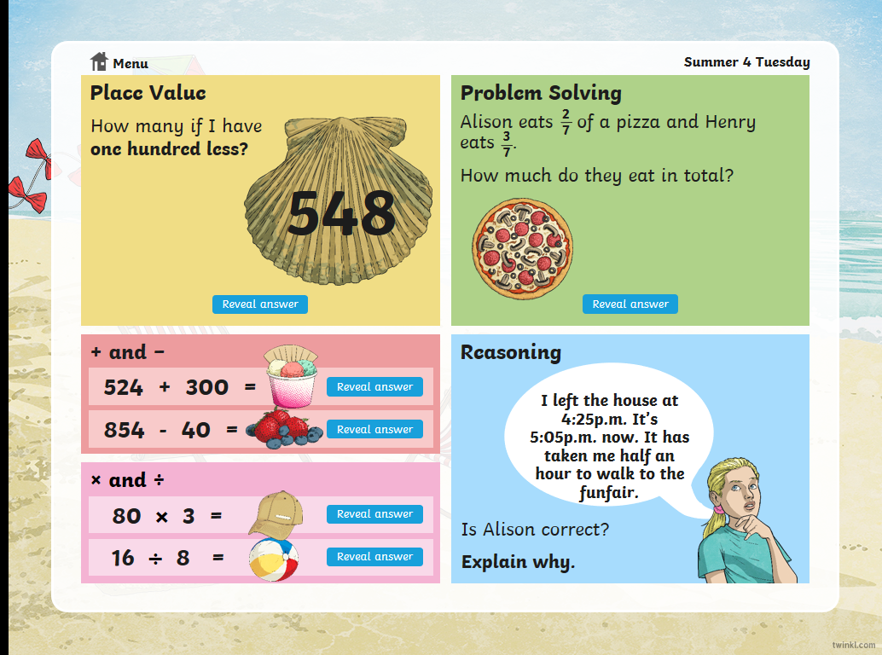
Maths | 45 Mins | To understand tenths  A 10th is a whole (1) split into 10 equal parts. If you have 3 of those tenths you would have 3 tenths.  Watch the video lesson 3  https://whiterosemaths.com/homelearning/year-3/  Have a go at the activity  If you have anytime left over, get on TT Rock Stars  This is a great website to help understand fractions. https://www.mathsisfun.com/fractions.html
TT Rock Stars | 15 Mins | If you get time
Science | For the week | LO: To design a bird feeder and monitor the birds in your garden.  As we can no longer increase the wildlife in the school grounds, I would like you to try to increase the bird life at your home.  This task takes preparation.  You are going to design and make a bird feeder. I have included some ideas of what you could do in your design.  Feed ideas: bread, savory cereal, seeds (if you have them.  After you have created your bird feeder, (you may want to leave it a while for the birds to get used to it), complete the table of which birds visited your feeder. When observing, stay well away from the feeder and stay there for around 20 minutes. Any movement will scare the birds, so stay very still.  Afterwards, I would really like to know the results, if you could email a photos of the chart, I would love to see it.

