Wednesday 1st April
Year R – Home Learning
Subject | Time allocated | Instructions
Keywords | 5-10 minutes | - Practise keywords
Ditty books | 10-15 minutes | - Use the same Ditty Book as yesterday  - Practise speed sounds  - Use Fred fingers to sound out Green words or read words on sight – as week progresses your child should begin to recognise each word  - Read red words  - Support child to read story – as the week progresses your child should need less support and be moving towards reading book independently  - Have a go at the speed words – read them all first, then adult say a word for child to find. Again, as week continues, your child should be more fluent reading these words.
Phonics | 15-20 mins | - Powerpoint – Phonics Wed 1st April  - Record task in home learning book – you can also use whiteboard to practise on  - If you cannot access the power point the words to write are moth, sloth, bath, thumb, thin, cloth. (Again, some of these words are getting trickier and need 4 fingers to sound out. Don’t worry about the b at the end of thumb. Bath is always tricky because the ‘a’ sound in the middle is not quite right!)
Reading | 15 minutes | - Choose one book from pack to read  - Have a look at https://home.oxfordowl.co.uk/  - Try and read an e-book (if you can read the same book as yesterday, to reinforce the learning. A second read should be more fluent.)
Maths | 30 minutes | - Mathletics: https://login.mathletics.com/  - 1 activity set on Mathletics  - Have a go at playing some shape games: https://www.topmarks.co.uk/maths-games/5-7-years/shapes  - Have a look at the Mirror Hunt PowerPoint and carry out your own mirror hunt  - Continue your number frieze – on a piece of paper write a big number 5 then draw a picture of 5 things. Do the same for number 6.
Writing | 15-30 minutes | - Have a look at this website: https://www.bbc.co.uk/teach/school-radio/nursery-rhymes-a-to-z-index/z4ddgwx  - Sing your favourite nursery rhyme and draw a picture to go with it.  - Have a go at writing a sentence about it
Understanding the world |  | Lunch diary  - Have a go at copying the day (Wednesday) at the top of the page  - Have lunch  - Draw a picture of what you ate for lunch  - Write a label if you want.
Other activities – for you and your family |  | - Have you made a rainbow for your window yet? Such a lovely thing to do to show support for everyone during this difficult time.  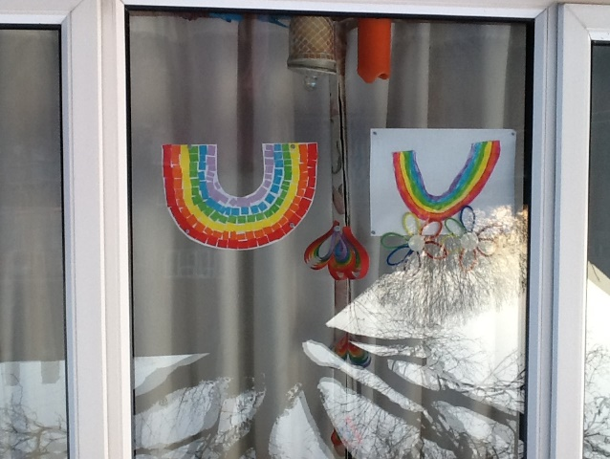  - Don’t forget a bit of Joe Wicks to get you going each morning: https://www.youtube.com/channel/UCAxW1XT0iEJo0TYlRfn6rYQ
Tidying up | However long it takes! | - https://www.youtube.com/watch?v=Dhw6JDF4A0Q  - https://www.youtube.com/watch?v=LV1sMws_Gqg

Please remember the timings are just a guide. If your child is finding it hard to settle to an activity, leave it and come back to it another time. They are used to doing 3 or 4 guided sessions each day, but with lots of play in between!

