Subject | Timings | Activity
PE | 30 mins | Joe Wicks Daily
Writing and art | 30-45 minutes | LO: To express an opinion about a book.  Watch to the end of the book.  https://vimeo.com/73026206  After watching the video, in full sentences, fill out the questions for the book review. For tomorrow's lesson, I would like a freshly designed book cover.  This is available on google docs or you can do this in your book. Well done to those who have managed to take photos of their work and attaching it to their google doc and sending it back to me.
Reading | 15 Minutes | Free read a story for 15 minutes or longer.
Spellings | 15 mins | Fresh spellings  Rule: When adding the suffix ‘ly’ to root words that end in ‘le’ then the ‘e’ is dropped and ‘y’ added. (gentle/gently)
Mental Maths | 10 mins | 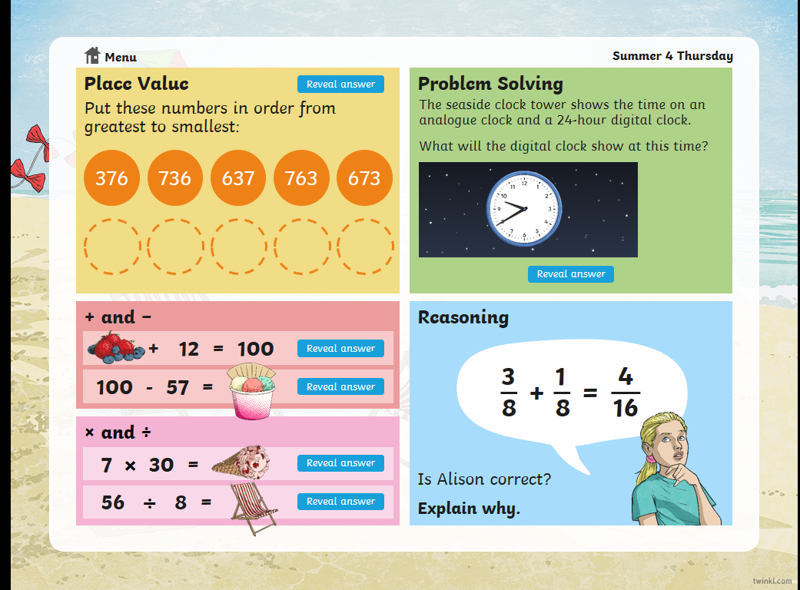
Maths | 45 Mins | To compare tenths as decimals and fractions.  https://whiterosemaths.com/homelearning/year-3/  Watch lesson 5 video. Have a pen and paper ready as there is a lot to take in.  count in tenths as fractions,  1/10, 2/10, 3/10, 4/10, 5/10, 6/10 etc.  This is a place value grid.  H T U . 1/10  If you notice that the last column is a fraction. 1/10. It is written as 0.1. So 0.1 is equal to 1/10. 0.2 is equal from 2/10, 0.3 is equal to 3/10 etc.  Have fun! Just do 45 minutes today, you can do more tomorrow.
TT Rock Stars | 15 Mins | If you get time
DT | 1 hour | Pick one (or more) of the origami templates to play with.
Project | As much time as you want | https://sites.google.com/d/1AACR2Wo2mrXsLNCLpsrDG3ZY8ucn7msd/p/1K1uGSLLTaXnfArgCfsd4xPAQj5-cNh_Z/edit

