Subject | Timings | Activity
PE | 30 mins | Cricket Week 1 - https://www.chancetoshine.org/staying-active-during-the-covid-19-outbreak?utm_source=Portal+Teachers&utm_campaign=4d044a96ba-EMAIL_CAMPAIGN_2020_04_14_04_17&utm_medium=email&utm_term=0_b4486fc5f7-4d044a96ba-123743345#h_66039831311586267782474  If you are happy with Cricket Week 1 then go to Week 2 Brilliant Bowler.  Or  Joe Wicks Daily
Mental Maths | 5 minutes | 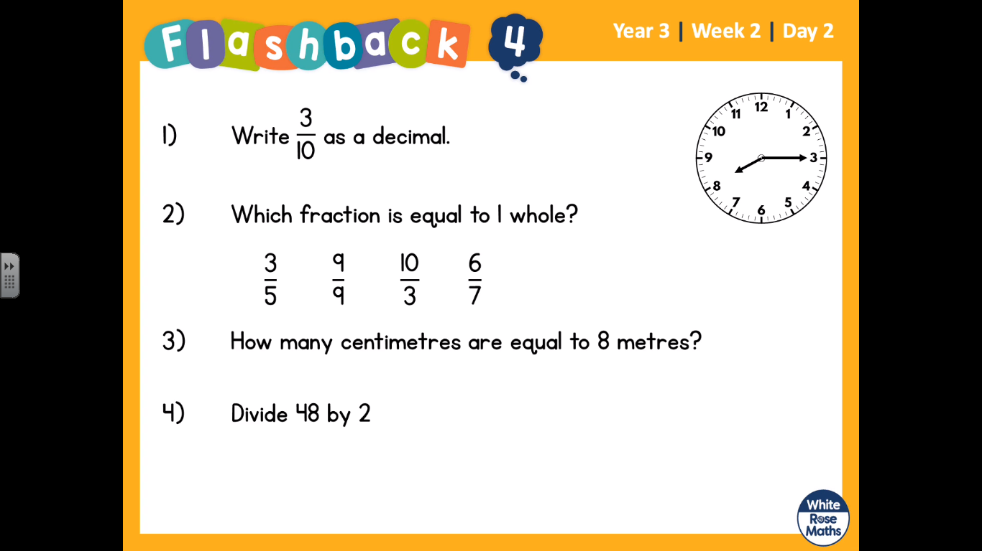  These questions are on the video on White Rose home learning week 2. Pause the video whilst you answer them.  Question one is tricky as we haven’t covered this properly.  To answer it, think about a number line of fractions and decimals.  1/10, 2/10, 3/10, 4/10 etc  Then try the same with decimals  0-----------------------------------------------------------------1  0.1, 0.2, 0.3, 04,
Maths | 45 minutes | LO: find fractions of an amount.  Steps to success:  ¼ the bottom of the fraction tells you how many groups you have. Draw 4 circles.  Of 12, break the 12 into the 4 groups.  Then look at the top fraction. In this case it is 1. So you circle and count one group. = 3  https://whiterosemaths.com/homelearning/year-3/  Week 2 Lesson 2 - whiterose home learning
Reading | 15 Minutes | https://www.lovereading4kids.co.uk/extract/11823/  This is a link to some short stories.  Finish the Snake Prince. What did you find interesting about the story?
Writing | 30 minutes | Lesson 2 – Retrieving information  LO: To retrieve information from a text  Listen to and enjoy part or all of the Big Blue Whale, by Nicola Davies. While you are listening, jot down as many facts as you can about blue whales that you learn from the text. Try and organise these into sections as per the below table (available on page 11) https://vimeo.com/60259773  Use the sheet provided or create your own.  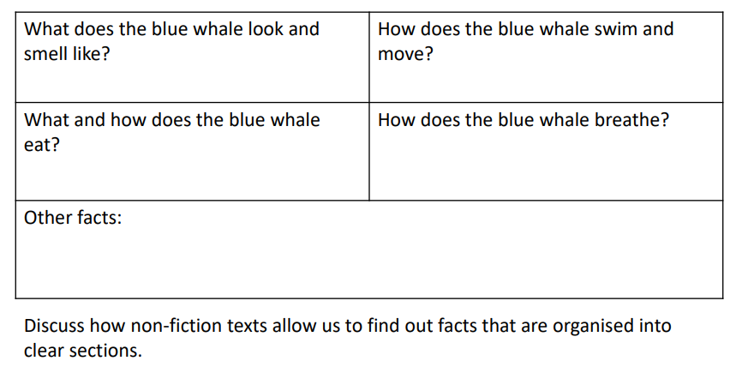
Spellings | 15 mins | Pictowords. This is a weekly task, do not try to complete all your spellings in one go. Just do 15 minutes. You need to find the meaning of each spelling, and draw a picture around the word to show the meaning. See the picture below. Here are your spellings: basically, frantically, dramatically, historically, nationally, emotionally, accidentally, automatically, traditionally, specifically  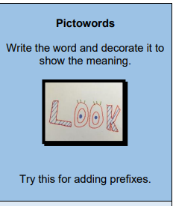
Topic | 1 hour | LO: To create a Roman shield.  https://www.knowtheromans.co.uk/Videos/RomanEmpireTimeline/  You need to know that BC means Before the Common Era or commonly known as Before Christ. It means the time before Jesus was born.  In less than 200 years (from 237 to 44 BCE) the Romans have taken over a vast amount of land including Spain, France, Greece, Turkey and part of North Africa! How did they do it? Watch this video to show how they organised their armies.  https://www.youtube.com/watch?v=-OCFeUDUohs  Your task (if you chose to accept it) is to make or draw a Roman Shield.  https://www.youtube.com/watch?v=YIbv92T_Nqc  If you are wanting to make a shield it does take time, but you can use your remaining topic time to complete it. You must have permission from your adults and support from them with the cutting of cardboard. The link I have supplied is just a suggestion, as always put your own spin on it.  You can draw and paint your shield if you do not fancy making it. However, you must come up with a Roman design of your own.
Any free time check out our website for extra activities | N/A | https://sites.google.com/d/1AACR2Wo2mrXsLNCLpsrDG3ZY8ucn7msd/p/1K1uGSLLTaXnfArgCfsd4xPAQj5-cNh_Z/edit  There is a link to a lesson about astronomy on Wednesday at 10am.  WWF have some great resources this week with links.  A new sketching tasks about sharks.  Yoga and Joe Wicks.

