Subject | Timings | Activity
PE | 30 mins | Cricket Week 1 - https://www.chancetoshine.org/staying-active-during-the-covid-19-outbreak?utm_source=Portal+Teachers&utm_campaign=4d044a96ba-EMAIL_CAMPAIGN_2020_04_14_04_17&utm_medium=email&utm_term=0_b4486fc5f7-4d044a96ba-123743345#h_66039831311586267782474  If you are happy with Cricket Week 1 then go to Week 2 Brilliant Bowler.  Or  Joe Wicks Daily
Mental Maths | 5 minutes | 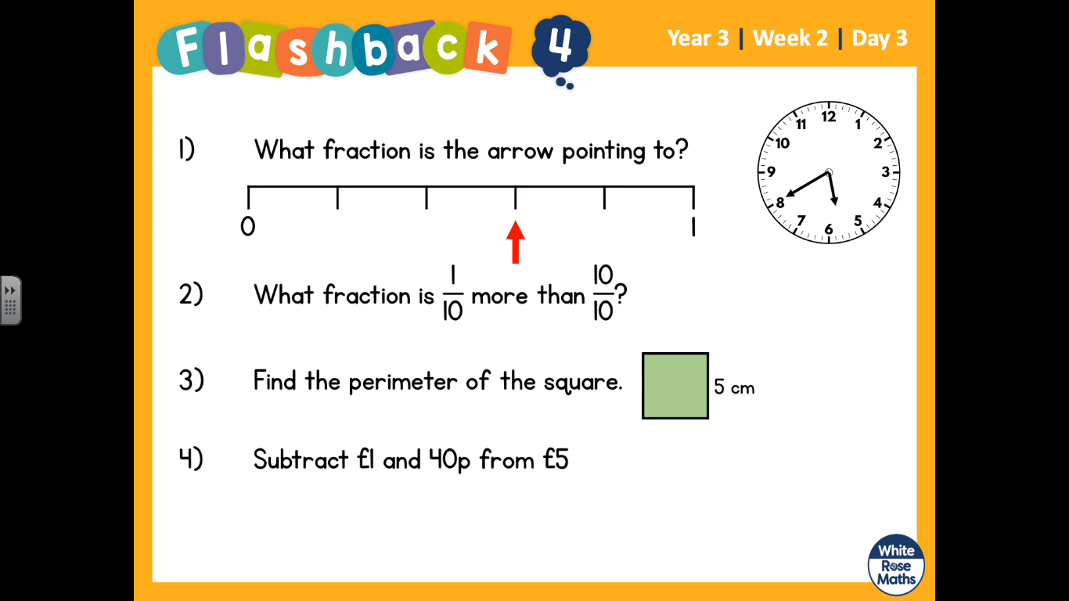  Help:  - Count the divisions between 0-1, how many does it have? This would be our bottom part of our fraction. Then count how far the arrow is ahead, that is your top fraction.  - Count up in tenths: 1/10, 2/10 etc, count passed 10/10 (there are 2 answers  - Perimeter means the space around the outside, march around the outside of the shape and count.  - Lay out your sum  Ones £ . Tens P . Ones P
Maths | 45 minutes | LO: fractions of a set of objects  Steps to success:  These steps are the same as yesterday apart from one change.  ⅖ of 15  2/5 the bottom of the fraction tells you how many groups you have. Draw 5 circles.  Of 15, break the 15 into the 5 groups.  Then look at the top fraction. In this case it is 2. So you circle and count 2 groups. = 6  https://whiterosemaths.com/homelearning/year-3/  Week 2 Lesson 3 - whiterose home learning
Reading | 15 Minutes | https://www.lovereading4kids.co.uk/extract/11823/  Now you have read the Snake Prince, I would like you to draw the Snake Queen and label the descriptions that you have read around her.  Complete this in your books.
Writing | 30 minutes | Lesson 3 – Grammar Practise and Play - Similes  LO: To learn the meanings of similes  Read the sentences below from the Big Blue Whale:  Reach out and touch the blue whales skin.It’s springy and smooth like a hardboiled egg, and as slippery as wet soap.  Look into its eye. It’s as big as a teacup and as dark as the deep sea.  When it breathes out, it makes a great misty puff, as high as a house.  Discuss how the author uses similes to help the reader learn facts about the blue whale in this non-fiction text. How do they help us to make comparisons?
Spellings | 15 mins | Pictowords. This is a weekly task, do not try to complete all your spellings in one go. Just do 15 minutes. You need to find the meaning of each spelling, and draw a picture around the word to show the meaning. See the picture below. Here are your spellings: basically, frantically, dramatically, historically, nationally, emotionally, accidentally, automatically, traditionally, specifically  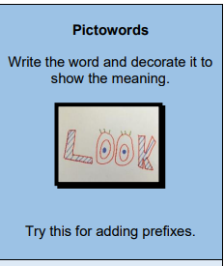
Science | 40 minute lecture and then 20 minutes q and a | This is not our science topic, but it is a great opportunity to learn. The lecture starts at 10 but you need to register before so do so.  https://www.eventbrite.co.uk/e/primary-school-space-session-tickets-102260943234
Any free time check out our website for extra activities | N/A | https://sites.google.com/d/1AACR2Wo2mrXsLNCLpsrDG3ZY8ucn7msd/p/1K1uGSLLTaXnfArgCfsd4xPAQj5-cNh_Z/edit  There is a link to a lesson about astronomy on Wednesday at 10am.  WWF have some great resources this week with links.  A new sketching tasks about sharks.  Yoga and Joe Wicks.

