Subject | Timings | Activity
PE | 30 mins | Cricket Week 1 - https://www.chancetoshine.org/staying-active-during-the-covid-19-outbreak?utm_source=Portal+Teachers&utm_campaign=4d044a96ba-EMAIL_CAMPAIGN_2020_04_14_04_17&utm_medium=email&utm_term=0_b4486fc5f7-4d044a96ba-123743345#h_66039831311586267782474  If you are happy with Cricket Week 1 then go to Week 2 Brilliant Bowler.  Or  Joe Wicks Daily
Mental Maths | 5 minutes | 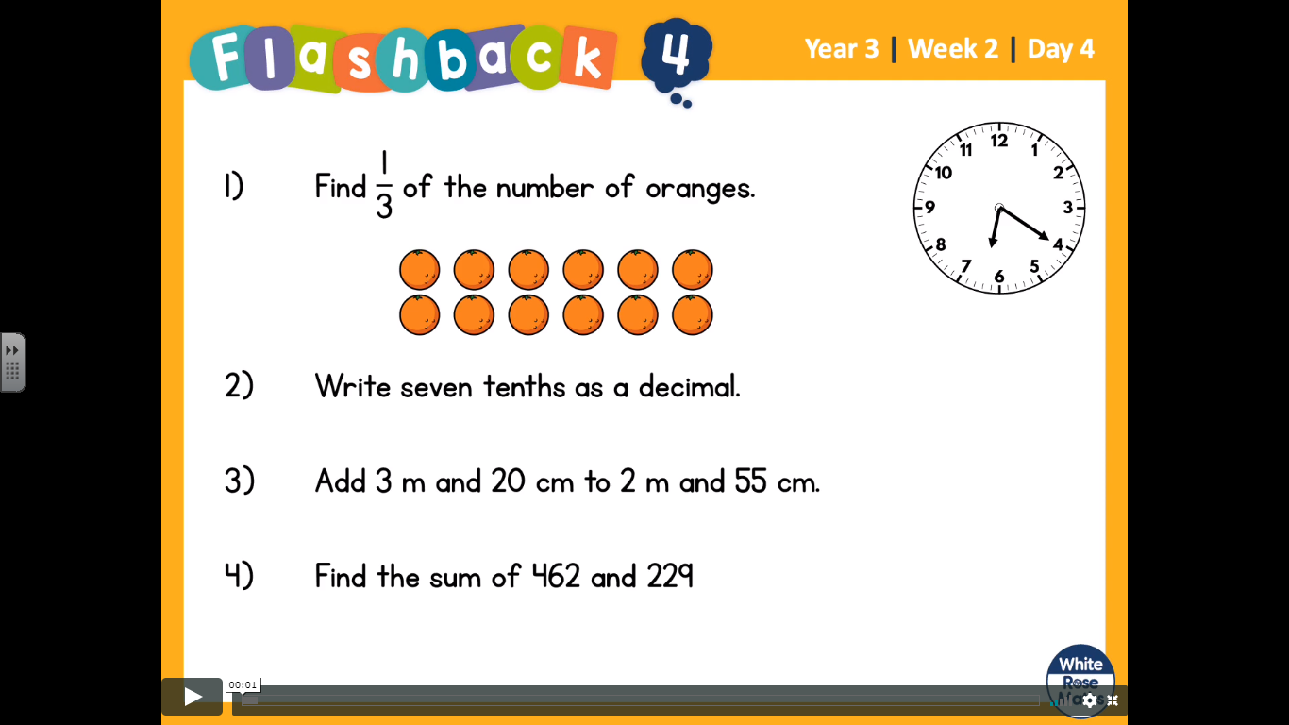  These questions are on the video on White Rose home learning week 2 Day 4. Pause the video whilst you answer them.  Help:  - Becuase the fraction is 1/3 you need to draw 3 circles, then split the oranges equally into the groups.  - To answer it, think about a number line of fractions and decimals.  1/10, 2/10, 3/10, 4/10 etc  Then try the same with decimals  0-----------------------------------------------------------------1  0.1, 0.2, 0.3, 04,  - Organise your adding into M tens and ones CM  - Next, organise your sums into Hundreds, Tens and ones.
Maths | 45 minutes | LO: find fractions of an amount.  The steps to success are similar to the previous days, the only difference is the numbers will be pounds, kilometres and cherries.  Steps to success:  ⅖ of 10 km  2/5 the bottom of the fraction tells you how many groups you have. Draw 5 circles.  Of 10km, break the 10km into the 5 groups. How many do you have in each group.  Then look at the top fraction (⅖). In this case it is 2. So you circle and count two groups. = 2+2 = 4  https://whiterosemaths.com/homelearning/year-3/  Week 2 Lesson 2 - whiterose home learning
Reading | 15 Minutes | https://www.lovereading4kids.co.uk/extract/11823/  Write down 3 questions that you would have for the snake queen.
Writing | 30 minutes | Writing Challenges  This is a two day writing challenge. Spend time on creating a good piece of writing.  Having visited the zoo and learnt about non-fiction texts try one of the following:  1) Write a non-fiction page based on one of the animals you (hopefully) saw at the zoo. Think about appearance, habitat, how they move and fun features. You may wish to do some further research about the animals to help you. Draw pictures and label them.  2) Create a visitors guide for San Diego Zoo, describing the animals that people will see if they visit the zoo. Make it look attractive and create plenty of fun facts, including similes!  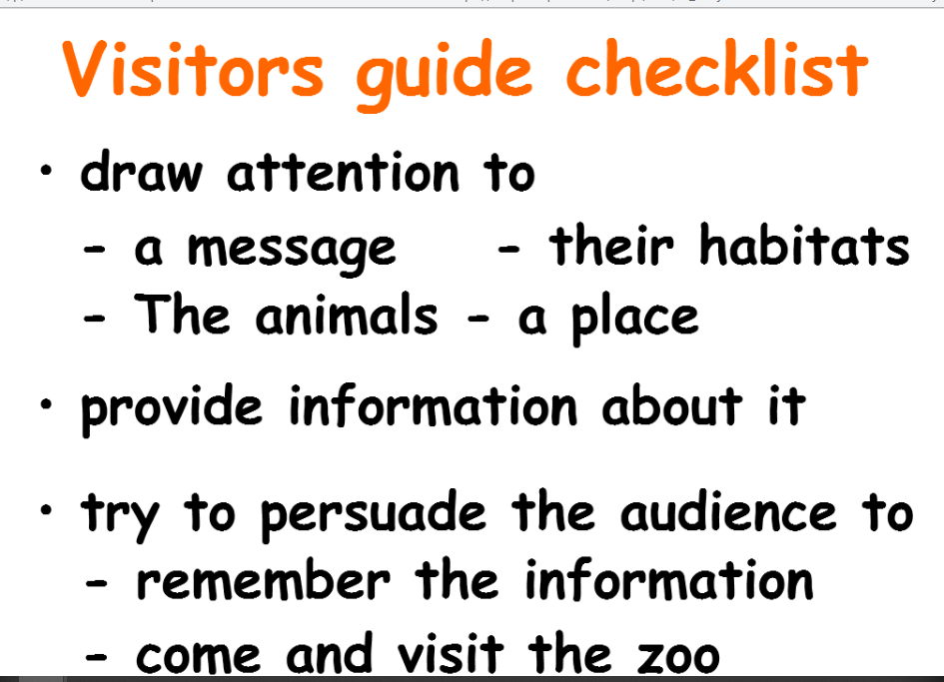
Spellings | 15 mins | Complete your spelling tasks on spelling shed. spellings: basically, frantically, dramatically, historically, nationally, emotionally, accidentally, automatically, traditionally, specifically
Wellbeing | 1 hour | LO: Learn to be a part of a team.  https://www.bbc.co.uk/bitesize/articles/z773bdm  Attached is a sheet for you to think about what attributes you have to help a team.
Any free time check out our website for extra activities | N/A | https://sites.google.com/d/1AACR2Wo2mrXsLNCLpsrDG3ZY8ucn7msd/p/1K1uGSLLTaXnfArgCfsd4xPAQj5-cNh_Z/edit  There is a link to a lesson about astronomy on Wednesday at 10am.  WWF have some great resources this week with links.  A new sketching tasks about sharks.  Yoga and Joe Wicks.

