Subject | Timings | Activity
PE | 30 mins | Cricket Week 1 - https://www.chancetoshine.org/staying-active-during-the-covid-19-outbreak?utm_source=Portal+Teachers&utm_campaign=4d044a96ba-EMAIL_CAMPAIGN_2020_04_14_04_17&utm_medium=email&utm_term=0_b4486fc5f7-4d044a96ba-123743345#h_66039831311586267782474  If you are happy with Cricket Week 1 then go to Week 2 Brilliant Bowler.  Or  Joe Wicks Daily
Maths | 45 minutes | TT Rock Stars, practice Garage, Sound Checks
Reading | 15 Minutes | https://www.lovereading4kids.co.uk/extract/11823/  Write down 3 questions that you would have for the snake queen.
Writing | 30 minutes | Writing Challenges  This is a two day writing challenge. Spend time on creating a good piece of writing.  Having visited the zoo and learnt about non-fiction texts try one of the following:  1) Write a non-fiction page based on one of the animals you (hopefully) saw at the zoo. Think about appearance, habitat, how they move and fun features. You may wish to do some further research about the animals to help you. Draw pictures and label them.  2) Create a visitors guide for San Diego Zoo, describing the animals that people will see if they visit the zoo. Make it look attractive and create plenty of fun facts, including similes!  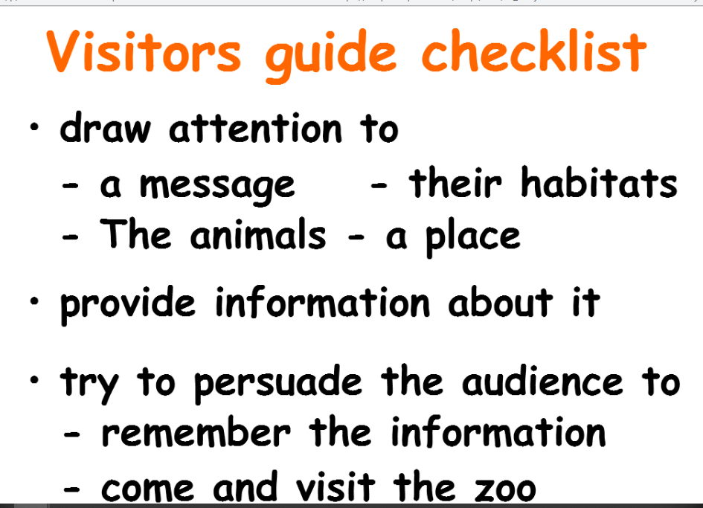
Spellings | 15 mins | Complete your spelling tasks on spelling shed. spellings: basically, frantically, dramatically, historically, nationally, emotionally, accidentally, automatically, traditionally, specifically
Art | 1 hour | Today i would like you to sketch and colour your trip to the San Francisco Zoo (imaginary).  https://www.youtube.com/watch?v=B7pz-Lh66TQ  For simpler animals to draw try these:  Giraffe - https://www.youtube.com/watch?v=B7pz-Lh66TQ  Elephant - https://www.youtube.com/watch?v=MI85reX71wQ  Panda - https://www.youtube.com/watch?v=PORZHk7YJiY  As always, put your spin on it.
Any free time check out our website for extra activities | N/A | https://sites.google.com/d/1AACR2Wo2mrXsLNCLpsrDG3ZY8ucn7msd/p/1K1uGSLLTaXnfArgCfsd4xPAQj5-cNh_Z/edit  There is a link to a lesson about astronomy on Wednesday at 10am.  WWF have some great resources this week with links.  A new sketching tasks about sharks.  Yoga and Joe Wicks.

