Subject | Timings | Activity
PE | 30 mins | Cricket Week 2 and 3 -  Cricket Week 2 Week 2 Brlliant Bowler and Week 3  Or  We have a subscription to Online PE lessons, called Real PE  You need to enter the address:  home.jasmineactive.com  Then enter the email address:  parent@brockenhurst-1.com  Password: brockenhur
Mental Maths | 5-10 minutes | 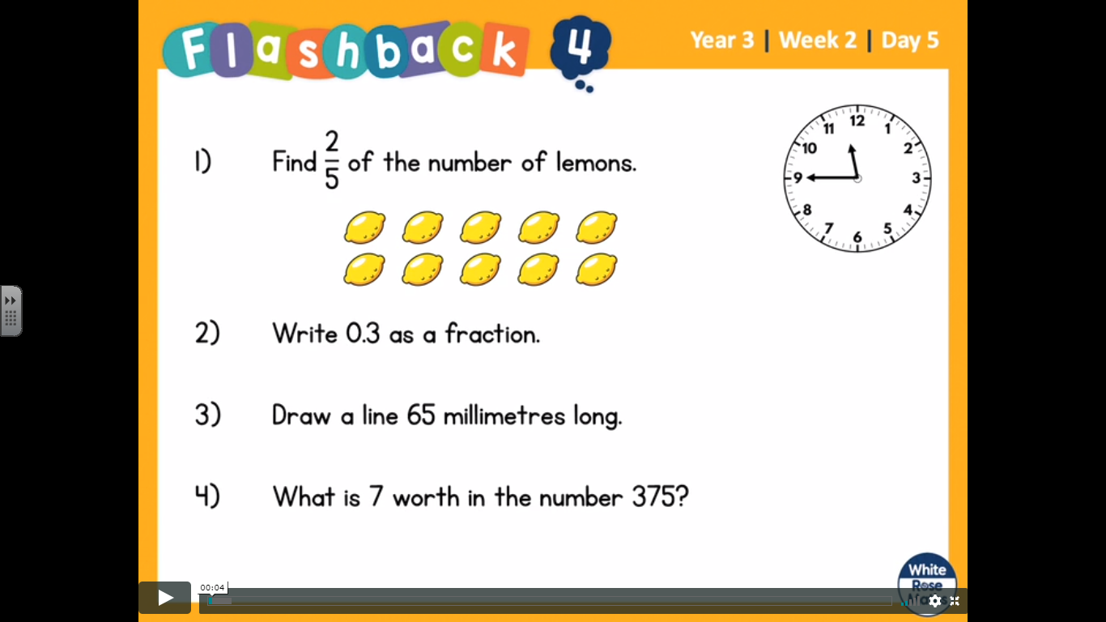
Maths | 45 minutes | White Rose Website. Week 2 Day 5  https://whiterosemaths.com/homelearning/year-3/  LO: To find equivalent fractions.  We have covered this before but we cheated and used multiplication grids. If anybody remembers how to do it, then 1 House Point. Otherwise follow the video
Reading | 15 Minutes | Read the Selkie’s Toes and make a note of new words or words you thought were powerful.  https://www.lovereading4kids.co.uk/extract/9936/B
Writing | 30 minutes | LO: To design and create your very own, original animal.  Have fun playing with the website or App. Create the craziest and funniest animals you can think of. The app even lets you add sound effects! Experiment with changing the habitat, legs, tail and heads. Now aim to create a really great animal that would be useful if it existed. Is it really strong? Will it survive extreme weather? Would it be helpful to humans? Choose an imaginative name for your new animal.  Presentation: print it out and write around the edges answering the questions or take a screenshot and using text boxes.  https://switchzoo.com/make_play.htm  https://switchzoo.com/map.html  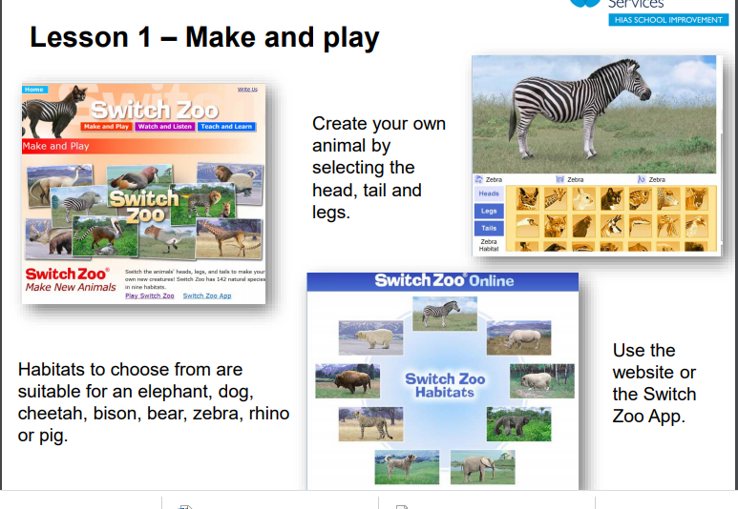
Spellings | 15 mins | Spellings: truly, duly, publicly, daily, slyly, shyly, fully, wholly, coyly, happily  Could you also try highlighting the ‘ly’ letters.  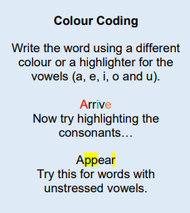
Learning in nature | 1 hour | Use the accompanying resources to learn about the outdoors or if you're fortunate to have a garden or outside area where you live, take learning outdoors and get hands on with nature.
Any free time check out our website for extra activities | N/A | https://sites.google.com/d/1AACR2Wo2mrXsLNCLpsrDG3ZY8ucn7msd/p/1K1uGSLLTaXnfArgCfsd4xPAQj5-cNh_Z/edit  Use the Snow Leopards websites and try the Just Dance Tasks, Chance to Shine Cricket, Sketching challenges or even tidying up.
Mindfulness Colouring | N/A | When you want to relax, I have included some colouring.

