Subject | Timings | Activity
PE | 30 mins | Cricket Week 2 and 3 -  Cricket Week 2 Week 2 Brilliant Bowler and Week 3  Or  We have a subscription to Online PE lessons, called Real PE  You need to enter the address:  home.jasmineactive.com  Then enter the email address:  parent@brockenhurst-1.com  Password: brockenhur
Mental Maths | 5-10 minutes | 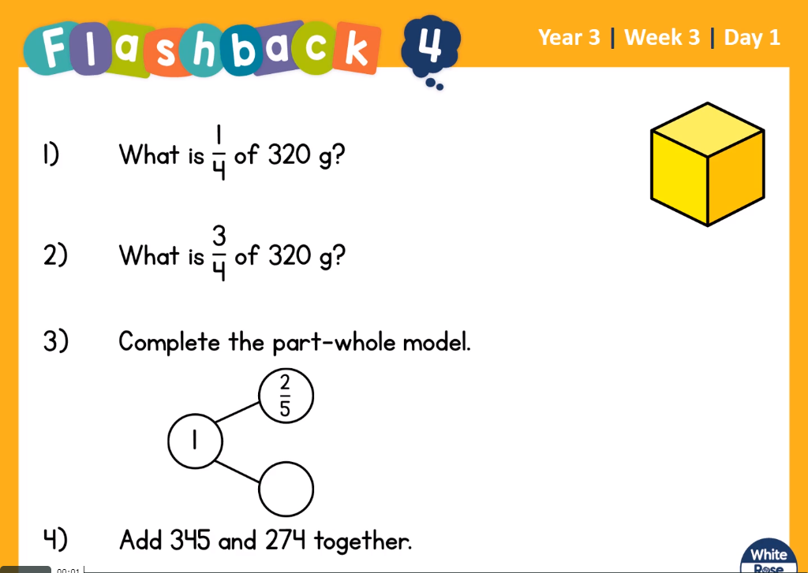  Help:  - Instead of sorting four groups of 320, it would take a long time. So you could do 4 groups of 32 then x each answer by 10. Or you could move tens into each group.  - Same as question one but circle three groups.  - Draw as a number line  - Break up the sum into 300+40+5  200+70+4  =
Maths | 45 minutes | White Rose Website. Summer 1 Week 1 Day 1  https://whiterosemaths.com/homelearning/year-3/  LO: To find equivalent fractions.  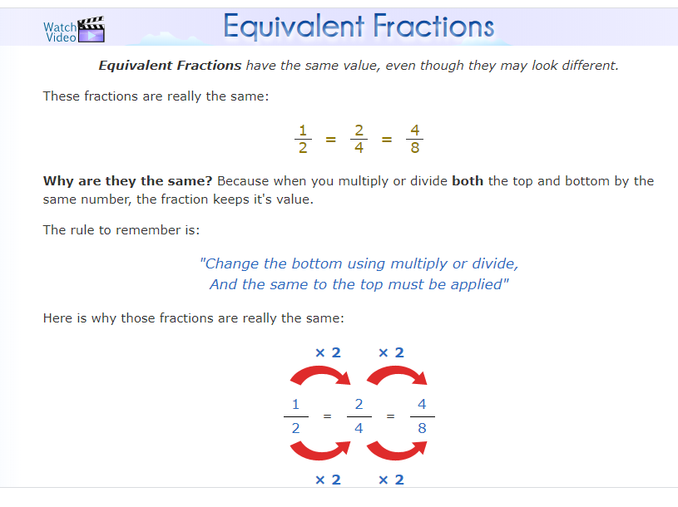
Reading | 15 Minutes | Read the Selkie’s Toes and make a note of new words or words you thought were powerful.  https://www.lovereading4kids.co.uk/extract/9936/B
Writing | 30 minutes | LO: Build a profile of your animal  Research Using the websites above, books from home, your own knowledge and imagination, build a profile of facts about your animal. Complete the grid. Use full sentences.  https://switchzoo.com/make_play.htm  https://switchzoo.com/map.html
Spellings | 15 mins | Spellings: truly, duly, publicly, daily, slyly, shyly, fully, wholly, coyly, happily  Could you also try highlighting the ‘ly’ letters.  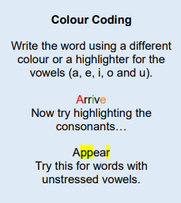
History The Romans | 1 hour | LO: What was life like before the Romans invaded.  today we will begin to learn about what Britain was like before the Romans came. Explain that this time was called The Iron Age because a group of Europeans had become expert at taking iron out of rock (called iron ore) and making it into tools and weapons. These people were known as Celts. They came to Britain around 500 years before Jesus was born. This date is written 500 BCE which stands for Before the Common Era. The Celts soon spread and settled across Britain. Today we will find out what sort of houses the Celtic people lived in.  https://www.youtube.com/watch?v=XQ9lvVCfyN8  https://www.youtube.com/watch?v=HMZDPlwMZgs  Task  Label the different objects inside the round house.
Any free time check out our website for extra activities | N/A | https://sites.google.com/d/1AACR2Wo2mrXsLNCLpsrDG3ZY8ucn7msd/p/1K1uGSLLTaXnfArgCfsd4xPAQj5-cNh_Z/edit  Use the Snow Leopards websites and try the Just Dance Tasks, Chance to Shine Cricket, Sketching challenges or even tidying up.
Mindfulness Colouring | N/A | When you want to relax, I have included some colouring.

