Subject | Timings | Activity
PE | 30 mins | Cricket Week 2 and 3 -  Cricket Week 2 Week 2 Brilliant Bowler and Week 3  Or  We have a subscription to Online PE lessons, called Real PE  You need to enter the address:  home.jasmineactive.com  Then enter the email address:  parent@brockenhurst-1.com  Password: brockenhur
Mental Maths | 5-10 minutes | 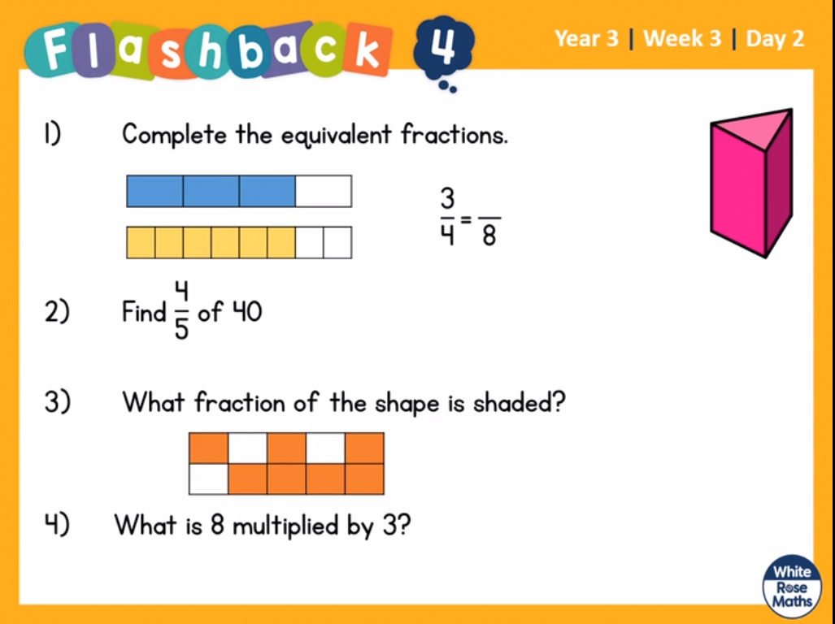
Maths | 45 minutes | White Rose Website. Summer 1 Week 1 Day 2  https://whiterosemaths.com/homelearning/year-3/  Similar to yesterday but instead, we are working in quarters.  LO: To find equivalent fractions.  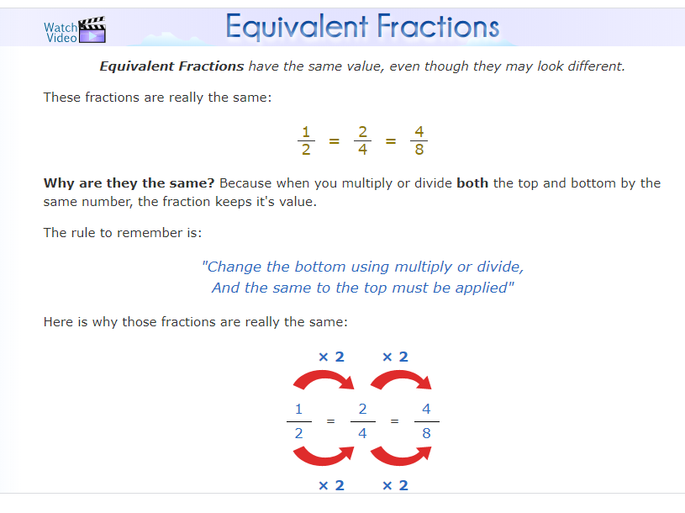
Reading | 15 Minutes | Read the Selkie’s Toes.  You can answer these questions in your books or simply reply to me with your answers.  1) What do you think is the moral of the story?  2) When and where is the story set? How do you know?  3) Which part of the story best describes the daughter?  https://www.lovereading4kids.co.uk/extract/9936/B
Writing | 30 minutes | LO: To uplevel your words from yesterday  Use an online thesaurus to find synonyms to improve word choices from your grid yesterday. Don’t just choose any word the thesaurus suggests though – just the appropriate ones for the animal you designed. Perhaps choose the 3 you think are the best choices. Complete the grid on the next page.  https://www.thesaurus.com/
Handwriting | 15 mins | Follow the sheets and complete the handwriting sheets. Remember, balance and pinch the pencil, straight posture, relax your shoulders.
History The Romans | 2 x 1 hour  Wednesday and Thursday | https://www.bbc.co.uk/bitesize/articles/z6j2mfr  Science States of Matter  Learn about the states of matter.  This lesson includes:  - three videos showing introducing the three states as well as how they transition between each other.  - two activities to reinforce learning.  Optional extra task:  Try different liquids and see if they freeze. Tomato sauce, vinegar etc. Check with your parents before doing this
Any free time check out our website for extra activities | N/A | https://sites.google.com/d/1AACR2Wo2mrXsLNCLpsrDG3ZY8ucn7msd/p/1K1uGSLLTaXnfArgCfsd4xPAQj5-cNh_Z/edit  Use the Snow Leopards websites and try the Just Dance Tasks, Chance to Shine Cricket, Sketching challenges or even tidying up.
Mindfulness Colouring | N/A | When you want to relax, I have included some colouring.

