Subject | Timings | Activity
PE | 30 mins | Cricket Week 2 and 3 -  Cricket Week 2 Week 2 Brilliant Bowler and Week 3  Or  We have a subscription to Online PE lessons, called Real PE  You need to enter the address:  home.jasmineactive.com  Then enter the email address:  parent@brockenhurst-1.com  Password: brockenhur
Mental Maths | 5-10 minutes | 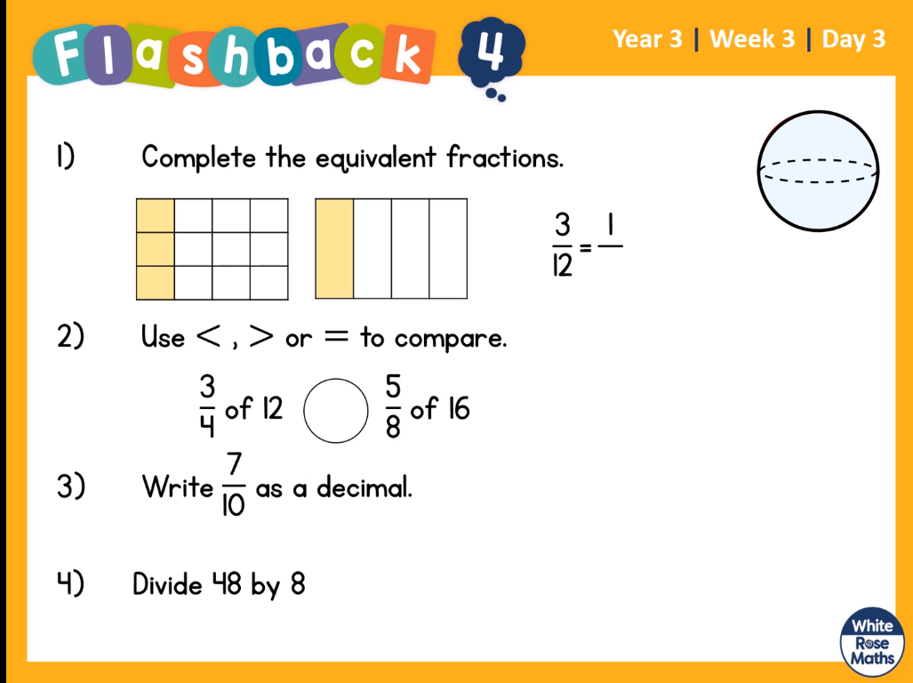  Help:  - Count the 2nd bar. What is the total? This is your denominator (bottom fraction number). Could how many are shaded, this is your numerator (top number).  - See the box below, for understanding the symbols.  - Write your fraction line  1/10, 2/10, 3/10 etc  Then below it, write your decimal line  0.1, 0.2, 0.3, etc. Then compare them  - How many 8s can you fit into 48?
Maths | 45 minutes | White Rose Website. Summer 1 Week 1 Day 3  https://whiterosemaths.com/homelearning/year-3/  Similar to yesterday but instead, we are working in quarters.  LO: To compare fractions  Top tip:  Draw out the fractions like a bar,  Make both fraction bars the same size,  Then divide them into the fraction and shade.  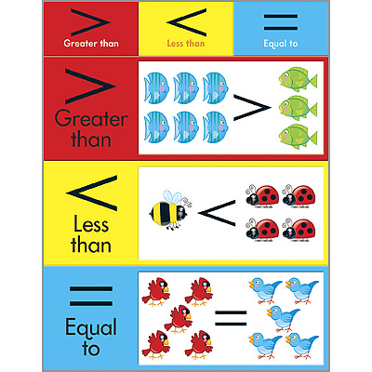
Reading | 15 Minutes | Free to read your book at home.
Writing | 30 minutes | LO: To plan for your writing challenge  Have a look at the writing challenges for tomorrow (see below). Choose the one you would most like to write. Plan your ideas in whatever form you prefer, so you are ready to write tomorrow.  It is best to mind map your ideas first then organise them into clear boxes.  Choose one from the following writing challenges:  1) Write a letter to the Natural History Museum. You have found an incredible creature on your travels and would like it to be registered for everyone to know about. You will need to explain everything you know about the animal.  2) Create an information leaflet about the animal, including how it moves, what it eats, where it lives etc. You can make it funny if you want to!  3) You are a zookeeper and have a new animal to look after. Write instructions on how to look after the animal so other zookeepers can help you.  Think about quality not quantity – how will you engage your reader?
Handwriting | 15 mins | Follow the sheets and complete the handwriting sheets. Remember, balance and pinch the pencil, straight posture, relax your shoulders.
Science | 2 x 1 hour  Wednesday and Thursday | https://www.bbc.co.uk/bitesize/articles/z6j2mfr  Science States of Matter  Learn about the states of matter.  This lesson includes:  - three videos showing introducing the three states as well as how they transition between each other.  - two activities to reinforce learning.  Optional extra task:  Try different liquids and see if they freeze. Tomato sauce, vinegar etc. Check with your parents before doing this  You do not need to write anything in your books for this.
Any free time check out our website for extra activities | N/A | https://sites.google.com/d/1AACR2Wo2mrXsLNCLpsrDG3ZY8ucn7msd/p/1K1uGSLLTaXnfArgCfsd4xPAQj5-cNh_Z/edit  Use the Snow Leopards websites and try the Just Dance Tasks, Chance to Shine Cricket, Sketching challenges or even tidying up.
Mindfulness Colouring | N/A | When you want to relax, I have included some colouring.

