Subject | Timings | Activity
PE | 30 mins | Cricket Week 2 and 3 -  Cricket Week 3 and Week 4  Or  We have a subscription to Online PE lessons, called Real PE  You need to enter the address:  home.jasmineactive.com  Then enter the email address:  parent@brockenhurst-1.com  Password: brockenhur
Mental Maths | 5-10 minutes | 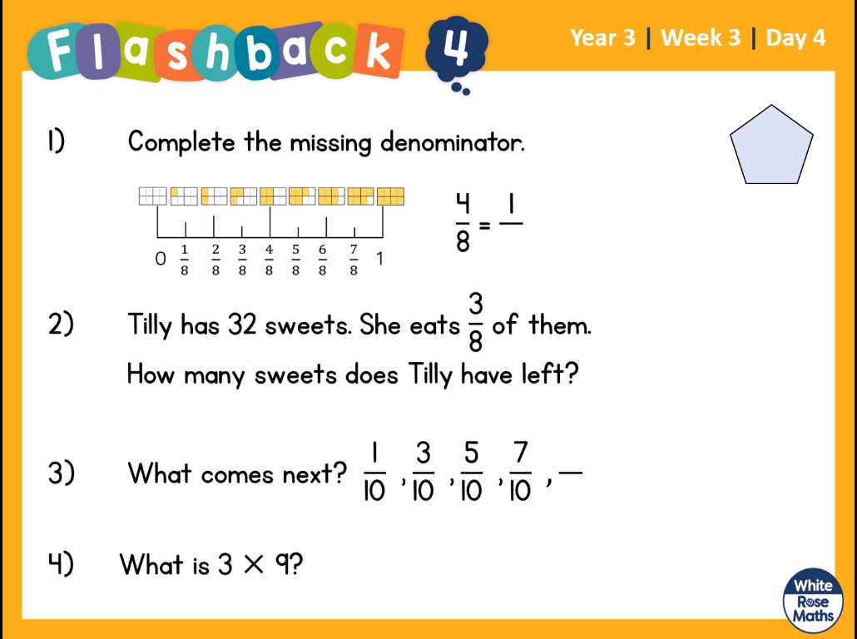  Help:  - What do you need to do to a 4 to change it to a 1? Then do the same to 8.  - Draw 8 circles and divide 32 dots between them. How many are in 3 groups of them? How many are left?  - Draw a fraction number line
Maths | 45 minutes | White Rose Website. Summer 1 Week 1 Day 4  https://whiterosemaths.com/homelearning/year-3/  Similar to Thursdays lesson  LO: To order fractions
Spelling | 15 Minutes | Syllable Fun  Remember a syllable is a beat. Colour in each syllable in a different colour. Elephant Try this for words with unstressed vowels  Spellings: Address, certain, arrive, experience, history, mention, occasionally, probably, reign, sentence
Writing | 30 minutes | LO: Respond to the pictures  Look at the picture of The Alchemist by Pablo 365.  Consider what is unusual about the content of each bottle.  Using the image, discuss what you can see in the jars. Collect words and phrases to describe the different settings in each bottle. Write in a description for each one.  How can parents, carers and siblings help?  •Read the extracts aloud with your child  •Collect interesting words and phrases on paper / post-its as they read  •Talk to your children about their ideas before they write  •Adapt any of the resources and materials as you feel necessary to support your  child's needs
Reading | 15 mins | https://www.lovereading4kids.co.uk/extract/9936/B reaking-the-Spell-Stories-of-Magic-and-Mysteryfrom-Scotland-by-Lari-Don.html  Breaking the Spell of Tann Linn, Page 6.  Over the next three days, I would like you to read the story, write down and look up words that you do not understand and then finally, create the front cover for the story, so we can turn it into a book.
Topic | 1 hour | LO: To understand how the Romans invaded Britain  Read through the BBC website. We have already watched the first video, you can watch it again if you wish.  https://www.bbc.co.uk/bitesize/topics/zqtf34j/articles/z9j4kqt  Roman Army formations  https://www.youtube.com/watch?v=kkgjiCKHvoY  Task: What I would like you to do is to learn the latin commands for organising a Roman legion. You will need 1 or more other people to command.  Simple Latin Commands for Young Legionaries
  Command in Latin | Meaning | Action
  dexter | right | Hold up your right hand
  sinister | left | Hold up your left hand
  claudio | halt | Both hands in front,  palms facing forward
  silentium | silence | Finger placed on lips
  redi | about turn | One finger in the air circling
  parati | get ready | Lower head, one hand in front, one behind  (as if about to start a race
  equaliter ambula | march forward | Lower hands one  at a time palm down and repeat the action
  Testudo | tortoise | Lace fingers,  palms down to make a shell
  percute | charge | Slow motion running action with arms
Any free time check out our website for extra activities | N/A | https://sites.google.com/d/1AACR2Wo2mrXsLNCLpsrDG3ZY8ucn7msd/p/1K1uGSLLTaXnfArgCfsd4xPAQj5-cNh_Z/edit  Use the Snow Leopards websites and try the Just Dance Tasks, Chance to Shine Cricket, Sketching challenges or even tidying up.
Mindfulness Colouring | N/A | When you want to relax, I have included some colouring.

