Subject | Timings | Activity
PE | 30 mins | Cricket Week 3 and 4 -  Cricket Week 3 and Week 4  Or  We have a subscription to Online PE lessons, called Real PE  You need to enter the address:  home.jasmineactive.com  Then enter the email address:  parent@brockenhurst-1.com  Password: brockenhur
Mental Maths | 5-10 minutes | 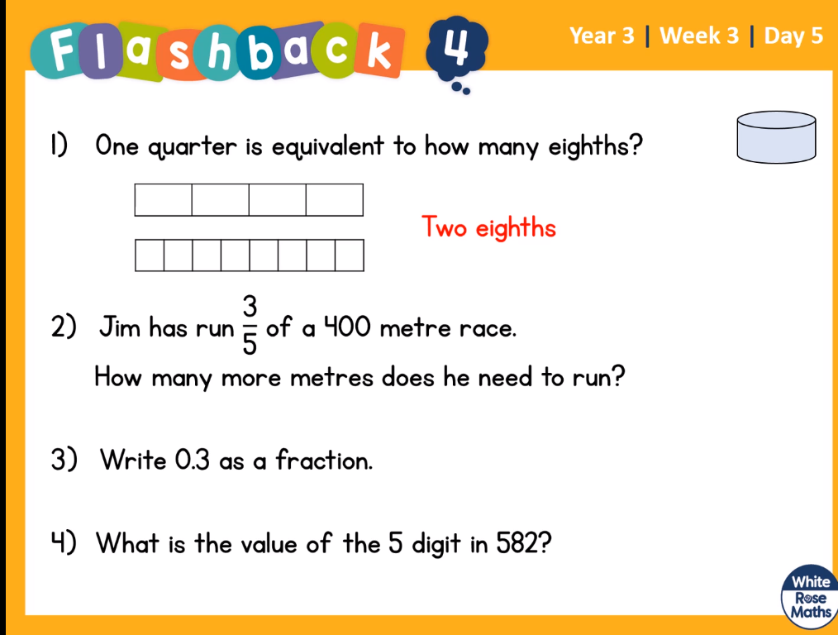  Help:  - Colour in ¼ - follow the bar down and match it with the 8ths.  - Draw 5 circles and spread 400 into the 5 circles (do it in 10s to save time)  - Draw a line with 0.1, 0.2, 0.3 etc then repeat for fractions.  1/10, 2/10, 3/10  - You know this.
Maths | 45 minutes | White Rose Website. Summer 1 Week 2 Day 1  https://whiterosemaths.com/homelearning/year-3/  LO: Add fractions  Tips, just add the top numbers, the bottom numbers stay the same.
Spelling | 15 Minutes | Syllable Fun  Remember a syllable is a beat. Colour in each syllable in a different colour. Elephant Try this for words with unstressed vowels  Spellings: Address, certain, arrive, experience, history, mention, occasionally, probably, reign, sentence
Writing | 30 minutes | LO: Respond to the text  Read and enjoy the extract from George's Marvellous Medicine on page 7 and  complete a read aloud, think aloud, marking and highlighting key features of the text.  Capital letters  for ingredients and repetition have already been highlighted as  examples.  Look out for:  - verbs,  - adjectives,  - similes  - and nouns
Reading | 15 mins | https://www.lovereading4kids.co.uk/extract/9936/B reaking-the-Spell-Stories-of-Magic-and-Mysteryfrom-Scotland-by-Lari-Don.html  Breaking the Spell of Tann Linn, Page 6.  Over the next three days, I would like you to read the story, write down and look up words that you do not understand and then finally, create the front cover for the story, so we can turn it into a book.
Music | 1 hour | LO: To learn about pulse and rhythm by clapping and using your body.  Follow the lesson from the BBC  https://www.bbc.co.uk/bitesize/articles/z6mmxyc  Complete the two  Try activities 1 and 2. These tasks do require bravery.
Any free time check out our website for extra activities | N/A | https://sites.google.com/d/1AACR2Wo2mrXsLNCLpsrDG3ZY8ucn7msd/p/1K1uGSLLTaXnfArgCfsd4xPAQj5-cNh_Z/edit  Use the Snow Leopards websites and try the Just Dance Tasks, Chance to Shine Cricket, Sketching challenges or even tidying up.
Mindfulness Colouring | N/A | When you want to relax, I have included some colouring.

