Supertato - Activities
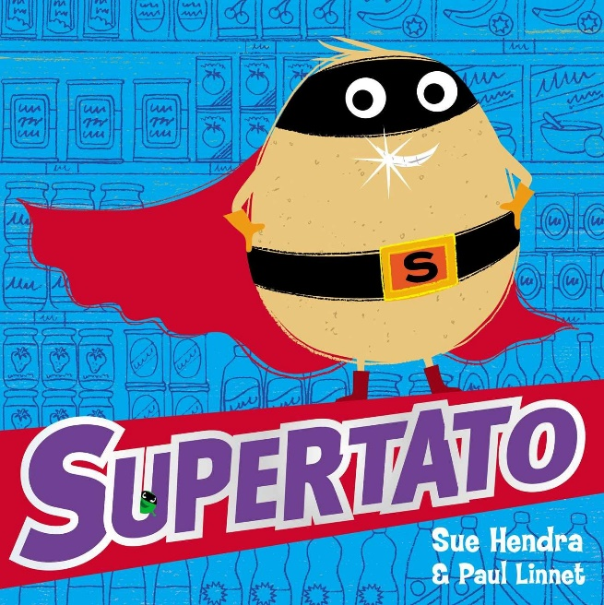

Choose any number of activities from the table below to do with your child over the course of the week.
Literacy Activities | - Can you design a superhero: draw a picture of your superhero. Give them a name and write about their super powers  - Evil Pea Wanted poster: Draw a picture of Evil Pea then write what he is wanted for – what did he do wrong?  - The alphabet game – can you think of something that you might see at the supermarket for every letter of the alphabet. Have a go at writing them down (this is potentially a lot of writing and the children will need help. It is a great talking exercise too.
Creative Activities | - Make your own Supertato  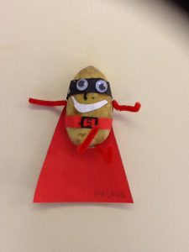  - Paint/darw/collage a picture of Supertato  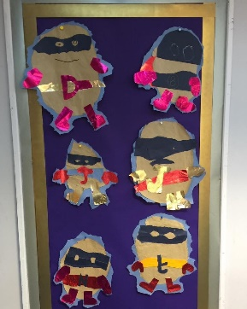  - Make a paper plate Evil Pea:  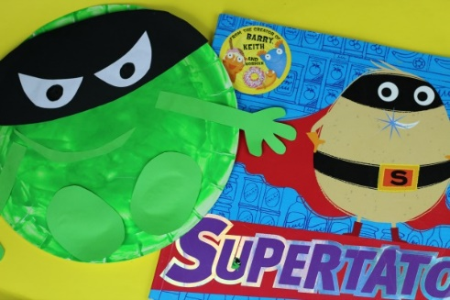  - Design your own Superhero mask  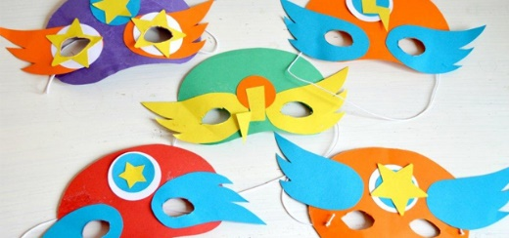
Sing some songs | One potato, two potato - https://www.youtube.com/watch?v=RbBuH4QlfOI
Cooking ideas | There were lots of healthy vegetable recipes last week, so this week I was more inspired by the sweet elements in the story  - Make jelly  - Sprinkle Fairy Cakes  https://www.goodtoknow.co.uk/recipes/sprinkle-fairy-cakes    - Chocolate cupcakes  https://www.bbcgoodfood.com/recipes/easy-chocolate-cupcakes  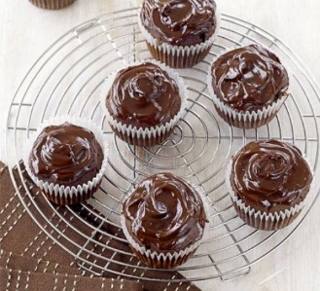
Science Activities | - Cola Super Fountain  - Flying Superheroes  - Magnetic Superhero Scene  I have attached the instructions for these Science experiments – they require very specific materials which you might or might not have to hand at home. They look quite good fun if you have got the things you need, but don’t worry if you haven’t.

