Subject | Timings | Activity
PE | 30 mins | Cricket Week 3 and 4 -  Cricket Week 3 and Week 4  Or  We have a subscription to Online PE lessons, called Real PE  You need to enter the address:  home.jasmineactive.com  Then enter the email address:  parent@brockenhur-1.com  Password: brockenhur  Dance Challenge - for those people who fancy it.  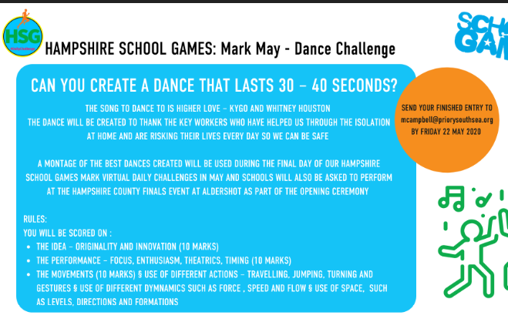
Mental Maths | 5-10 minutes | 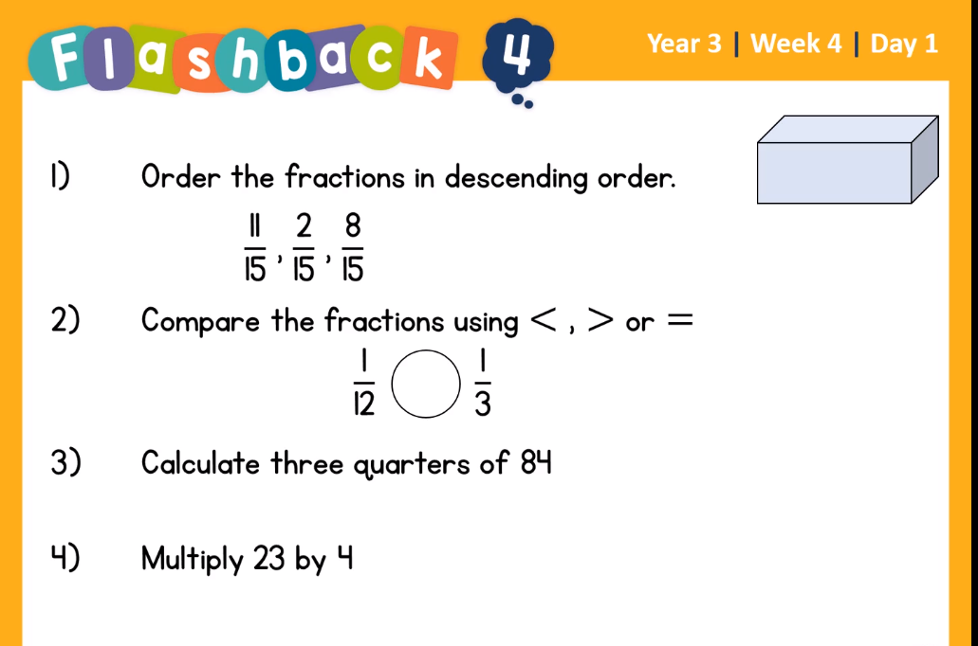  Help:  - If ascend means to climb, what does descend mean?  - Greater than, less than, equals  - Draw 4 circles and break 84 into them  - Don’t do that: do 2x 4 then multiply it by 10, then 3 x 4 and add them together.
Maths | 45 minutes | White Rose Website. Summer 1 Week 2 Day 2  https://whiterosemaths.com/homelearning/year-3/  LO: Subtract fractions  Tips, just Subtract the top numbers, the bottom numbers stay the same.
Spelling | 15 Minutes | Syllable Fun  Remember a syllable is a beat. Colour in each syllable in a different colour. Elephant Try this for words with unstressed vowels  Spellings: Address, certain, arrive, experience, history, mention, occasionally, probably, reign, sentence
Writing + Art | 1 hour 30 minutes | LO: Use prepositions to express place  Create your own dream place in a jar (This could be drawn or created in a jam jar  using the template on page 13).  Once you have created your dream place complete the table with words that you  could use in your writing (template on page 11). I have included some landscape art idea videos, however, watching these will dampen your creativity. I would like your ideas.  After, you can complete the box on Google classroom or print out the table and write in the boxes.  https://www.youtube.com/watch?v=v368l7nAltE  https://www.youtube.com/watch?v=EJPuP50_ZqM
Reading | 15 mins | https://www.lovereading4kids.co.uk/extract/9936/B reaking-the-Spell-Stories-of-Magic-and-Mysteryfrom-Scotland-by-Lari-Don.html  Breaking the Spell of Tann Linn, Page 6.  Over the next three days, I would like you to read the story, write down and look up words that you do not understand and then finally, create the front cover for the story, so we can turn it into a book.
Art | 1 hour | Art - see English
Any free time check out our website for extra activities | N/A | https://sites.google.com/d/1AACR2Wo2mrXsLNCLpsrDG3ZY8ucn7msd/p/1K1uGSLLTaXnfArgCfsd4xPAQj5-cNh_Z/edit  Use the Snow Leopards websites and try the Just Dance Tasks, Chance to Shine Cricket, Sketching challenges or even tidying up.
Mindfulness Colouring | N/A | When you want to relax, I have included some colouring.

