Subject | Timings | Activity
PE | 30 mins | Cricket Week 3 and 4 -  Cricket Week 3 and Week 4  Or  We have a subscription to Online PE lessons, called Real PE  You need to enter the address:  home.jasmineactive.com  Then enter the email address:  parent@brockenhur-1.com  Password: brockenhur  Dance Challenge - for those people who fancy it.  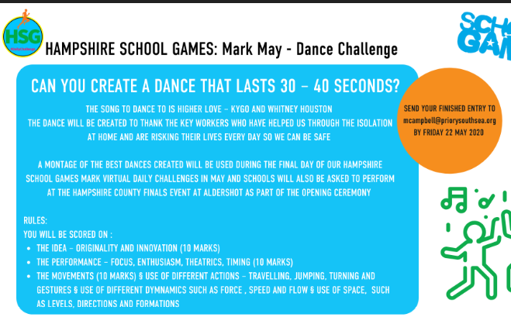
Mental Maths | 5-10 minutes | TT Rock Stars
Maths | 45 minutes | White Rose Website. Summer 1 Week 2 Day 3  https://whiterosemaths.com/homelearning/year-3/  LO: Problem solving fractions  This is tough today. Follow the video. Do not do longer than 45 minutes.
Handwriting | 15 Minutes | Practice page 2 and 3 handwriting
Writing | 30 minutes | LO: Write sentences using prepositions  Using the picture or jar you created  talk about the scene.  What does it look like?  Write sentences using prepositions to show where something is.  The crystal blue sky stretched high above the mountain tops.  The small, white flowers clung precariously to the sheer rocky faces.
Reading | 15 mins | Free read
Science | 1 hour | https://www.bbc.co.uk/bitesize/articles/znm4kmn  Complete activity 1 and 2.
Any free time check out our website for extra activities | N/A | https://sites.google.com/d/1AACR2Wo2mrXsLNCLpsrDG3ZY8ucn7msd/p/1K1uGSLLTaXnfArgCfsd4xPAQj5-cNh_Z/edit  Use the Snow Leopards websites and try the Just Dance Tasks, Chance to Shine Cricket, Sketching challenges or even tidying up.
Mindfulness Colouring | N/A | When you want to relax, I have included some colouring.

