Subject | Timings | Activity
PE | 30 mins | Cricket Week 4 and 5 -  Cricket Week 4 and Week 5  Or  We have a subscription to Online PE lessons, called Real PE  You need to enter the address:  home.jasmineactive.com  Then enter the email address:  parent@brockenhur-1.com  Password: brockenhur  Dance Challenge - for those people who fancy it.  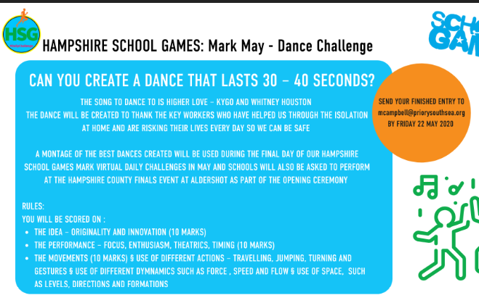
Mental Maths | 5-10 minutes | TT Rock Stars
Maths | 45 minutes | White Rose Website. Summer 1 Week 2 Day 4  https://whiterosemaths.com/homelearning/year-3/  LO: Problem solving fractions  This is tough today. Follow the video. Do not do longer than 45 minutes.
Spellings | 15 Minutes | Your spellings this week: teacher, catcher, richer, stretcher, watcher, dispatcher butcher, preacher, scruncher, stalker  Here is your spelling task. Spend 3 days doing this properly ready for your Friday spelling test.  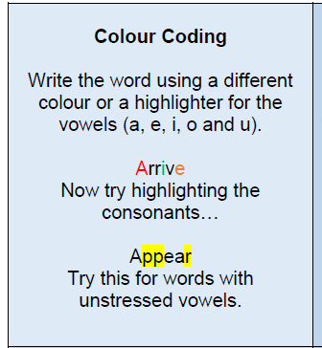
Writing | 30 minutes | LO: Read, watch and learn how children around the world travel to school  You do not need to write anything down today, but you can if you want. You do need to discuss the questions with somebody.  Look at the photos on the weekly plan.  Read the websites and watch the videos on the following links:  UNESCO  A look at Journeys to school around the world  https://www.youtube.com/watch?v=MxBfqd639BE  BBC Newsround  6 Epic Journeys to School  https://www.bbc.co.uk/newsround/22015415  TheirWorld  13 Unusual and Dangerous Journeys to School  https://theirworld.org/news/most dangerous journeys to school in world  Discuss what you have seen:  - Can you imagine any of those being your journey to school?  - Which would make you feel frightened?  - Would you like any to be your journey to school?  Challenge:  - Do you know where the places are in the world? Find them on a map or  online.
Reading | 15 mins | Free read
Topic | 1 hour | https://www.bbc.co.uk/bitesize/clips/zy98q6f  https://www.youtube.com/watch?v=e-x74MFiWkg  LO: Investigate what the Romans did for entertainment.  Watch the video about the colosseum.  Attached is a sheet with artefacts showing gladiators fighting.  What do these artefacts tell about the Roman times?  What can you see from the artefacts?  Task:  I would like you to draw (on the sheet on age 5) your favourite artefact from the sheets then answer the questions on the sheet.
Any free time check out our website for extra activities | N/A | https://sites.google.com/d/1AACR2Wo2mrXsLNCLpsrDG3ZY8ucn7msd/p/1K1uGSLLTaXnfArgCfsd4xPAQj5-cNh_Z/edit  Use the Snow Leopards websites and try the Just Dance Tasks, Chance to Shine Cricket, Sketching challenges or even tidying up.
Mindfulness Colouring | N/A | When you want to relax, I have included some colouring.

