Subject | Timings | Activity
PE | 30 mins | Cricket Week 4 and 5 -  Cricket Week 4 and Week 5  Or  We have a subscription to Online PE lessons, called Real PE  You need to enter the address:  home.jasmineactive.com  Then enter the email address:  parent@brockenhur-1.com  Password: brockenhur  Dance Challenge - for those people who fancy it.  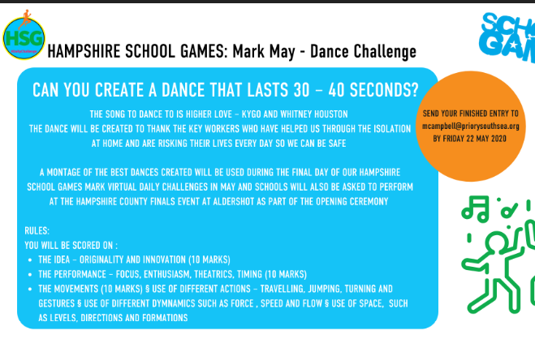
Mental Maths | 5-10 minutes | TT Rock Stars
Maths | 45 minutes | White Rose Website. Summer 1 Week 3 Day 1  https://whiterosemaths.com/homelearning/year-3/  LO: To convert pounds and pence  This should be fairly straight forward.  If you find this too easy...  https://www.mathsisfun.com/money/money-master.html  Just have fun with this game.
Spellings | 15 Minutes | Your spellings this week: teacher, catcher, richer, stretcher, watcher, dispatcher butcher, preacher, scruncher, stalker  Here is your spelling task. Spend 3 days doing this properly ready for your Friday spelling test.  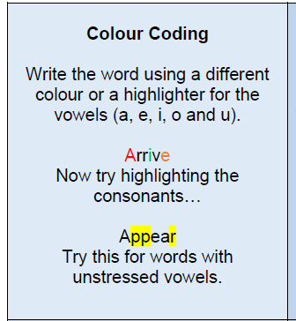
Writing | 30 minutes | LO: To ask questions and form an opinion about how these people travel to school  I've created three sheets with the pictures on from the 2nd page. Choose one of the picture not all of them.  Come up with 5 questions to ask one of the children in the pictures.  If you could ask one of the children in the image five  questions, what would they be? Aim to find as much  information as possible through good questions.  What … ?  How …?  When …?  Where … ?  Why … ?  How does it make you feel knowing that children around the world have to travel to school in dangerous conditions?  Try to use these words in your answer: appalled, shocked, envious,  concerned, excited or surprised.
Reading | 15 mins | Week’s long reading - e-book. Do not print out, just read it online. See attached with English.
Topic | 1 hour | In this lesson, I would like you to carry out an experiment on what substances dissolve and which do not.  Find out what these keywords mean first: dissolve, substances, soluble, insoluble.  Carry out the following experiment that is attached to the sheet.
Any free time check out our website for extra activities | N/A | https://sites.google.com/d/1AACR2Wo2mrXsLNCLpsrDG3ZY8ucn7msd/p/1K1uGSLLTaXnfArgCfsd4xPAQj5-cNh_Z/edit  Use the Snow Leopards websites and try the Just Dance Tasks, Chance to Shine Cricket, Sketching challenges or even tidying up.
Mindfulness Colouring | N/A | When you want to relax, I have included some colouring.

