What ... | 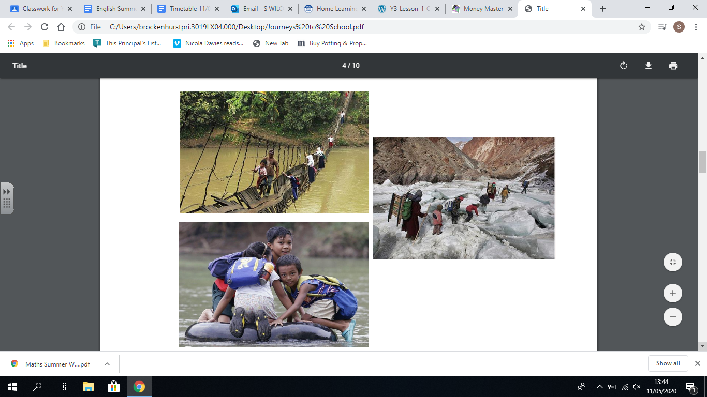
How ...
When ...
Where...
Why ...
How does it make you feel knowing that children around the world have to travel to school in dangerous conditions?

What ...
How ...
When ...
Where...
Why ...
How does it make you feel knowing that children around the world have to travel to school in dangerous conditions?

What ...
How ...
When ...
Where...
Why ...
How does it make you feel knowing that children around the world have to travel to school in dangerous conditions?

