Subject | Timings | Activity
PE | 30 mins | Cricket Week 4 and 5 -  Cricket Week 4 and Week 5  Or  We have a subscription to Online PE lessons, called Real PE  You need to enter the address:  home.jasmineactive.com  Then enter the email address:  parent@brockenhur-1.com  Password: brockenhur  Dance Challenge - for those people who fancy it.  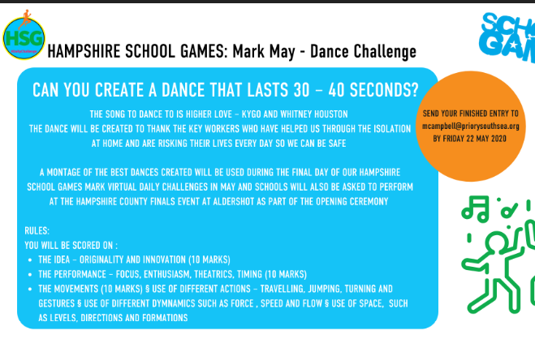
Mental Maths | 5-10 minutes | TT Rock Stars
Maths | 45 minutes | White Rose Website. Summer 1 Week 3 Day 2  https://whiterosemaths.com/homelearning/year-3/  LO: To add pounds and pence  This should be fairly straight forward.  If you find this too easy...  https://www.mathsisfun.com/money/money-master.html  Just have fun with this game.
Spellings | 15 Minutes | Your spellings this week: teacher, catcher, richer, stretcher, watcher, dispatcher butcher, preacher, scruncher, stalker  Here is your spelling task. Spend 3 days doing this properly ready for your Friday spelling test.  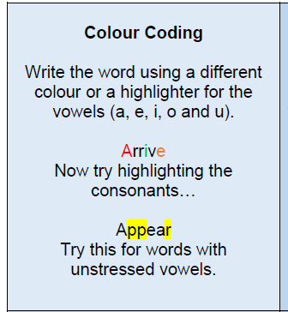
Writing | 30 minutes | LO: To ask questions and form an opinion about how these people travel to school  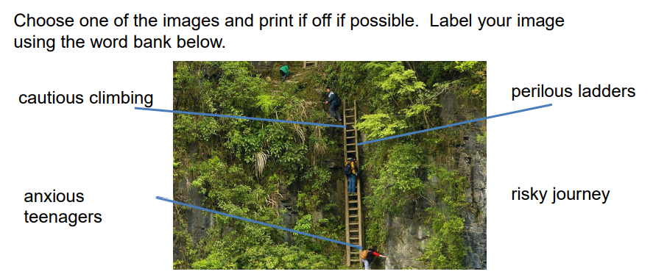  Try to use these words for your descriptions.  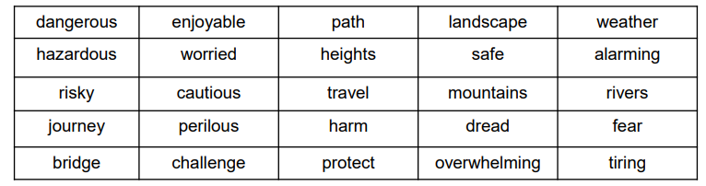  Challenge - can you create alliteration descriptions.
Reading | 15 mins | Week’s long reading - e-book. Do not print out, just read it online. See attached with English.  With history Hackers, you need to press the download button which is the arrow pointing down on the top right corner. It will download the book in a funny format. But it should work.  If all else fails, free read.  https://www.twinkl.co.uk/resource/t2-e-4300-history-hackers-roman-rescue-ebook
Art | 1 hour | LO: Create a family portrait.  Step into the bizarre imagination of Salvador Dali with this handy presentation and photopack. Then create your own family portrait gallery with this helpful activity; will you choose to use a more traditional style, or experiment with surrealism?  Activity  Look at the photos of Salvador Dali’s work. Have a look at the prompt questions that go along with it. None of these need to be printed out.  After, sketch your family following the 2nd prompt sheet.
Any free time check out our website for extra activities | N/A | https://sites.google.com/d/1AACR2Wo2mrXsLNCLpsrDG3ZY8ucn7msd/p/1K1uGSLLTaXnfArgCfsd4xPAQj5-cNh_Z/edit  Use the Snow Leopards websites and try the Just Dance Tasks, Chance to Shine Cricket, Sketching challenges or even tidying up.
Mindfulness Colouring | N/A | When you want to relax, I have included some colouring.

