Subject | Timings | Activity
PE | 30 mins | Cricket Week 4 and 5 -  Cricket Week 4 and Week 5  Or  We have a subscription to Online PE lessons, called Real PE  You need to enter the address:  home.jasmineactive.com  Then enter the email address:  parent@brockenhur-1.com  Password: brockenhur  Dance Challenge - for those people who fancy it.  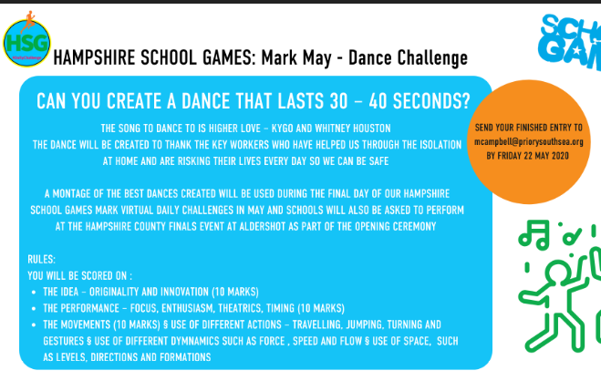
Mental Maths | 5-10 minutes | TT Rock Stars
Maths | 45 minutes | White Rose Website. Summer 1 Week 3 Day 3  https://whiterosemaths.com/homelearning/year-3/  LO: To subtract pounds and pence  https://www.mathsisfun.com/money/money-master.html  Just have fun with this game.
Spellings | 15 Minutes | Your spellings this week: teacher, catcher, richer, stretcher, watcher, dispatcher butcher, preacher, scruncher, stalker  Here is your spelling task. Spend 3 days doing this properly ready for your Friday spelling test.  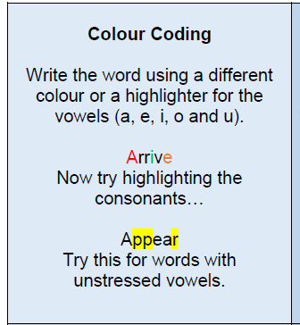
Writing | 30 minutes | LO: To create emotive sentences about travelling to school  Using the labels around your image from yesterday, create some emotive sentences about the journey to school. Use the examples below and the sentence starter grid to help you.  These sentences will help you in your writing challenge tomorrow.  Examples:  Without a doubt, the perilous ladders must be slippery.  Surely the teenagers must be anxious about climbing the ladders.  Just imagine if this risky journey was your only way to get to school.  I feel that the children have lots of courage to climb the ladders everyday.  Sentence Starters To Help  Obviously …  I’m sure you will agree …  In fact …  I don’t agree with …  It seems to me that …  On the other hand …  Tomorrow’s writing challenge  Using everything you have learnt this week, your writing challenge is to persuade the government to improve the safety of journeys to school. Use the image and country you wrote about in lessons 3 and 4. You can present your work in any form you like. You could write: • A letter • A speech • A leaflet • Power point presentation • Or a form of your own choice. Think about layout and being really persuasive.
Reading | 15 mins | Week’s long reading - e-book. Do not print out, just read it online. See attached with English.  With history Hackers, you need to press the download button which is the arrow pointing down on the top right corner. It will download the book in a funny format. But it should work.  If all else fails, free read.  https://www.twinkl.co.uk/resource/t2-e-4300-history-hackers-roman-rescue-ebook
Science | 1 hour | https://www.bbc.co.uk/bitesize/articles/z4m6hbk  Learn about vertebrates and invertebrates  There are 3 activities to try.
Any free time check out our website for extra activities | N/A | https://sites.google.com/d/1AACR2Wo2mrXsLNCLpsrDG3ZY8ucn7msd/p/1K1uGSLLTaXnfArgCfsd4xPAQj5-cNh_Z/edit  Use the Snow Leopards websites and try the Just Dance Tasks, Chance to Shine Cricket, Sketching challenges or even tidying up.
Mindfulness Colouring | N/A | When you want to relax, I have included some colouring.

