Subject | Timings | Activity
PE | 30 mins | Cricket Week 4 and 5 -  Cricket Week 4 and Week 5  Or  We have a subscription to Online PE lessons, called Real PE  You need to enter the address:  home.jasmineactive.com  Then enter the email address:  parent@brockenhur-1.com  Password: brockenhur  Dance Challenge - for those people who fancy it.  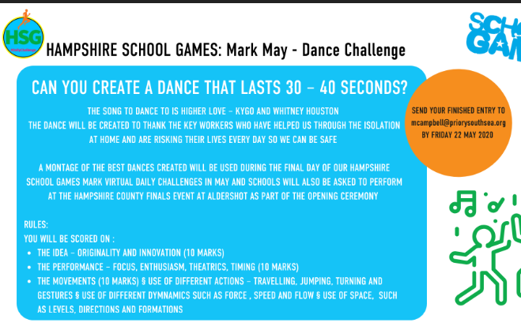
Maths | 45 minutes | TT Rock Stars. The scores you are all getting are amazing. Keep it up.
Spellings | 15 Minutes | Your spellings this week: teacher, catcher, richer, stretcher, watcher, dispatcher butcher, preacher, scruncher, stalker  Spelling test
Writing | 30 minutes | Today’s writing challenge  Using everything you have learnt this week, your writing challenge is to persuade the government to improve the safety of journeys to school. Use the image and country you wrote about in lessons 3 and 4.  You can present your work in any form you like. You could write:  • A letter  • A speech  • A leaflet  • PowerPoint presentation  • Or a form of your own choice.  Think about layout and being really persuasive.
Reading | 15 mins | Week’s long reading - e-book. Do not print out, just read it online. See attached with English.  With history Hackers, you need to press the download button which is the arrow pointing down on the top right corner. It will download the book in a funny format. But it should work.  If all else fails, free read.  https://www.twinkl.co.uk/resource/t2-e-4300-history-hackers-roman-rescue-ebook
Explore and have fun | 1 hour | This is the Best Museum (interactively) in the world.  Can you find anything to do with the Romans?  https://britishmuseum.withgoogle.com/  Explore Mars  Accessmars.withgoogle.com  If you can figure out how to make the moon rover move, let me know.
Any free time check out our website for extra activities | N/A | https://sites.google.com/d/1AACR2Wo2mrXsLNCLpsrDG3ZY8ucn7msd/p/1K1uGSLLTaXnfArgCfsd4xPAQj5-cNh_Z/edit  Use the Snow Leopards websites and try the Just Dance Tasks, Chance to Shine Cricket, Sketching challenges or even tidying up.
Mindfulness Colouring | N/A | When you want to relax, I have included some colouring.

