Subject | Timings | Activity
PE | 30 mins | Cricket Week 4 and 5 -  Cricket Week 5 and Week 6  Or  We have a subscription to Online PE lessons, called Real PE  You need to enter the address:  home.jasmineactive.com  Then enter the email address:  parent@brockenhur-1.com  Password: brockenhur  Dance Challenge - for those people who fancy it.  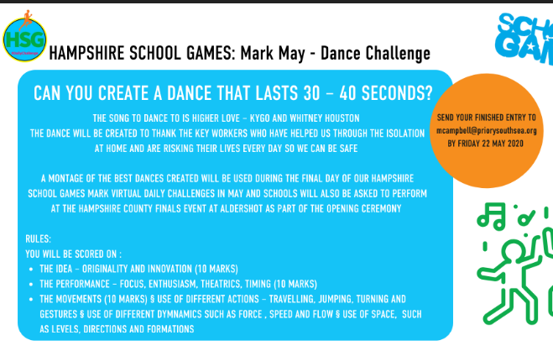
Mental Maths | 5-10 minutes | TT Rock Stars
Maths | 45 minutes | White Rose Website. Summer 1 Week 4 Day 1  https://whiterosemaths.com/homelearning/year-3/  LO: To multiply and divide by 4 and 8
Spellings | 15 Minutes | Your spellings this week: scheme, chorus, chemist, echo, character, stomach, monarch, school, anchor, chaos,  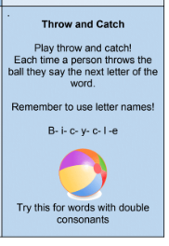
Writing | 30 minutes | LO: Read aloud and visualise  Print off the poem  Sketch the meaning of the lines of the poem  Here is an example  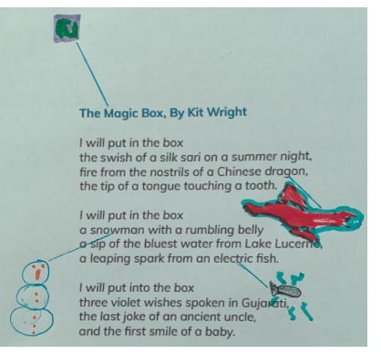
Reading | 15 mins | If you are still reading last week’s book, keep reading it. Let me know what you thought about it.  Here is a link to last week’s book: https://www.twinkl.co.uk/resource/t2-e-4300-history-hackers-roman-rescue-ebook  If you have finished and would like a new book to read, here it is.  Week’s long reading - e-book. Do not print out, just read it online. See attached with English.  Jazz Harper, Space Explorer,  If this does not work, free read.  https://www.twinkl.co.uk/resource/jazz-harper-space-explorer-ebook-t2-or-650
Topic | 1 hour | This could take you a week. If you want to focus on this rather than the other topic tasks that is fine.  But this week, I would like you to make a Roman Chariot. It could be made out of anything you can get your hands on, however it must move. If you want to use lego then go for it.  This video explains (with a crazy enthusiast) about chariots  https://www.youtube.com/watch?v=Rrjtkv5QpPQ  Here is a video of a reenactment of a chariot race  https://www.youtube.com/watch?v=KjXP-wstrUY  Lego Chariot: not a great video  https://www.youtube.com/watch?v=-BhwUet_Dok
Any free time check out our website for extra activities | N/A | https://sites.google.com/d/1AACR2Wo2mrXsLNCLpsrDG3ZY8ucn7msd/p/1K1uGSLLTaXnfArgCfsd4xPAQj5-cNh_Z/edit  Use the Snow Leopards websites and try the Just Dance Tasks, Chance to Shine Cricket, Sketching challenges or even tidying up.
Mindfulness Colouring | N/A | When you want to relax, I have included some colouring.

