Subject | Timings | Activity
PE | 30 mins | Cricket Week 4 and 5 -  Cricket Week 5 and Week 6  Or  We have a subscription to Online PE lessons, called Real PE  You need to enter the address:  home.jasmineactive.com  Then enter the email address:  parent@brockenhur-1.com  Password: brockenhur  Dance Challenge - for those people who fancy it.  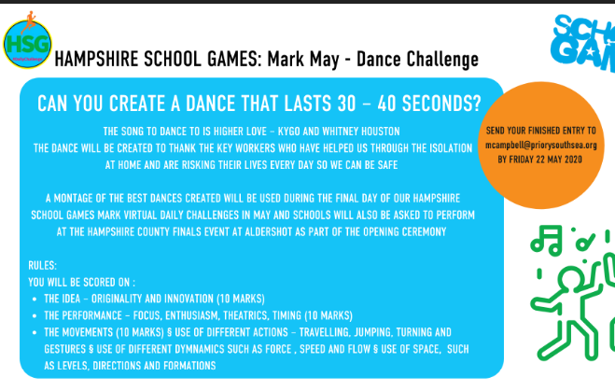
Mental Maths | 5-10 minutes | TT Rock Stars
Maths | 45 minutes | White Rose Website. Summer 1 Week 4 Day 1  https://whiterosemaths.com/homelearning/year-3/  LO: To multiply and divide by 4 and 8
Spellings | 15 Minutes | Your spellings this week: scheme, chorus, chemist, echo, character, stomach, monarch, school, anchor, chaos,  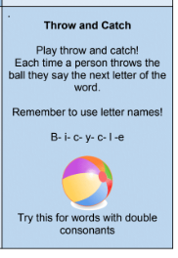
Writing | 30 minutes | LO: To understand the great pieces of vocabulary in the poem  Read the poem again. Highlight or underline the words and phrases which make you think there is something magical about this box… For example, ‘violet wishes’ or ‘a fifth season.’  Transfer these words and phrases into the table above (a blank version is available to download on page 11) and fill out each column to explain the choices further (examples have been provided above to help you get started).
Reading | 15 mins | If you are still reading last week’s book, keep reading it. Let me know what you thought about it.  Here is a link to last week’s book: https://www.twinkl.co.uk/resource/t2-e-4300-history-hackers-roman-rescue-ebook  If you have finished and would like a new book to read, here it is.  Week’s long reading - e-book. Do not print out, just read it online. See attached with English.  Jazz Harper, Space Explorer,  If this does not work, free read.  https://www.twinkl.co.uk/resource/jazz-harper-space-explorer-ebook-t2-or-650
Science | 1 hour | https://www.bbc.co.uk/bitesize/articles/zvp8jhv  LO: to understand friction
Any free time check out our website for extra activities | N/A | https://sites.google.com/d/1AACR2Wo2mrXsLNCLpsrDG3ZY8ucn7msd/p/1K1uGSLLTaXnfArgCfsd4xPAQj5-cNh_Z/edit  Use the Snow Leopards websites and try the Just Dance Tasks, Chance to Shine Cricket, Sketching challenges or even tidying up.
Mindfulness Colouring | N/A | When you want to relax, I have included some colouring.

