Rumble in the Jungle - Activities
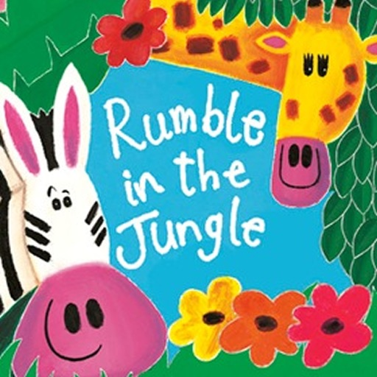

Choose any number of activities from the table below to do with your child over the course of the week.
Literacy Activities | - Listen to the story of Rumble in the Jungle - https://www.booktrust.org.uk/books-and-reading/have-some-fun/storybooks-and-games/rumble-in-the-jungle/  - Design a new book cover for Rumble in the Jungle  - Have a look at the What am I jungle - powerpoint. Can you guess what the animals are? Have a go at writing your own clues for a different animal and see if your family can guess correctly.  - Have a look at the Jungle Facts powerpoint. Choose an animal you like. Draw a picture of it. Do some research to find out some facts about it. Ask your adult to help you write some facts about it.  - Listen to the story again and pause on each page – can you find the rhyming words in each animal verse?  - Match the animals – can you read the names of the animals and match them to the correct picture  - Have a look at the Jungle Pictures. Choose the image you like the best and imagine you are there. Use your senses to help you imagine what it would be like. You could have a go at writing about it: I can see ….., I can hear ……….., I can smell ………., I can touch ……, I can taste……… .  - Listen to Listen to Elephant Me read by the author Giles Andreae himself: https://www.youtube.com/watch?v=XsbLk9bI-as  Can you find any other books by Giles Andreae – you might have some on your bookshelf?
Sing some songs | - 5 little monkeys:  https://www.youtube.com/watch?v=7zMPy6VgAyo  - The animal fair:  https://www.youtube.com/watch?v=kbcKvW-mjfA  - Down in the jungle:  https://www.youtube.com/watch?v=Rq1t__qI91Y
Creative Activities | - Make an online jungle picture:  https://www.booktrust.org.uk/books-and-reading/have-some-fun/storybooks-and-games/jungle-picture-maker/  - Make a paper plate animal of your favourite jungle creature:  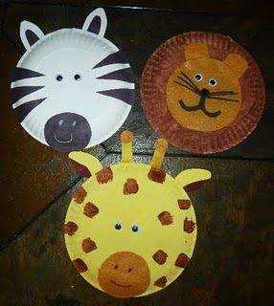  - Make a paper chain snake:  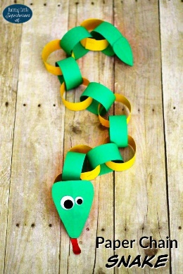  - Make a paper bag monkey:  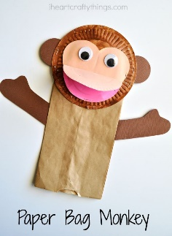  - Paint a lion and give him a pasta mane:  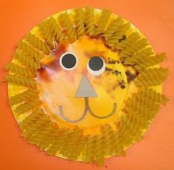
Science Activities | - Balancing Dragonfly  - Jumping Frogs  - Shaving Foam Clouds  As always, these activities need quite specific resources that you might or might not have, so don’t worry if you don’t manage top do them.
Cooking ideas | - Make your fruit snack into a jungle scene:  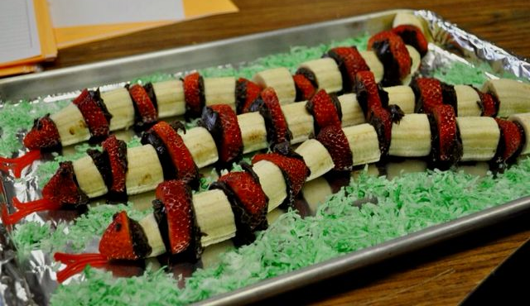  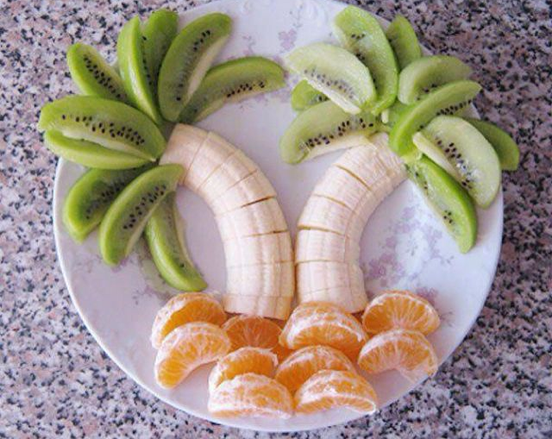  - Turn your orange into a tiger:  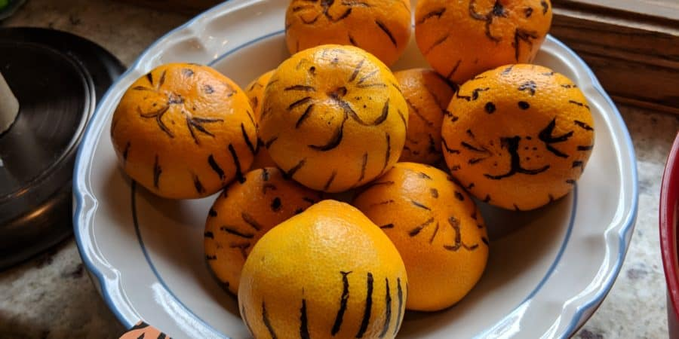  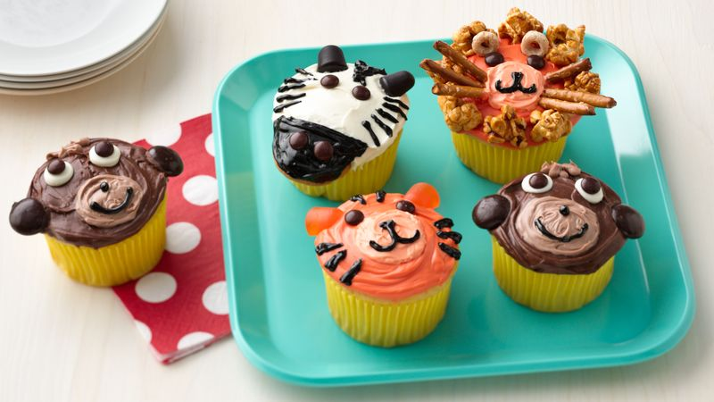  - If you’re feeling adventurous – Jungle themed cupcakes:

