Subject | Timings | Activity
PE | 30 mins | Cricket Week 4 and 5 -  Cricket Week 5 and Week 6  Or  We have a subscription to Online PE lessons, called Real PE  You need to enter the address:  home.jasmineactive.com  Then enter the email address:  parent@brockenhur-1.com  Password: brockenhur  Dance Challenge - for those people who fancy it.  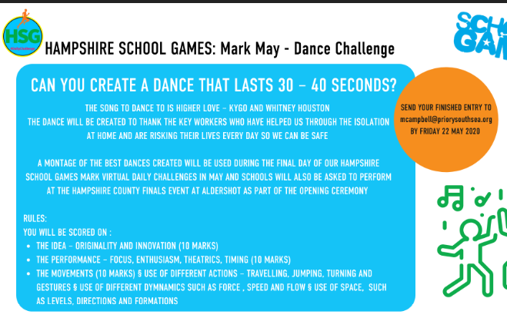
Mental Maths | 5-10 minutes | TT Rock Stars
Maths | 45 minutes | White Rose Website. Summer 1 Week 4 Day 3  https://whiterosemaths.com/homelearning/year-3/  LO: To divide 2 digits by 1 digit
Spellings | 15 Minutes | Your spellings this week: scheme, chorus, chemist, echo, character, stomach, monarch, school, anchor, chaos,  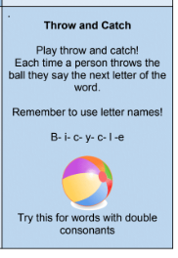
Writing | 30 minutes | LO: To create your own magic box  Create a magical box. Collect unusual images and items that you would put into your own magical box.  Create magical and unusual phrases for your different images and items.  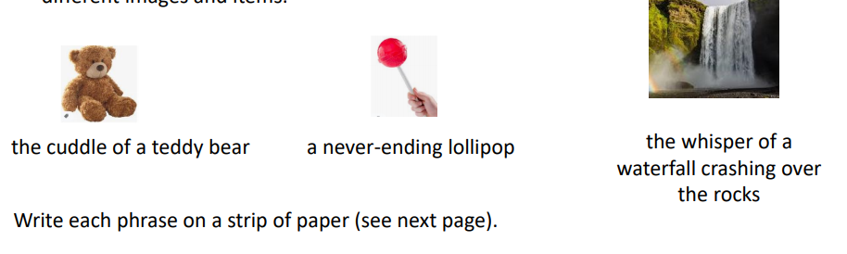  Lesson 5 - Friday  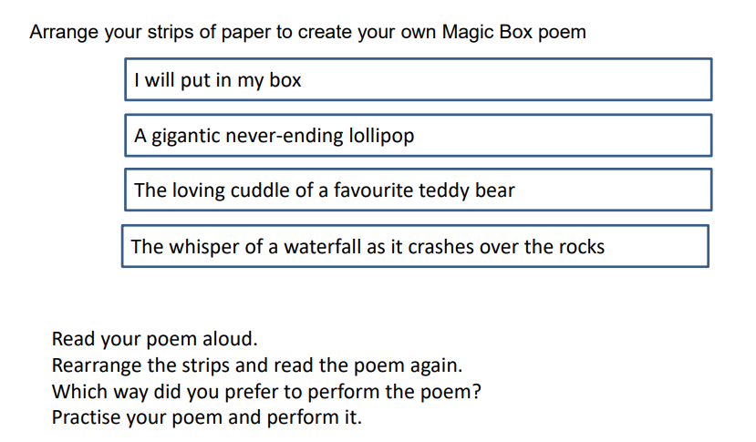
Reading | 15 mins | If you are still reading last week’s book, keep reading it. Let me know what you thought about it.  Here is a link to last week’s book: https://www.twinkl.co.uk/resource/t2-e-4300-history-hackers-roman-rescue-ebook  If you have finished and would like a new book to read, here it is.  Week’s long reading - e-book. Do not print out, just read it online. See attached with English.  Jazz Harper, Space Explorer,  If this does not work, free read.  https://www.twinkl.co.uk/resource/jazz-harper-space-explorer-ebook-t2-or-650
Art | 1 hour | https://www.bbc.co.uk/bitesize/articles/zjvj7nb  LO: Draw character expressions  Watch the 30 minute video  There are 3 activities to try. You do not need to do them all, you do not even need to print out all the pages if you are very good at drawing face shapes.  Definitely try the last activity and if you can send me a photo.
Any free time check out our website for extra activities | N/A | https://sites.google.com/d/1AACR2Wo2mrXsLNCLpsrDG3ZY8ucn7msd/p/1K1uGSLLTaXnfArgCfsd4xPAQj5-cNh_Z/edit  Use the Snow Leopards websites and try the Just Dance Tasks, Chance to Shine Cricket, Sketching challenges or even tidying up.
Mindfulness Colouring | N/A | When you want to relax, I have included some colouring.

