Rainbow Fish - Activities
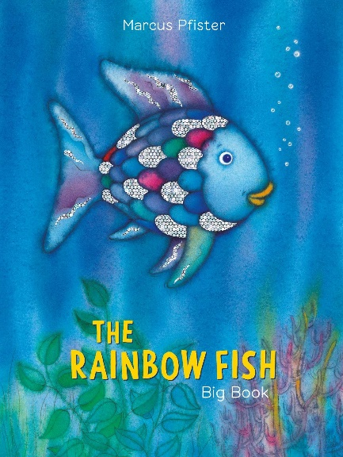

Choose any number of activities from the table below to do with your child over the course of the week.
Literacy Activities | - Listen to the story of The Rainbow Fish by Marcus Pfister - https://www.youtube.com/watch?v=2jQTjTe42-0  - Use the sequencing pictures or draw your own to retell the story. Put the pictures in the correct order. You could write a sentence for each picture or ask your grown up to help you.  - What is your most prized possession? Draw a picture of it and write a sentence to say why it is so special.  - Look at the Under the sea – simple sentence cards (either printed or online). Have a go at reading the sentences. Cover up the sentences and have a go at writing them yourself.  - Have a go at finding out some facts about a different creature that lives under the sea. You could look in books or on the internet. You could make a little book about your creature or design a poster.  - Talk about different ways you can be a good friend.  - Watch this animation of The Rainbow Fish - https://www.youtube.com/watch?v=ifXlc0QI2kY  - Listen to Ava’s Poppy, another book by Marcus Pfister https://www.youtube.com/watch?v=kt9zmgq5sIk
Sing some songs | - The Rainbow Fish song  https://www.youtube.com/watch?v=TzgpA86x94U  - 1, 2, 3, 4, 5 Once I caught a fish alive  https://www.youtube.com/watch?v=9ir_l7qTiZ4  - Under the sea  https://www.youtube.com/watch?v=Fkusy4ylhiY  - The Frog Chorus  https://www.youtube.com/watch?v=PcDVH8DiBnM
Creative Activities | - Make a different rainbow animal. It can be any animal you like. You could colour it in, paint it or even make a collage.  - Make a paper plate rainbow fish:  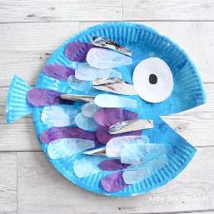  - Print a rainbow pattern on a fish. You could use celery to print the scales:  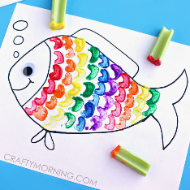  - Have a go at paper weaving a rainbow fish:  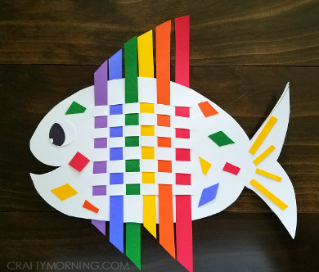  - Make an octopus:  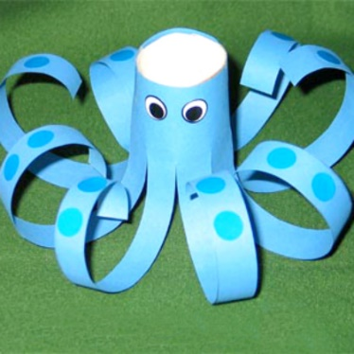
Science Activities | - Have a go at the sensory bottle activity  - Have a go at the Rainbow Fish Sparkle Activity (RF Sparkle Science Experiment, rainbow Fish Poster, RF Sparkle Prompt card)  As always, these activities need quite specific resources that you might or might not have, so don’t worry if you don’t manage top do them.
Cooking ideas | - Make some rainbow fish skewers  - Rainbow fish digestive biscuits  https://www.organiccookeryschool.org/blog//storytime-chefs-rainbow-fish-digestive-biscuits-cooking-with-kids  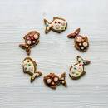  - Fishy fish cakes  https://recipes.sainsburys.co.uk/recipes/main-courses/fishy-fishcakes  

