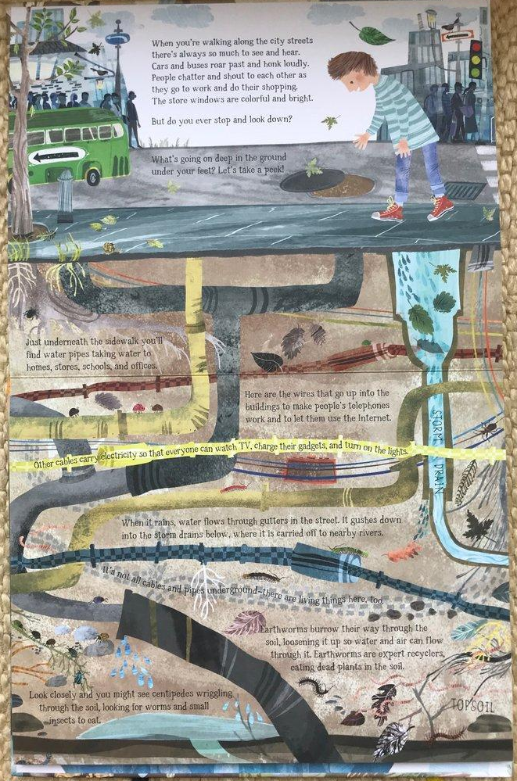
When you’re walking along the city streets there’s always so much to see and hear. Cars and buses roar past and beep loudly. People chatter and shout to each other as they go to work and do their shopping. The shop windows are colourful and bright.
But do you ever stop to look down?
What’s going on deep in the ground under your feet? Shall we take a peek? Just underneath the pavement you’ll find water pipes taking water to homes, shops, schools and offices.
Here are the wires that go up into the buildings to make people’s telephones work and let them use the internet. Other cables carry electricity so that everyone can watch TV, boil the kettle and turn on the lights.
When it rains, water flows through the gutters in the street. It gushes down into the storm drains below, where it is carried off to nearby rivers.
It’s not all cables and pipes underground – there are living things there too. Earthworms burrow their way through the soil, loosening it up so water can flow through it. Earthworms are expert recyclers, eating dead plants in the soil. Look closely and you might see centipedes wriggling through the soil, looking for worms and small bugs to eat.

