Subject | Timings | Activity
PE | 30 mins | Cricket Week 7 and 8 -  Cricket Week 7 and Week 8  Or  We have a subscription to Online PE lessons, called Real PE  You need to enter the address:  home.jasmineactive.com  Then enter the email address:  parent@brockenhur-1.com  Password: brockenhur
Mental Maths | 5-10 minutes | 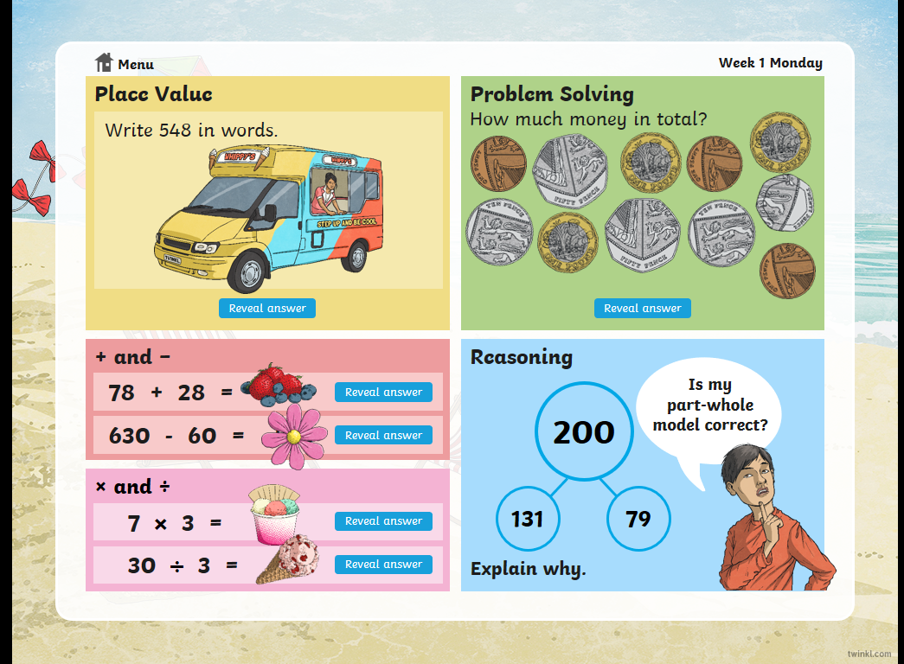
Maths | 45 minutes | White Rose Website. Summer 1 Week 5 Day 3  https://whiterosemaths.com/homelearning/year-3/  LO: To understand tenths
Spellings | 15 Minutes | Your spellings this week the s sound spelt ‘sc’:  Science, scene, discipline, fascinate, crescent, scissors, ascend, scented, scenery, descend  Play on spelling shed
Writing | 30 minutes | Don’t watch the short film all the way through until you have seen the points you need to pause at  https://vimeo.com/24962214  At the end of the week:  You will write your own short story to accompany the film.  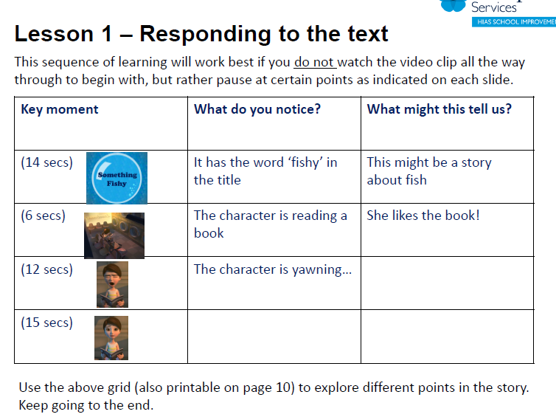
Reading | 15 mins | Check in the English folder for the PDF version of the book. Let me know if it does not work.  Here is your weekly reading session. This book is great as it explains how, it is thought, Rome was established.
World Oceans Day | 1 hour | The World oceans’s day lecture starts at 10.  https://www.wwf.org.uk/learn/love-nature/oceans?dm_i=38LF,11M0P,54TLN5,3ZIEA,1  If you didn’t sign up to the lecture, have a look at this cool resource that look at the different issues around our planet’s oceans.  https://www.ourplanet.com/en/explorable-globe/landing/
Any free time check out our website for extra activities | N/A | https://sites.google.com/d/1AACR2Wo2mrXsLNCLpsrDG3ZY8ucn7msd/p/1K1uGSLLTaXnfArgCfsd4xPAQj5-cNh_Z/edit  Use the Snow Leopards websites and try the Just Dance Tasks, Chance to Shine Cricket, Sketching challenges or even tidying up.
Mindfulness Colouring | N/A | When you want to relax, I have included some colouring.

