Subject | Timings | Activity
PE | 30 mins | Cricket Week 7 and 8 -  Cricket Week 7 and Week 8  Or  We have a subscription to Online PE lessons, called Real PE  You need to enter the address:  home.jasmineactive.com  Then enter the email address:  parent@brockenhur-1.com  Password: brockenhur
Mental Maths | 5-10 minutes | 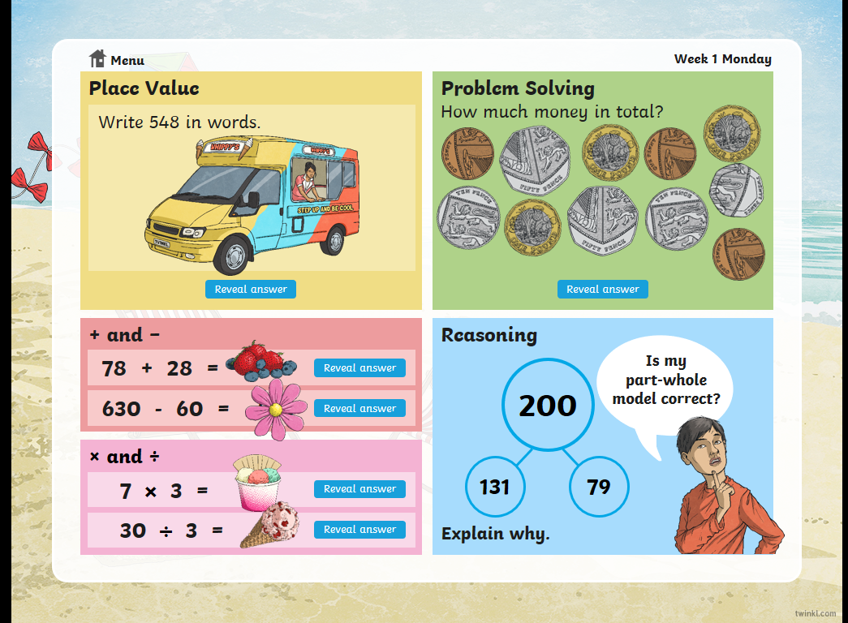
Maths | 45 minutes | White Rose Website. Summer 1 Week 5 Day 4  https://whiterosemaths.com/homelearning/year-3/  LO: To count in tenths
Spellings | 15 Minutes | Your spellings this week the s sound spelt ‘sc’:  Science, scene, discipline, fascinate, crescent, scissors, ascend, scented, scenery, descend  Play on spelling shed
Writing | 30 minutes | Don’t watch the short film all the way through until you have seen the points you need to pause at  https://vimeo.com/24962214  At the end of the week:  You will write your own short story to accompany the film.  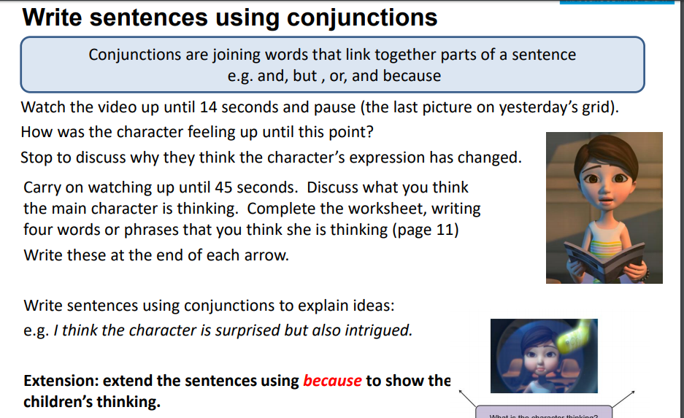
Reading | 15 mins | There is a non-fiction text about the Romans for you to read. It is on the main page.
World Oceans Day | 1 hour | Look at the different issues around our planet’s oceans.  https://www.ourplanet.com/en/explorable-globe/landing/  Click on - home of the whales.  What brings food to whales?  How many humpback whales are there (estimated) in our oceans?  What other creatures are affected by high seas?  What is the human problem inside the oceans?  What are the solutions?
Any free time check out our website for extra activities | N/A | https://sites.google.com/d/1AACR2Wo2mrXsLNCLpsrDG3ZY8ucn7msd/p/1K1uGSLLTaXnfArgCfsd4xPAQj5-cNh_Z/edit  Use the Snow Leopards websites and try the Just Dance Tasks, Chance to Shine Cricket, Sketching challenges or even tidying up.
Mindfulness Colouring | N/A | When you want to relax, I have included some colouring.

