Subject | Timings | Activity
PE | 30 mins | Cricket Week 7 and 8 -  Cricket Week 7 and Week 8  Or  We have a subscription to Online PE lessons, called Real PE  You need to enter the address:  home.jasmineactive.com  Then enter the email address:  parent@brockenhur-1.com  Password: brockenhur
Mental Maths | 5-10 minutes | 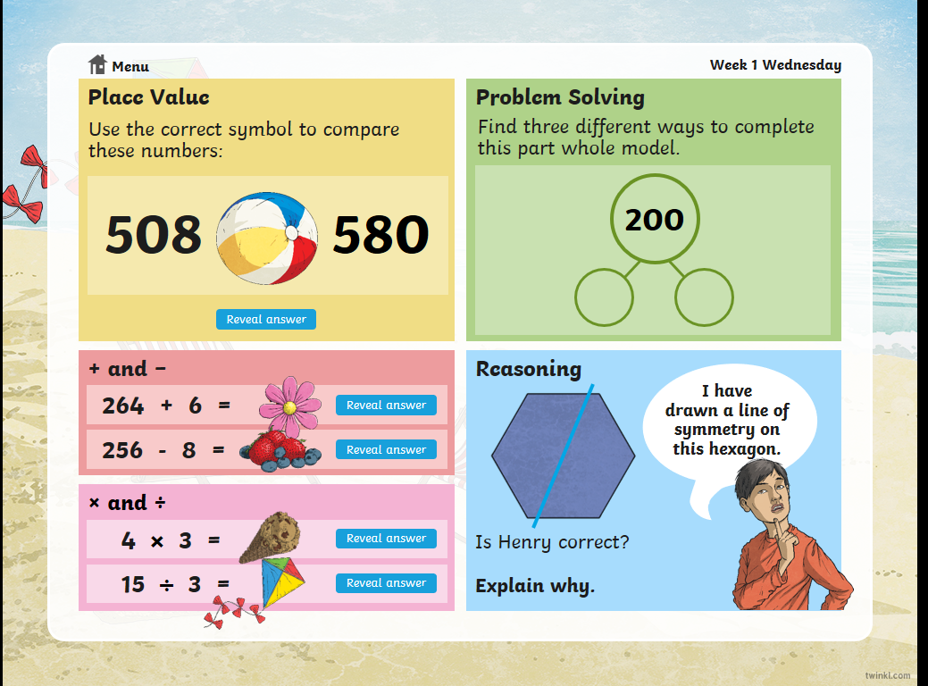
Maths | 45 minutes | White Rose Website. Summer 1 Week 5 Day 4  https://whiterosemaths.com/homelearning/year-3/  LO: To understand tenths
Spellings | 15 Minutes | Your spellings this week; the ‘s’ sound spelled ‘sc’:  Science, scene, discipline, fascinate, crescent, scissors, ascend, scented, scenery, descend  Play on spelling shed
Writing | 30 minutes | Don’t watch the short film all the way through until you have seen the points you need to pause at  https://vimeo.com/24962214  At the end of the week:  You will write your own short story to accompany the film.  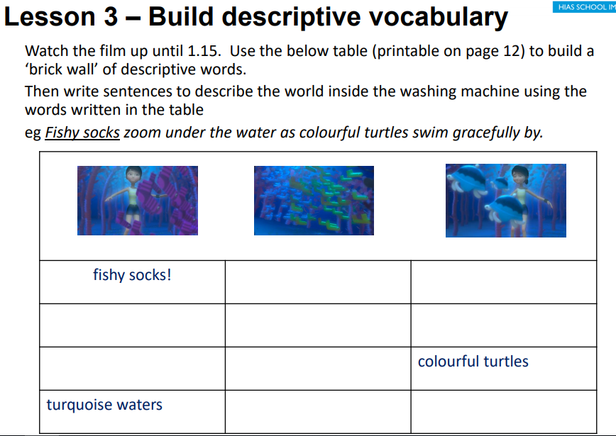
Reading | 15 mins | There is a non-fiction text about the Romans for you to read. It is on the main page.
Science | 1 hour | In this lesson, learn about renewable and non-renewable energy.  two videos  three activities to reinforce learning.  https://www.bbc.co.uk/bitesize/articles/zhvc86f
Any free time check out our website for extra activities | N/A | https://sites.google.com/d/1AACR2Wo2mrXsLNCLpsrDG3ZY8ucn7msd/p/1K1uGSLLTaXnfArgCfsd4xPAQj5-cNh_Z/edit  Use the Snow Leopards websites and try the Just Dance Tasks, Chance to Shine Cricket, Sketching challenges or even tidying up.
Mindfulness Colouring | N/A | When you want to relax, I have included some colouring.

