Harry and the bucketful of Dinosaurs - Activities
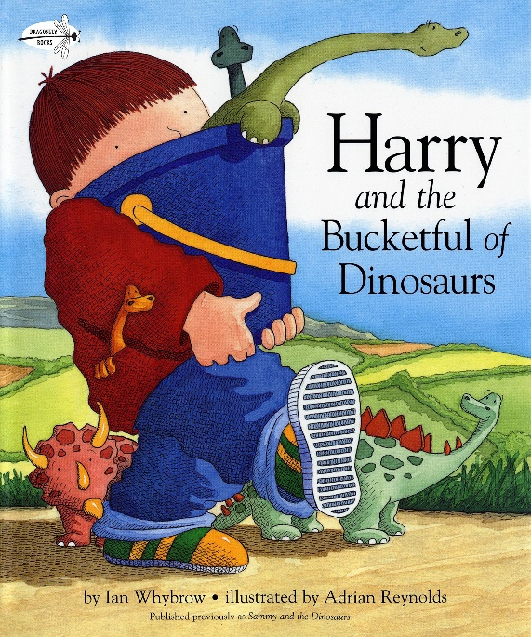

Choose any number of activities from the table below to do with your child over the course of the week.
Literacy Activities | - Listen to the story of Harry and the bucketful of Dinosaurs by Ian Whybrow - https://www.youtube.com/watch?v=uWoopkMgLqM&t=13s  - Read a non-fiction book about dinosaurs or research on the internet. Write down 3 facts you find out about dinosaurs.  - Design and draw a new dinosaur. Think about whether it will have a long or short neck, spikes, scales or feathers and what its tail will look like. Can you create a name for your new dinosaur?  - Look at the Dinosaur – simple sentence cards (either printed or online). Have a go at reading the sentences. Cover up the sentences and have a go at writing them yourself.  - Use the Dinosaur Writing Activity to write sentences about dinosaurs.  - Listen to Harry and the robots, another book by Ian Whybrow  https://www.youtube.com/watch?v=1JHySjqNtQU  - Listen to Harry and the dinosuars say ‘Raaah!’, another book by Ian Whybrow  https://www.youtube.com/watch?v=eyTF2FyIP78  - There are lots more stories and animations – just have a search on YouTube
Creative Activities | - Can you draw, paint or collage a picture of your new dinosaur, or you could make a 3D model of it.  - Play some music and dance like a dinosaur. You could ask you family to join in. Make some dinosaur roars while you stomp around the room.  - Make some paper plate dinosaurs:  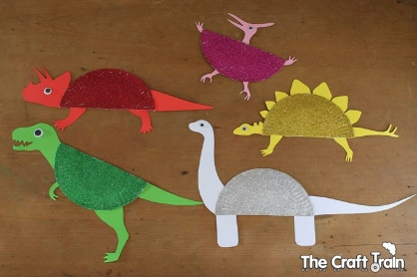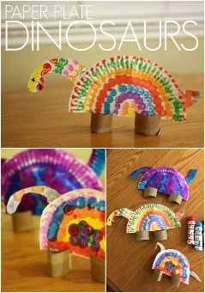  - Use lolly sticks to make a dinosaur:  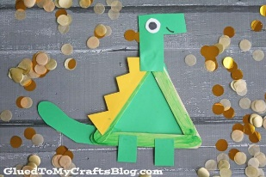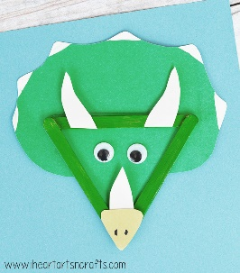  - Make a dinosaur skeleton using cotton buds or pasta:  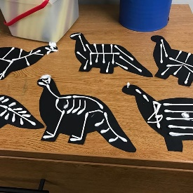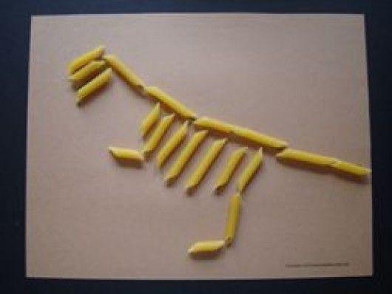
Science Activities | - Make a dinosaur fossil  - Floating dinosaur rescue  - Volcano Science Experiment  As always, these activities need quite specific resources that you might or might not have, so don’t worry if you don’t manage to do them.
Cooking ideas | - Make dinosaur biscuits:  https://realfood.tesco.com/recipes/dinosaur-biscuits.html  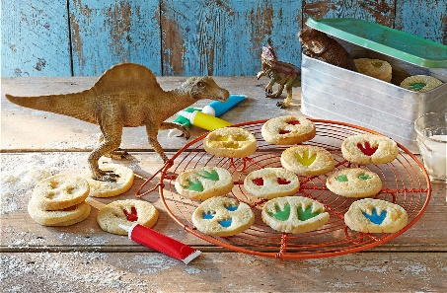  - Dino fruit skewers with yoghurt dip  https://www.findingzest.com/dino-fruit-skewers-with-yogurt-fruit-dip/  

