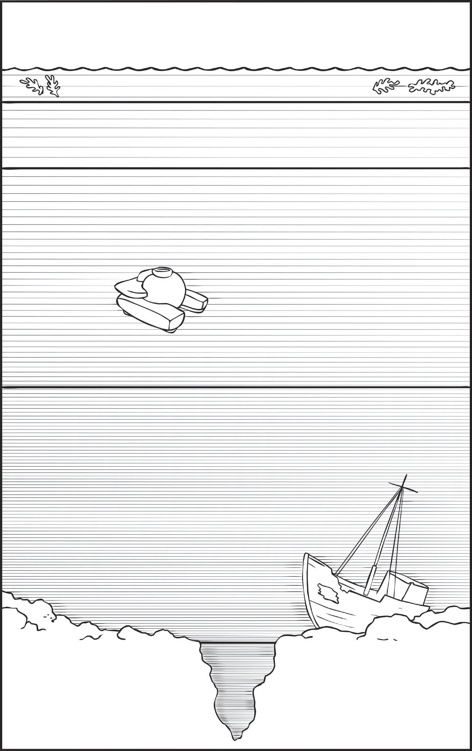

Cut out the labels for the layers of the ocean and place them in order from the lowest to the highest layer. The first one has been done for you.
Midnight Zone
Most creatures have tiny eyes. Animals create their own light, and lure their prey.
Other hunters ‘sit and wait’
Sunlight Zone
Sleek bodied fish swim fast to catch their prey. Sunlight allows plants to grow so plant feeders are also found.
Twilight Zone
Due to lack of sunlight no plants grow. Creatures tend to be slower moving. They will filter the water to feed, graze or hunt.
The Abyss
There is no light whatsoever, so often creatures will not have eyes. They are likely to be small due to the pressure and will feed on dead matter from above.

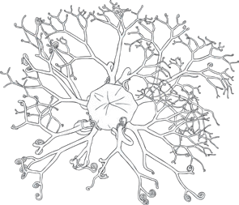
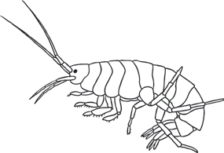
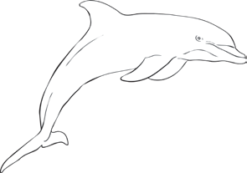
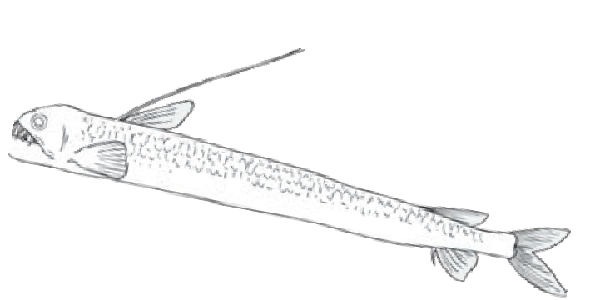
- Draw the creatures in the ocean layers picture.

Basket Star (Starfish with tree like appearance that catches food matter in its net)

Amphipod
(See-through eyeless
shrimp)

Dolphin
(Warm blooded mammal that sometimes comes up for air)

Viper Fish
(Waits for its prey to be lured by its glow)

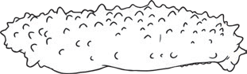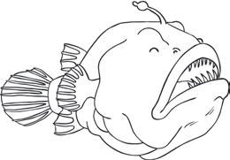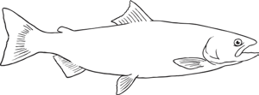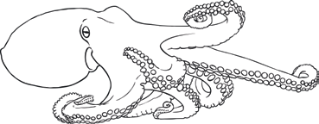

Sea Cucumber
(Many tentacled creature that crawls along the sea floor to find food)

Angler fish
(Fish with light up bulb hanging in front of its face to attract prey)

Salmon
(Speedy fish that lives in salt and fresh water)

Octopus
(8 legged creatures that searches and hunts
for prey)

