Subject | Timings | Activity
PE | 30 mins | Cricket Week 7 and 8 -  Cricket Week 7 and Week 8  Or  We have a subscription to Online PE lessons, called Real PE  You need to enter the address:  home.jasmineactive.com  Then enter the email address:  parent@brockenhur-1.com  Password: brockenhur
Mental Maths | 5-10 minutes | 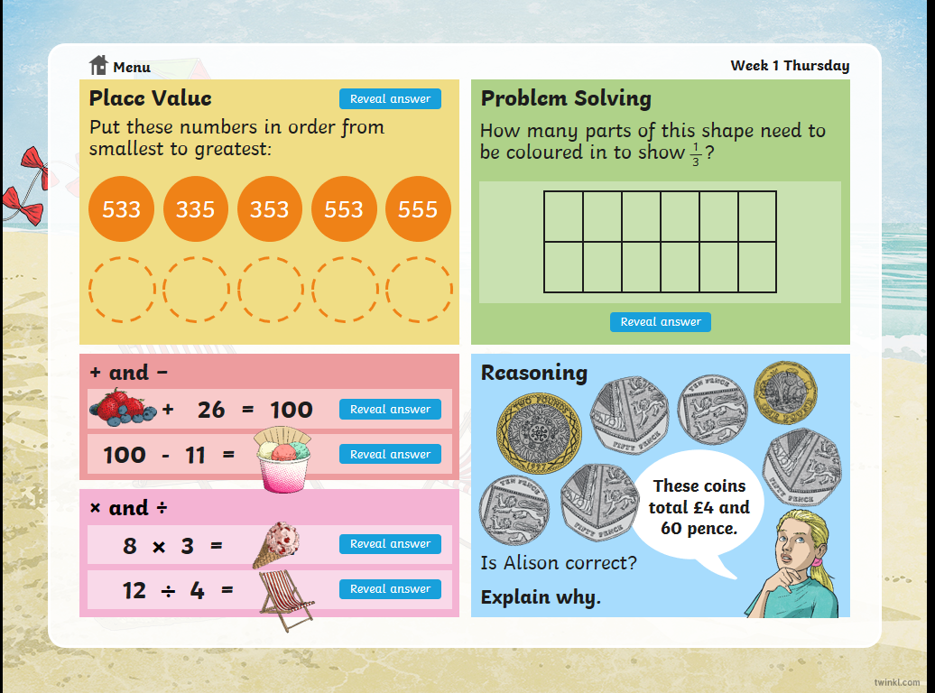
Maths | 45 minutes | White Rose Website. Summer 1 Week 6 Day 2  https://whiterosemaths.com/homelearning/year-3/  LO: To understand fractions on a number line
Spellings | 15 Minutes | Your spellings this week; the ‘s’ sound spelled ‘sc’:  Science, scene, discipline, fascinate, crescent, scissors, ascend, scented, scenery, descend  Play on spelling shed
Writing | 30 minutes | Don’t watch the short film all the way through until you have seen the points you need to pause at  https://vimeo.com/24962214  At the end of the week:  You will write your own short story to accompany the film.  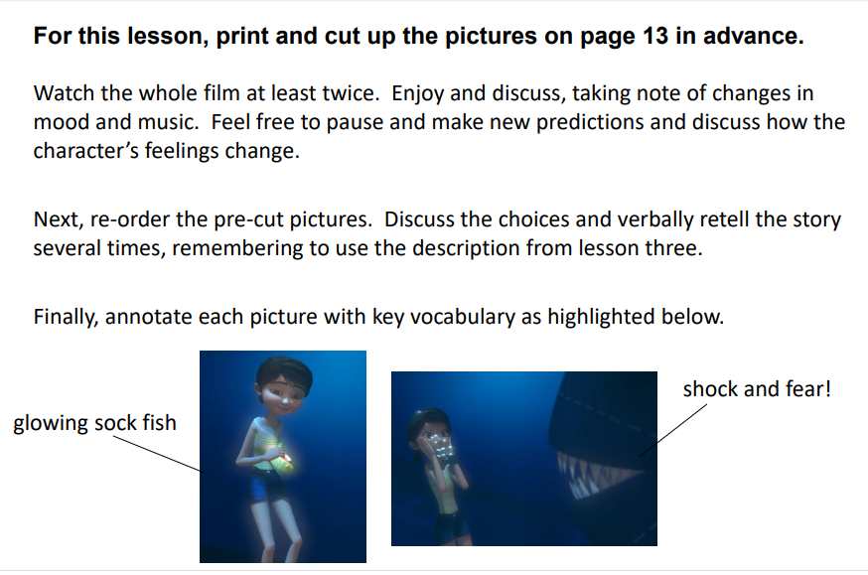
Reading | 15 mins | There is a non-fiction text about the Romans for you to read. It is on the main page.
Oceans | 1 hour | Read through the PowerPoint.  Print out the activity sheet and cut out the different layers of the ocean.

