Subject | Timings | Activity
PE | 30 mins | Cricket Week 7 and 8 -  Cricket Week 7 and Week 8  Or  We have a subscription to Online PE lessons, called Real PE  You need to enter the address:  home.jasmineactive.com  Then enter the email address:  parent@brockenhur-1.com  Password: brockenhur
Mental Maths | 5-10 minutes | 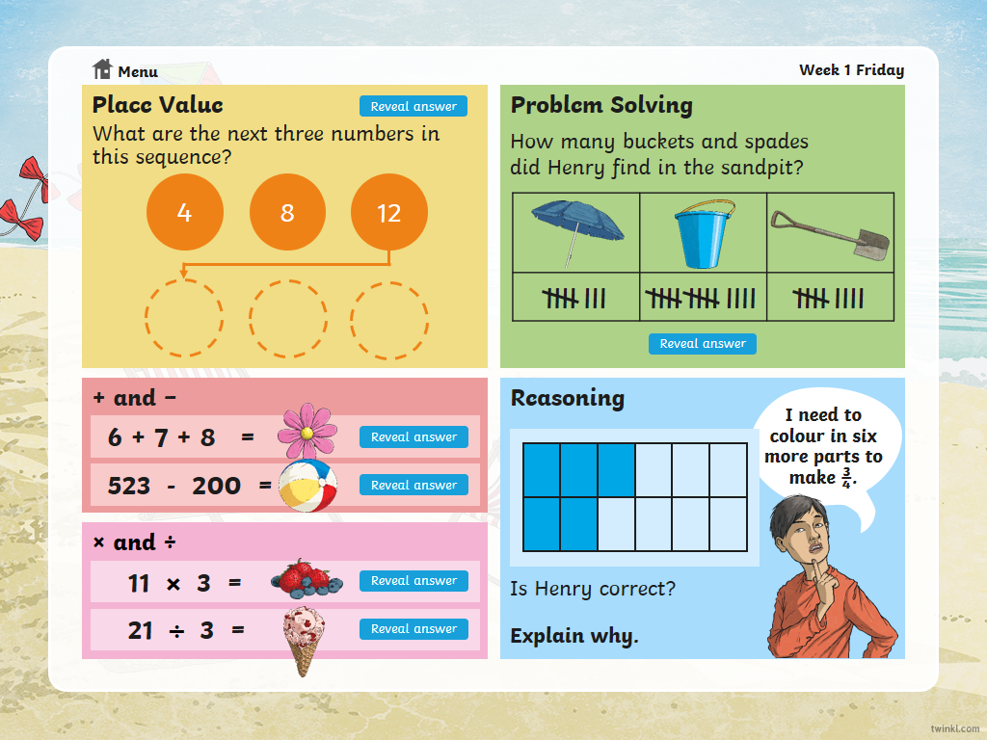
Maths | 45 minutes | TT - Rock Stars, Try to beat my challenge.
Spellings | 15 Minutes | Spelling test  Your spellings this week; the ‘s’ sound spelled ‘sc’:  Science, scene, discipline, fascinate, crescent, scissors, ascend, scented, scenery, descend  Play on spelling shed
Writing | 30 minutes | Don’t watch the short film all the way through until you have seen the points you need to pause at  https://vimeo.com/24962214  At the end of the week:  You will write your own short story to accompany the film.  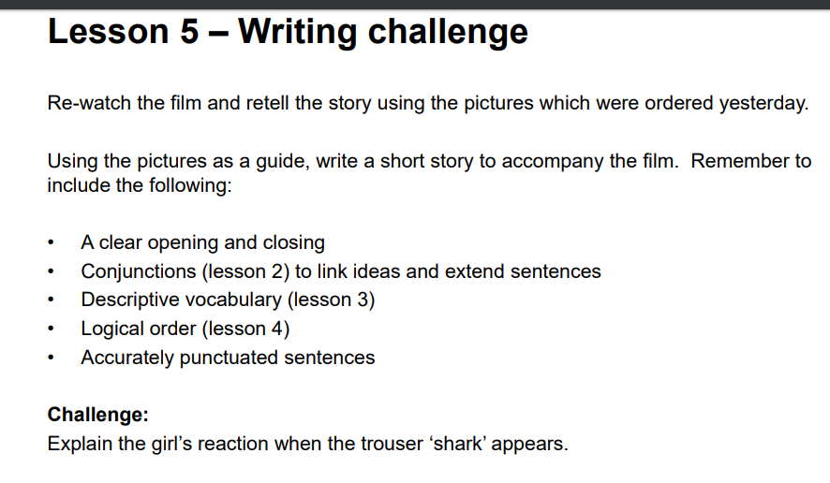
Reading | 15 mins | There is a non-fiction text about the Romans for you to read. It is on the main page.
Wellbeing | 1 hour | Create a Wellbeing Jar  Use these craft instructions to create your own wellbeing jar. Having things to look forward to can make you feel happier and improve your wellbeing. Each time you think of something you would like to do in the future, write it on a piece of paper and place it inside your decorated jar.

