Subject | Timings | Activity
PE | 30 mins | Cricket Week 8 and Week  Or  We have a subscription to Online PE lessons, called Real PE  You need to enter the address:  home.jasmineactive.com  Then enter the email address:  parent@brockenhur-1.com  Password: brockenhur
Mental Maths | 5-10 minutes | 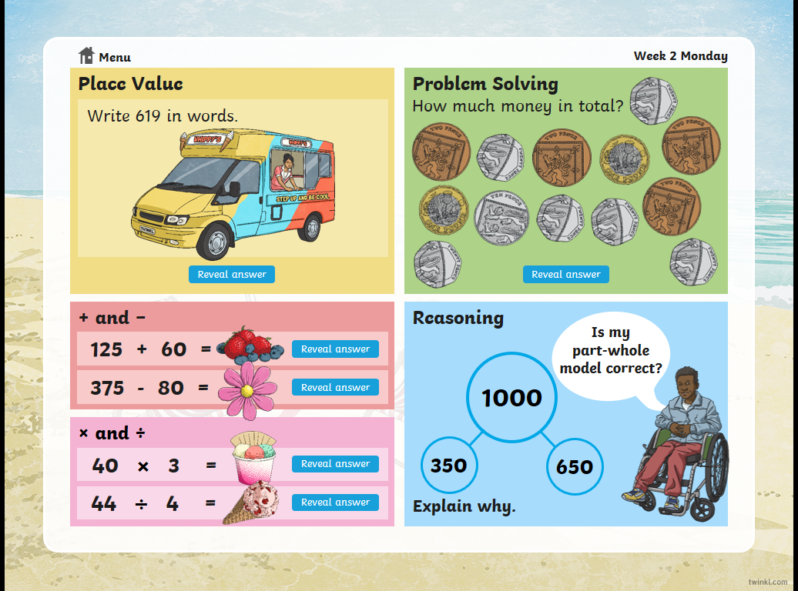
Maths | 45 minutes | White Rose Website. Summer 1 Week 6 Day 3  https://whiterosemaths.com/homelearning/year-3/  LO: TO calculate fractions from objects
Spellings | 15 Minutes | Spelling Shed  Your spellings this week; homophones  Ball, bawl, berry, burry, brake, break, fair, fare, mail, male  Play on spelling shed
Writing | 30 minutes | Listen to the play cast  Andy Stanton (bearded author of the Mr Gum books)  and Carrie Quinlan (unbearded actress, comedian and  and all-round weirdo) answer questions.  Listen as Andy and Carrie share their ‘wisdumb’ and  ‘nollidge’ in a feast of nonsense, hilarity and truly  outrageous lies.  https://play.acast.com/s/nincompoops/cbab5c2b-5400-415c-a103-b1d9bd348529  Answer the questions on the sheet.
Reading |  | Open up the questions, then press the play button. It sends you to a youtube link where the poem is read.
Oceans | 1 hour | Read through the PowerPoint.  Print out the activity sheet and cut out the different layers of the ocean.

