Subject | Timings | Activity
PE | 30 mins | Cricket Week 8 and Week  Or  We have a subscription to Online PE lessons, called Real PE  You need to enter the address:  home.jasmineactive.com  Then enter the email address:  parent@brockenhur-1.com  Password: brockenhur
Mental Maths | 5-10 minutes | 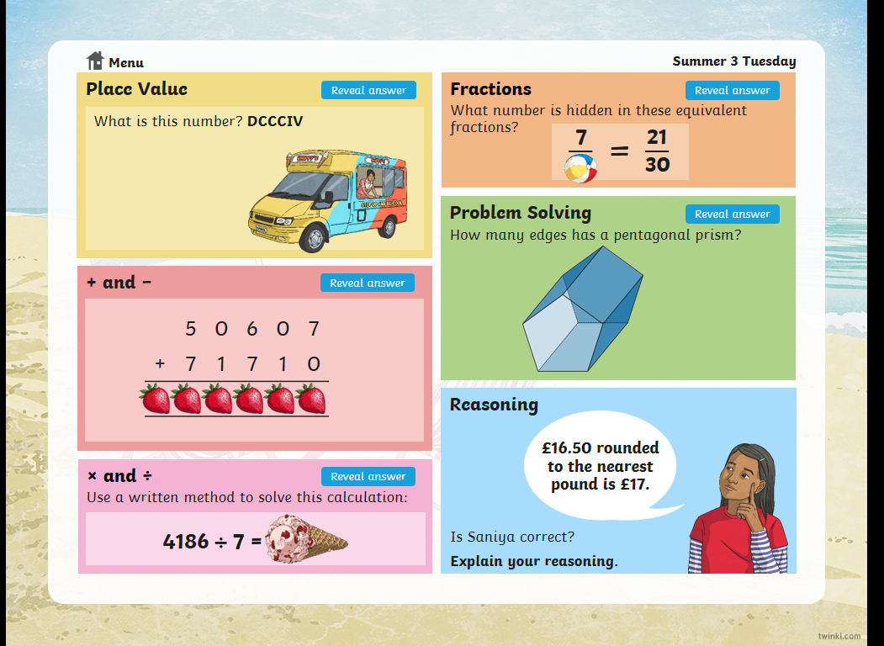
Maths | 45 minutes | White Rose Website. Summer 1 Week 6 Day 3  https://whiterosemaths.com/homelearning/year-3/  LO: TO calculate fractions from objects
Spellings | 15 Minutes | Spelling Shed  Your spellings this week; homophones  Ball, bawl, berry, burry, brake, break, fair, fare, mail, male  Play on spelling shed
Writing | 30 minutes | LO: To develop engaging questions  Reflect on what you heard yesterday: Did you find Andy and Carrie funny?  What made it humorous / not humorous? What was the atmosphere like in the studio? How did they achieve that? By the end of this unit, you will write your own interview. Brainstorm some possible crazy questions – come up with lots of ideas to start off with. Vary your question starters.  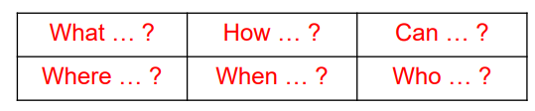  Discuss with family and friends – get them to help you choose the best three from your collection. Which will achieve the funniest answers?  https://play.acast.com/s/nincompoops/cbab5c2b-5400-415c-a103-b1d9bd348529  Answer the questions on the sheet.  Mr Wilcox’s examples:  What type of nut are you and why?  Room, desk and car – which do you clean first?  How would you get an elephant into a refrigerator?  What film have you watched the most …. and why is it Frozen?
Reading |  | Open up the questions, then press the play button (top right). It sends you to a youtube link where the poem is read.  The reading and answering questions should take you about 2 sessions.
Romans | 1 hour | https://www.bbc.co.uk/bitesize/articles/zjxmkty  This is a two-day activity  Did the Romans invade Scotland?  Go through the videos and spend a bit of time on task one. Use colour.

