Subject | Timings | Activity
PE | 30 mins | Cricket Week 8 and Week  Or  We have a subscription to Online PE lessons, called Real PE  You need to enter the address:  home.jasmineactive.com  Then enter the email address:  parent@brockenhur-1.com  Password: brockenhur
Mental Maths | 5-10 minutes | 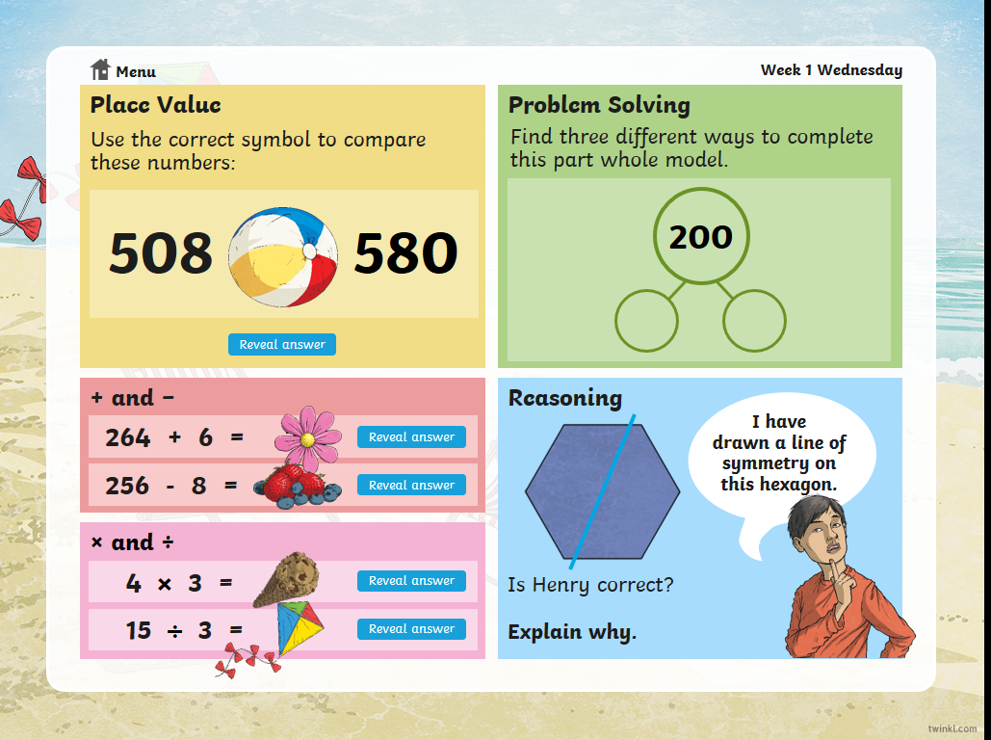
Maths | 45 minutes | White Rose Website. Summer 1 Week 6 Day 4  https://whiterosemaths.com/homelearning/year-3/  LO: TO calculate fractions from objects
Spellings | 15 Minutes | Spelling Shed  Your spellings this week; homophones  Ball, bawl, berry, burry, brake, break, fair, fare, mail, male  Play on spelling shed
Writing | 30 minutes | LO: Create some imaginative funny people and write how you will introduce them  Sound like an expert  Ask the Nincompoops podcasts are a clever mix of sounding like an expert whilst talking nonsense. Create some imaginative, funny people who will be involved in your answers to your three chosen interview questions.  Write how you will introduce them using the word bank below for ideas. Practise and play with ideas until you think you have the best introduction for each of your three answers.  Who invented the bounce in tennis balls?  Professor Whizz Babble was the respected scientist who created the ever so brilliant bounce in tennis balls. Professor Whizz Wisdom was the experienced inventor who confirmed it was possible to put a bounce in tennis balls and is famous all over the world.  https://play.acast.com/s/nincompoops/cbab5c2b-5400-415c-a103-b1d9bd348529
Reading |  | Open up the questions, then press the play button (top right). It sends you to a youtube link where the poem is read.  The reading and answering questions should take you about 2 sessions.  I’ve added a 2nd poem in case you have finished the first book.
Science | 1 hour | https://www.bbc.co.uk/bitesize/articles/zvk4f82  Discover what the digesting system and teeth do

