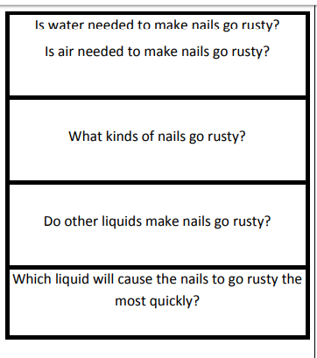
CHOOSE ONE ENQUIRY.

