Subject | Timings | Activity
PE | 30 mins | Cricket Week 8 and Week  Or  We have a subscription to Online PE lessons, called Real PE  You need to enter the address:  home.jasmineactive.com  Then enter the email address:  parent@brockenhur-1.com  Password: brockenhur
Mental Maths | 5-10 minutes | 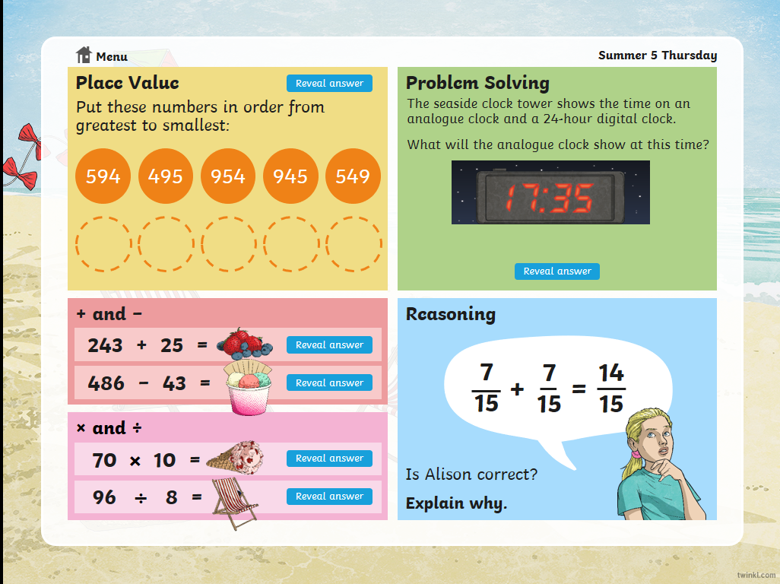
Maths | 45 minutes | White Rose Website. Summer 1 Week 7 Day 2  https://whiterosemaths.com/homelearning/year-3/  LO: TO calculate fractions from objects
Spellings | 15 Minutes | Spelling Shed  Your spellings this week; homophones  Ball, bawl, berry, burry, brake, break, fair, fare, mail, male  Play on spelling shed
Writing | 30 minutes | LO: plan your script for your crazy podcast.  https://play.acast.com/s/nincompoops/cbab5c2b-5400-415c-a103-b1d9bd348529
Reading |  | Open up the questions, then press the play button (top right). It sends you to a youtube link where the poem is read.  The reading and answering questions should take you about 2 sessions.  I’ve added a 2nd poem in case you have finished the first book.
Spanish | 1 hour | https://classroom.thenational.academy/lessons/to-be-able-to-describe-the-weather-in-spanish  Something different - here is a mini Spanish lesson for you to practice.

