Subject | Timings | Activity
PE | 30 mins | Cricket Week 8 and Week  Or  We have a subscription to Online PE lessons, called Real PE  You need to enter the address:  home.jasmineactive.com  Then enter the email address:  parent@brockenhur-1.com  Password: brockenhur
Mental Maths | 5-10 minutes | See slides
Maths | 45 minutes | TT - Rock Stars
Spellings | 15 Minutes | Spelling Shed - test yourself  Your spellings this week; homophones  Ball, bawl, berry, burry, brake, break, fair, fare, mail, male  Play on spelling shed
Writing | 30 minutes | 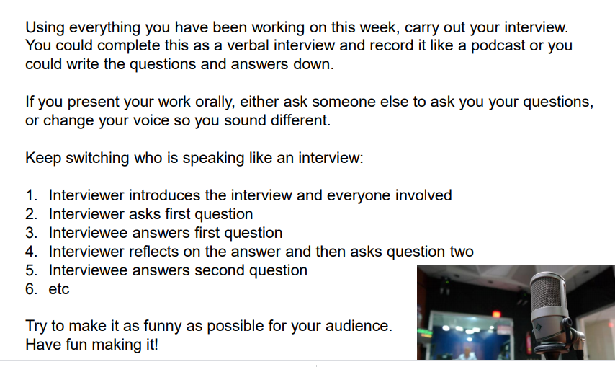
Reading |  | Open up the questions, then press the play button (top right). It sends you to a youtube link where the poem is read.  The reading and answering questions should take you about 2 sessions.  I’ve added a 2nd poem in case you have finished the first book.
Kahoot Quiz | 1 hour | See you on Zoom  This is for Monday: get some cool card ready  https://www.youtube.com/watch?v=ExeekGarOzo

