Space - Activities
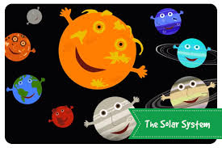

Choose any number of activities from the table below to do with your child over the course of the week.
Literacy Activities | - Listen to If I were an astronaut read by a real astronaut on the International Space Station:  https://www.youtube.com/watch?v=9wV8yw7iV8w&t=301s  - Write a list of 10 things you would take into space  - Draw a rocket and label its parts.  - Have a look at the Space simple sentence cards. Try and read the sentences or have a go at writing your own.  - Research the solar system (or sing the song), then see if you can put the planets in order  - Use the space word mat to help you write your own sentences about space and the solar system
Creative ideas | - Spaceship Porthole Craft  - Cardboard Tube Rocket Craft  - Hand and foot print aliens  - Space themed wreaths  http://www.3dinosaurs.com/wordpress/index.php/space-theme-wreath/  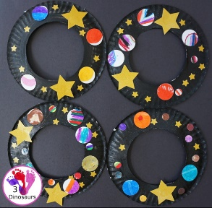  - Use the astronaut outline and a photo to turn yourself into an astronaut  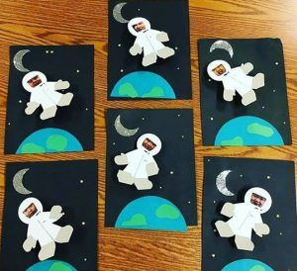  - Make a solar system mobile  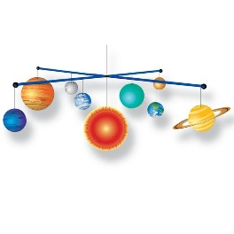
Science Activities | - Bubbling planets experiment  - Craters on the moon  - Glowing stars  As always, these activities need quite specific resources that you might or might not have, so don’t worry if you don’t manage to do them.
Sing some songs | - The Solar System Song:  https://www.youtube.com/watch?v=F2prtmPEjOc  - 5 Little Men in a Flying Saucer  https://www.youtube.com/watch?v=7_1-TrP9jwA  - Astronauts  https://www.youtube.com/watch?v=HSYaEBcl8xI  - Twinkle, twinkle, little star  https://www.youtube.com/watch?v=QjrQ1rmS44M
Cooking ideas | - Planet cookies:  https://www.bbcgoodfood.com/recipes/planet-cookies  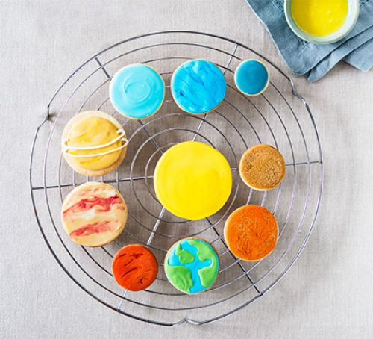  - Martian crackers:  https://www.taste.com.au/recipes/martian-crackers/f86abcfc-287b-4cf8-84eb-a965d7a0de98 (an australian recipe, you might need to change some ingredients, but they looked so good!)  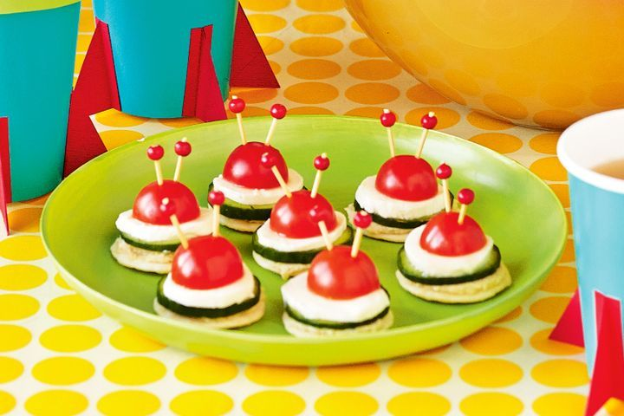  - Space rock cakes (see recipe sheet)  

