Zoom in on the picture and write your thoughts to the questions in the box

Where is the book set? | 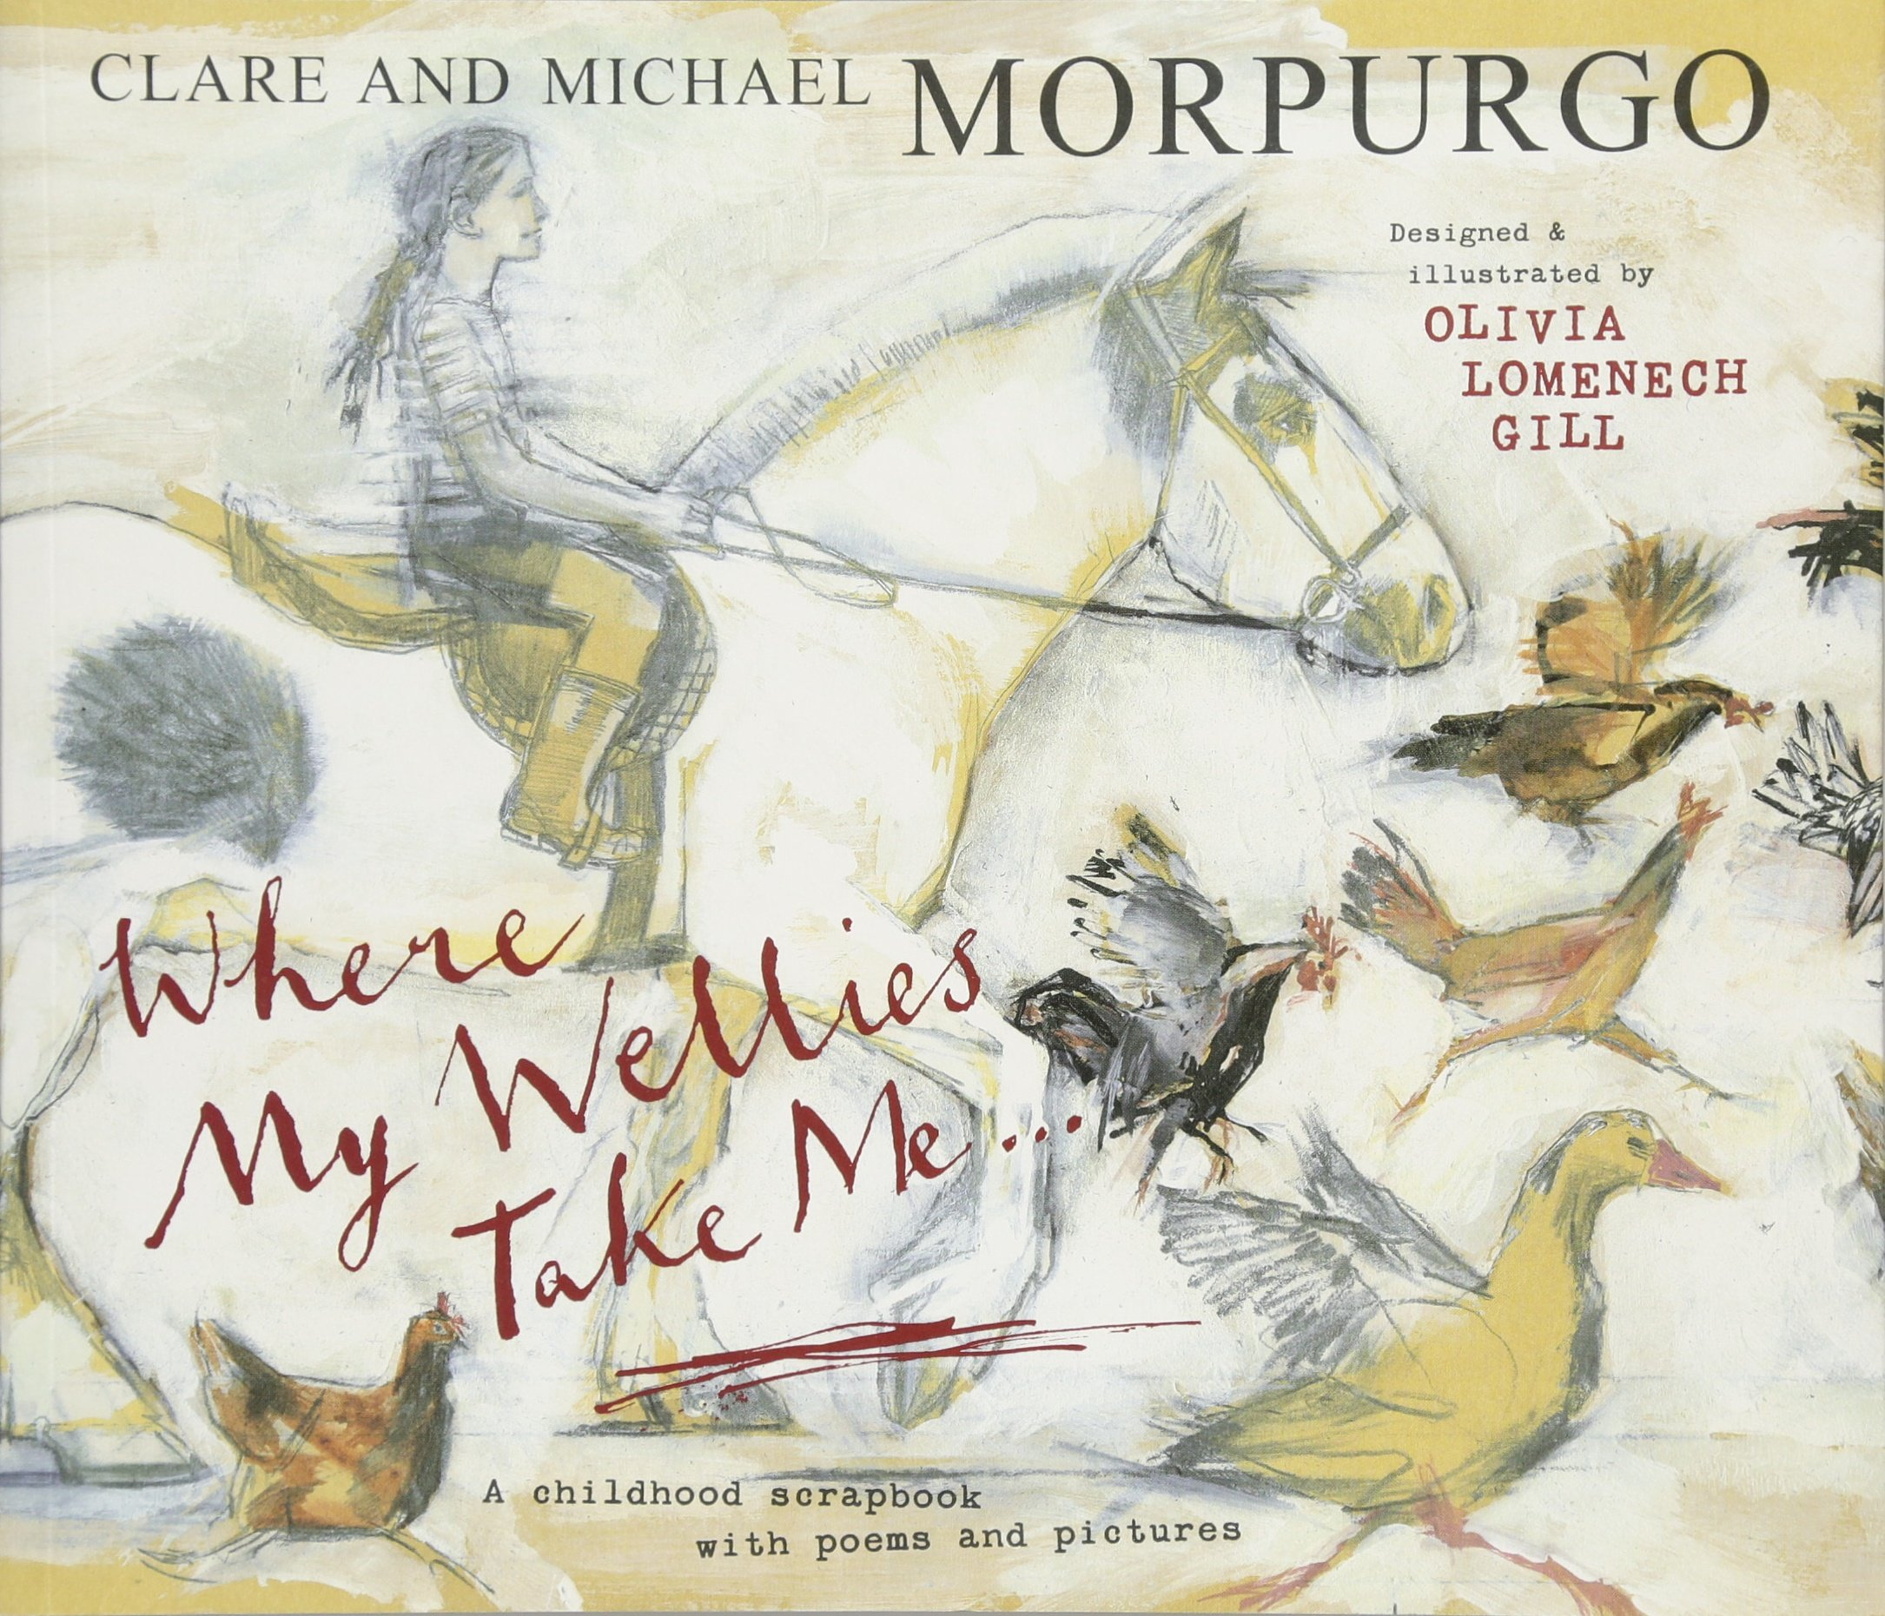 | Who are the characters?
What do you see in the pictures that is interesting? |  | What might the characters do?

Where is the book set? | 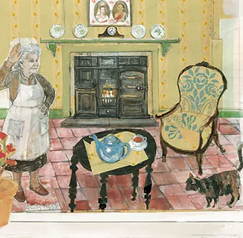 | Who are the characters?
What do you see in the pictures that is interesting? |  | What might the characters do?

Where could the postcard be from? | 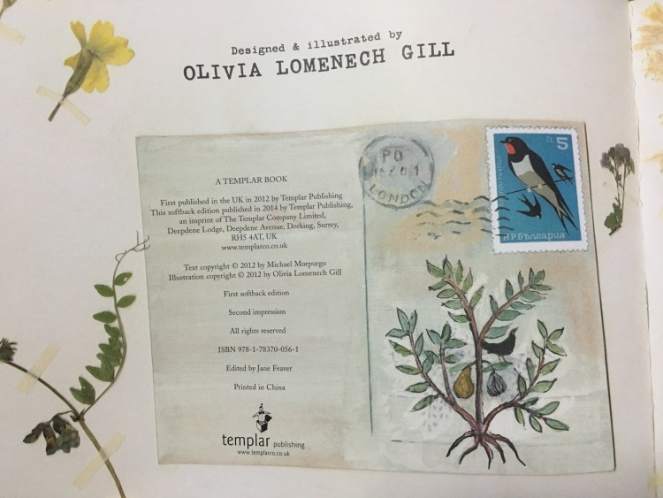 | What does the picture show?
What do you see in the pictures that is interesting? |  | What might happen in the story?

